We are looking for an icon that captures what an IXP is and how it relates to our website and the community. The video put together by Euro-IX also may be of help in understanding more about IXPs. See www.ixptoolkit.org and scroll down to the bottom-right of the home page.

IXP Image document

An Internet exchange point (IX or IXP) is a physical infrastructure through which Internet service providers (ISPs) exchange Internet traffic between their networks. Ideally, networks are “peering” at the exchange, meaning that they are exchanging traffic with each other at no cost.

A physical network infrastructure operated by a single entity with the purpose to facilitate the exchange of Internet traffic between Autonomous Systems. The number of Autonomous Systems connected should at least be three and there must be a clear and open policy for others to join.
So what does this definition mean, and what purpose do IXPs have?
In order to provide access to the 'global Internet', an Internet Service Provider (ISP) must, of course, have connectivity to the global Internet itself. ISPs generally buy Internet access (often called 'upstream transit') from one or more large ISPs. Due to the size of these networks, and their comprehensive interconnection with other networks, they can send and deliver Internet traffic to any network connected to the Internet (i.e., they have connectivity to the global Internet). It is this global connectivity that smaller ISPs buy (these ISPs are usually referred to as 'Tier 2' ISPs), and in turn sell access to the global Internet to their customers.
Now, consider the situation where there is traffic destined to travel between a customer of one Tier 2 ISP to a customer of another Tier 2 ISP. Both ISPs have to pay their upstream transit providers to deliver and receive this traffic. This is still the case even where both ISPs use the same upstream provider. Clearly, it would reduce costs, and reduce the amount of different networks (the number of 'hops') the traffic has to traverse, if the two ISPs networks were directly connected to each other. This solution is viable if there is considerable traffic between the two networks. While upstream costs are reduced there is a cost involved in providing physical connection between the two ISP's networks, and this must be considered when calculating the savings by having a direct interconnection. There are, however many thousands of ISP networks in many regions. It would not be cost effective, scaleable or manageable to interconnect with all of them individually.
Internet Exchange Points (IXPs) provide a solution to the above challenge. An IXP is a single physical network infrastructure, (often an Ethernet local area network) where many ISPs can connect and exchange traffic. Any ISP that is connected to the IXP can exchange traffic with any of the other ISPs connected to the IXP, using a single physical connection to the IXP. This allows them to overcome the “scaleability” problem of individual interconnections (what we mean by this is that they can access many networks at one time and exchange varying quantities of volume in one place and add more partners to exchange traffic with – rather than having many bilateral traffic exchanges that cost more, eat-up more bandwidth, and cost more). By enabling traffic to take a more direct route between many ISP networks, an IXP can improve the efficiency of the Internet, resulting in a better service for the end user – traffic moves more efficiently and the odds for better quality of service also are greater. In addition, as many networks have more than one connection to the Internet, it is not unusual to find several routes to the same network available at an IXP, thus providing a certain amount of redundancy.
Exchange of Internet traffic is known as 'peering' (hence IXPs are sometimes called 'peering points' or 'public peering points').
Most IXPs are non-commercial co-operatives funded by membership fees paid by the connected ISPs, and are operated for the benefit of the member ISPs and the Internet community at large. The membership fees are usually very modest in comparison with the amount of potential saving of upstream transit costs. The actual savings will depend on the cost of membership (the range of membership fees is quite wide) and amount of traffic that can be exchanged in relation to the ISPs total traffic, but savings of 10 to 20 times the membership fees are not unusual.
While the role of IXPs is often invisible to the end user, they form a very important part of the overall infrastructure of the Internet.

Here is a diagram showing the function of an IXP:
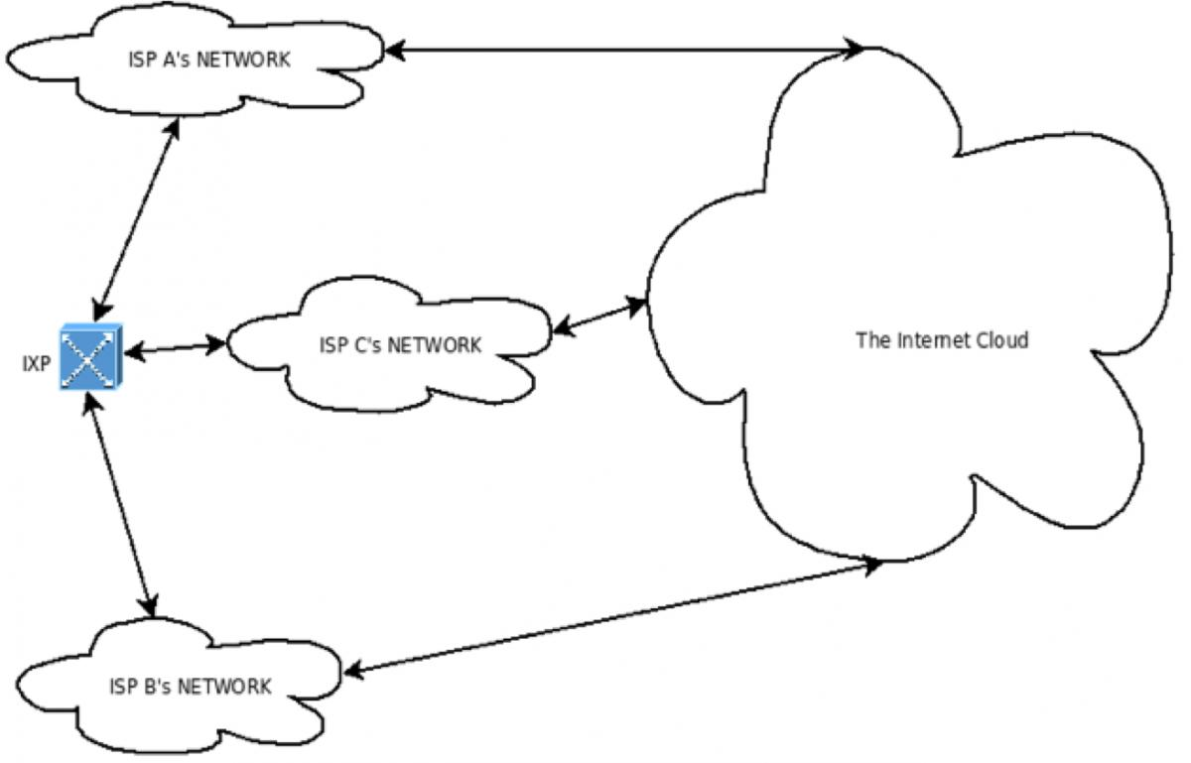
When there are at least three local networks that exchange traffic with each other, it is more efficient to set up a hub (the IXP) to which each network can connect. The diagram above, shows how three ISPs would use a local IXP to route their local traffic. An IXP can thus be viewed as the center of a group of local networks that makes it possible for local traffic to traverse through a single connection from each network to the hub.
Here is a map showing the location of IXPs around the world: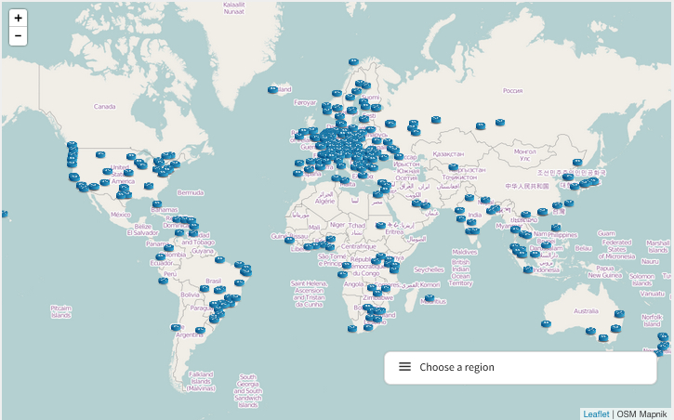
Here are a few pictures of what an IXP looks like and another video:

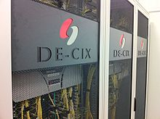

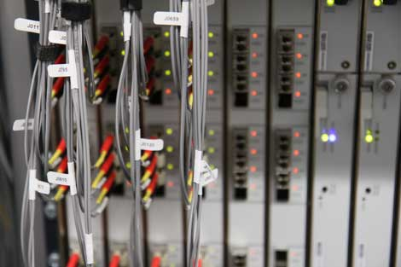

http://www.bloomberg.com/video/inside-the-internet-s-most-important-building-LpFhPvqoQB6a6Ae3s01iRA.html

http://www.telecitygroup.com/data-centres/internet-exchanges.htm (scroll down)

More data about IXPs can be found at www.ixptoolkit.org and www.euro-ix.net.

