NZIIU Brochure

Front Cover:

STUDENT EXCHANGE
The time of your life;
An experience for life

(include NZIIU logo – non-profit, charitable organisation)

Needs based scholarships available
------------------------------------------------------------------------------------------------------------------------------------

Page 1:

Have the adventure of a lifetime
Immerse yourself in a new culture
Sharpen those language skills
Make awesome new friends
You’ll gain confidence and a sense of independence that will probably exceed your expectations!

WE ARE ON YOUR SIDE
You are not just another client to us, not just another number
You choose the country and programme.
We’ll take care of the rest and as a non-profit organization, you can count on us to keep costs to a minimum.
_________________________________________________________________________________
Page 2:

PROGRAMMES TO CHOOSE FROM

Select your programme and destination:

DEPARTURE MONTH DESTINATION OPTIONS

Six Week Programmes
December France, Italy

Three Month Programmes (other variations maybe possible)
January France, Germany, Ireland, Italy
February Spain only
March Argentina, Japan
August Argentina, Ireland
September France, Germany, Italy, Spain

Semester Programmes ( a semester is of 4, 5 or 6 months duration)
January Brazil, France, Germany, Ireland, Italy, Netherlands, USA
February Argentina, Spain
March Japan only
July Brazil, Argentina
August Germany, Ireland, Japan, Netherlands, USA
September France, Germany, Italy, Spain

School Year Programme (a school year is of 10 or 11 months duration)

January Brazil, France, Germany, Italy, Netherlands
February Argentina, Spain
March Japan only
July Brazil only
August Argentina, Belgium, France, Germany, Ireland, Netherlands, USA
September France, Germany, Italy, Japan, Spain

Pg 3 (& 4?)
WHAT STUDENTS HAVE SAID
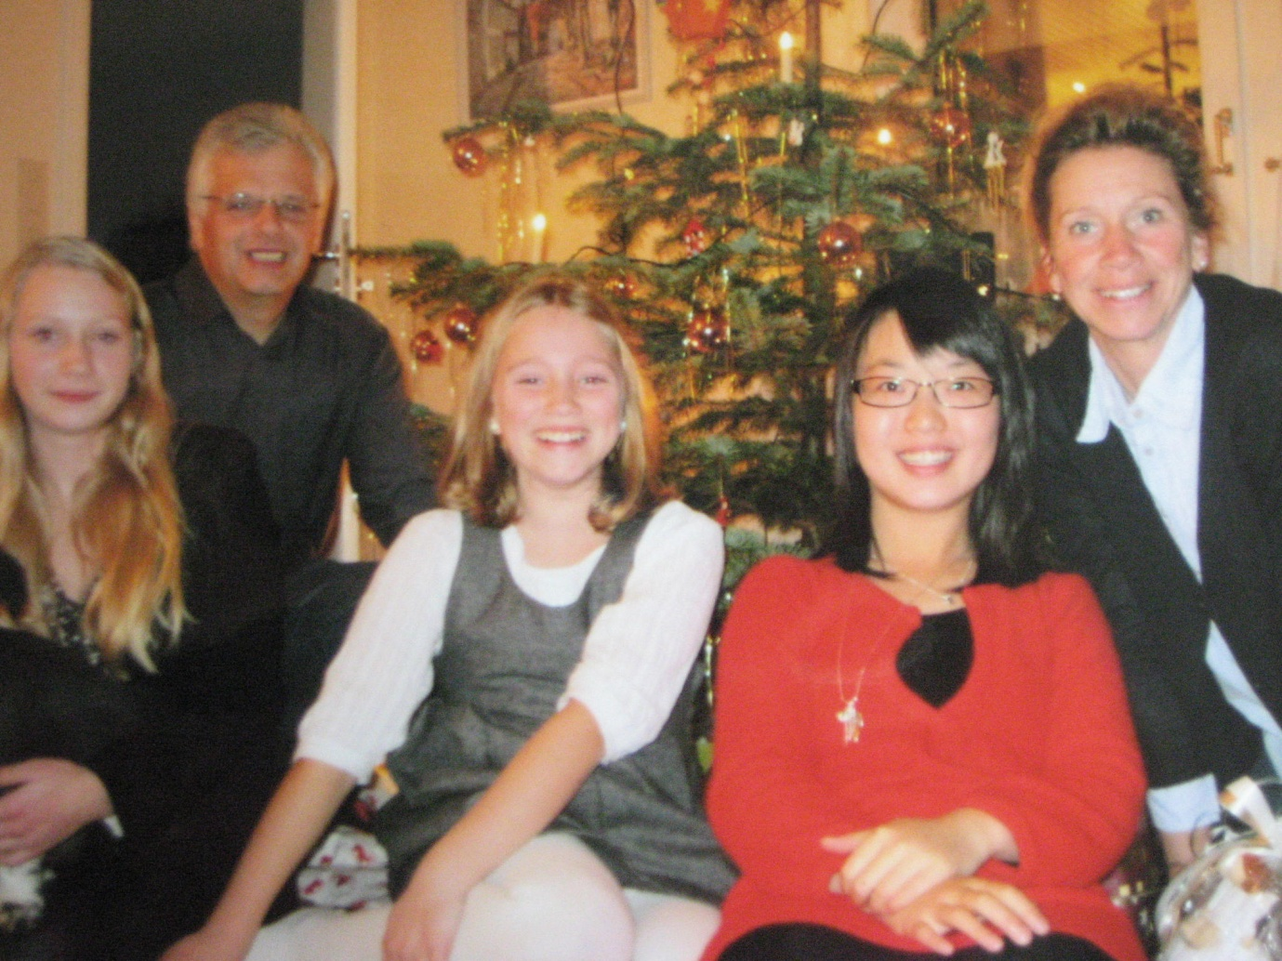
“The experience for me was so positive, I miss Germany now more than I missed home during the exchange. If not life-changing, the experience was unforgettable at the least; and the fact I was able to feel like a part of my host family, my neighborhood, my school meant so much to me. I just really want to thank NZIIU for making this all possible for me” Tiantian, Whangarei College, 2 months in Germany

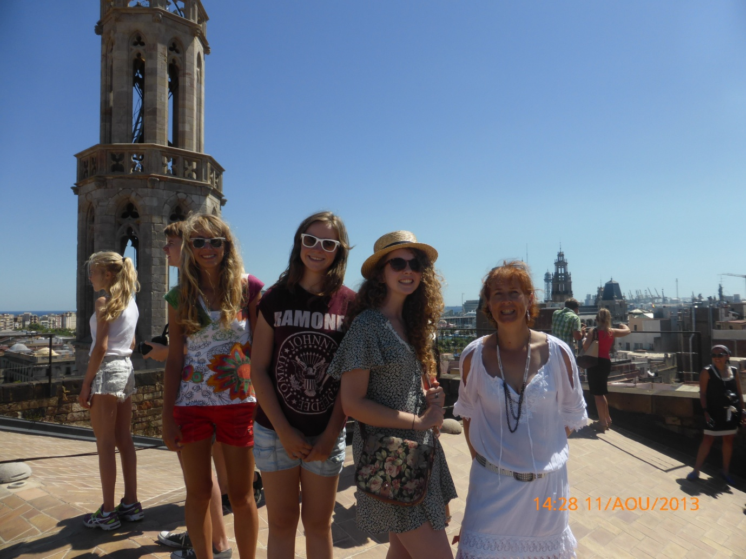

“I was so lucky with my host family placement. They were such good people, really funny and kind and soon after arriving I already felt like I was part of the family. They also really enjoyed travelling and took me to lots of awesome places which was so cool. I couldn't have asked for a better placement.” Ainsleigh, Bethlehem College, Academic Year in France

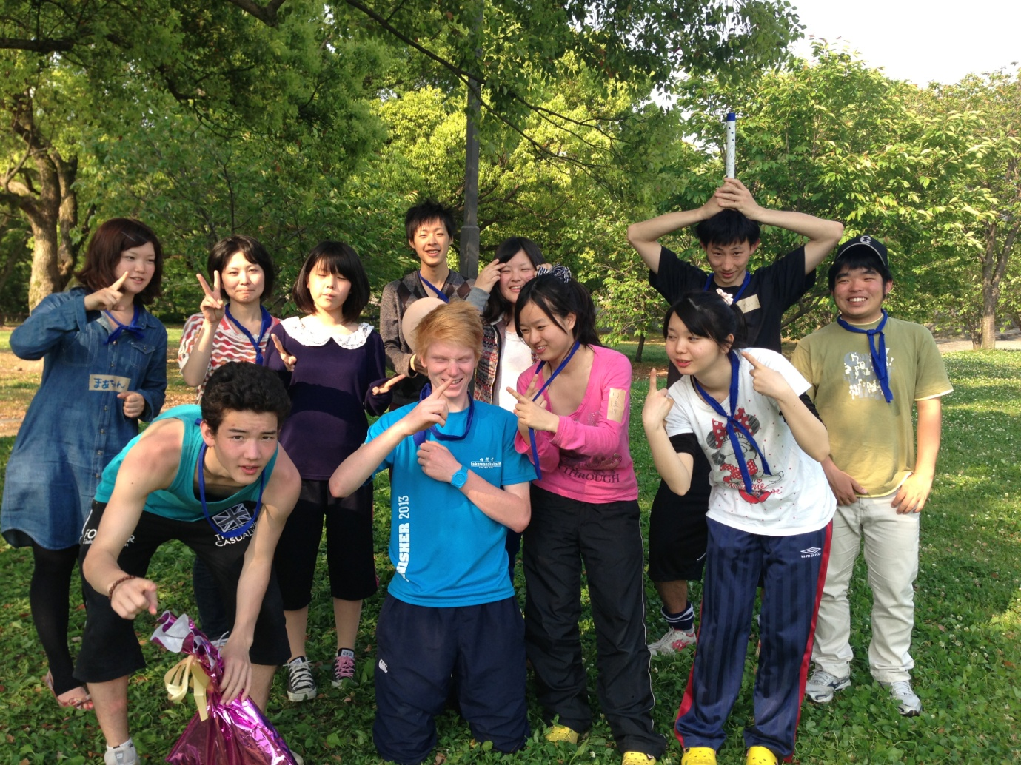
“I was lucky to go on lots of trip round Kyushu (with my host family and also with lads from school). I think school and club was always good. Also experience sports day and cultural festival at school. Overall experience of living abroad for 10 months teaches you so much. You learn about a unique culture and get a wider outlook on life. You also learn so many social skills and independence. You definitely grow up quickly." Jake, Southland Boys High School, Academic Year in Japan

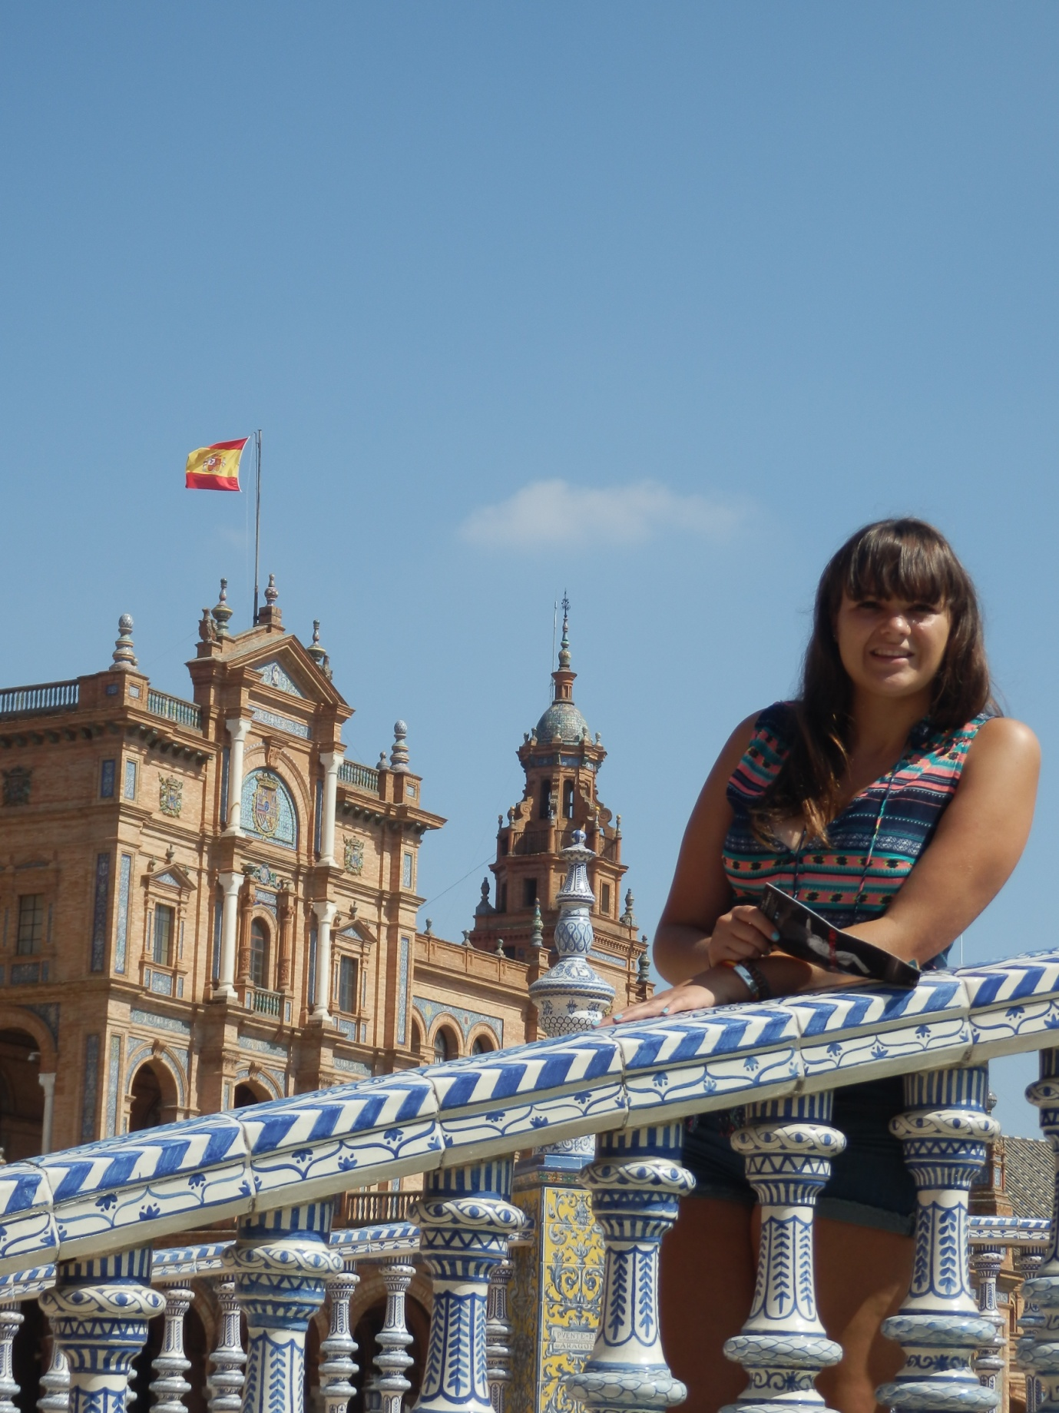
“I would recommend doing an exchange for a year as this gives you a good understanding of the language and culture. I love my host family. I was put with a family of three and I was lucky that my host brother was about my age so we got on really well.” Hannah, Massy High School, Academic Year in Spain.” Hannah, Massey High School, Academic Year in Spain

(Include student pics)
____________________________________________________________________________________________________

Pg 4
HOW TO GET STARTED

After you have chosen your destination and programme…

Step 1.INITIAL APPLICATION
Complete the initial application form and post it to us with a $50 deposit
(downloadable from our website)
Step 2. FULL APPLICATION
We will get in touch with you and send you the full application form
Step 3. INTERVIEW
Once you have submitted your full application form to us, we will arrange an interview with you and either both or one of your parents
Step 4. ACCEPTANCE
Once you are accepted, we will start arranging your flights, insurance, visa, host family and school placement
Step 5. ORIENTATION
You will have an orientation about a month prior to departure. This is to prepare you for your exchange. (You will also have an orientation in your host country)
Step 6. BON VOYAGE!
Now your adventure begins! An NZIIU representative will be at the airport to send you off. Once you arrive on the other side, you will be met by the host organisation who will provide you with an orientation then help you transfer to your host family.

For more information on our exchange programmes, visit

Official Website: www.student-exchange.co.nz
Facebook: www.facebook.com/nziiustudentexchange

Address: 8 Manukau Road/PO Box 99229
Newmarket
Auckland
New Zealand 1149

Phones: 09 520 6980
0800 924 264

Email: mari@nziiu.co.nz

