Logo Brief for Design Crowd. – Lelean Memorial School

Sakiasi Ditoka – Secretary, Lelean Old Students’ Association
sditoka@gmail.com , Mob: 679 9998633

Wikipedia Page: https://en.wikipedia.org/wiki/Lelean_Memorial_School

Lelean Memorial School
From Wikipedia, the free encyclopedia
Lelean Memorial School is one of the largest co-ed schools in Fiji. It was established in 1943 and is run by theMethodist Church of Fiji. It is co-located at the Davuilevu Methodist Compound with the Davuilevu Theological Collegeand the Young People's Department, which runs training for Methodist catechists.
Overlooking Fiji's largest river, the Rewa, the school gate faces the Rewa Bridge that was funded by the European Union and opened in 2006. Directly across the river is the village of Nausori and the old sugar town of the same name. The school roll for 2013 is 1600. Lelean Memorial School caters for students in the Tailevu, Naitasiri and Rewaprovinces but it also accepts those who apply from other parts of Fiji.

History
Towards the end of 1942, at the height of the Pacific Campaign of the Second World War, the Colonial Authority was issued a command to close all urban schools and surrender their compounds to the military, to be used as military camps for the war campaign against the Japanese threat. At that time, a missionary teacher by the name of Mr William Ewart Donnelly was serving as principal of Toorak Boys’ School or the Suva Methodist Boys' School. It was later renamed the Suva Methodist Primary School in the 1970s or 1980s.
Whilst other overseas teachers immediately left Fiji to await the end of the war, the missionary principal, Mr Donnelly, sent a circular to the senior classes of Classes 6, 7, and 8 of Toorak Boys School, inviting volunteers to come away with him, to continue their education. After consultation with the heads of the Methodist Church, he was given permission to use the Principal’s residence at the Davuilevu Technical School.
As a result, he and 50 volunteers from Toorak Boys School in Suva, met at the Principal’s residence on the 3rd of March, 1943. Their first classrooms were the two master bedrooms in the house and the long verandah on the eastern side as their library. There were two classes and two teachers; the late Mssrs W.E Donnelly andSemesa Sikivou.
At the 1943 Methodist Church Annual Conference, Mr Donnelly was given permission to expand his classes along the same ridge and as a result, the boys built three large Fijian buildings called bures, where the teachers staff quarters presently stand. He was also directed to name the new school Lelean Memorial School in memory of a missionary in Fiji, the Reverend Charles Oswald Lelean. Rev Lelean was an Australian missionary who served in Fiji for 36 years. Twenty of those years were spent by Rev Lelean as Senior Superintendent of the Davuilevu Mission and principal of the Methodist Theological College from 1914 to 1934.
The school founder, William Ewart Donnelly was a New Zealander, who became a teacher and General Secretary of the Students’ Christian Movement in the early 1930s and early 40s. He remained principal of Lelean from 1943 to 1945 when he returned to New Zealand.
Mr Donnelly returned to Fiji to establish Ratu Sir Lala Sukuna Memorial School in Suva, where he served for three years. He then served at Levuka Public School, on Ovalau, for one year before returning to Lelean in 1971 after the Ms Furnival tragedy.
Under Mr Donnelly’s guidance, the Lelean school motto, “Seek wisdom and spiritual understanding” was formulated.

List of Principals at Lelean
- 1943-45 W.E Donnelly
- 1945-48 S.G Andrews
- 1953 F.A Crane
- 1954-59 R.S Udy
- 1959-69 R.L Northcott
- 1970 Ms P.Furnival
- 1971 W.E Donnelly
- 1971-73 T.G.M Spooner
- 1974-76 N.Rika
- 1976-79 S.Finau
- 1980-82 P.Tiqatabua
- 1983 Mrs M.Koroi
- 1984 N.Rika
- 1985-86 A.Daunakamakama
- 1986-88 N.Rika
- 1988-89 A.Daunakamakama
- 1989-90 P.Sotutu
- 1991-92 J.Nabuka
- 1993 A.R Rarokoliwa
- 1993-96 A.D Racule
- 1997-99 S Vadiga
- 2000–2013 A.R Rarokoliwa
- 2013 Ledua Colati

Houses of Lelean
The houses of Lelean are named in honour of one Tongan and three Fijian missionaries. When the Lelean Memorial School was established, the houses had not yet been given names but were numbered Houses One, Two, Three and Four. In 1948, the Davuilevu Council named the houses after Joeli Bulu, Ilaijia Varani, Sailasa Naucukidi and Josua Mateinaniu. The names honour Fiji's local missionary effort amongst her own population as well its contribution to international Christian growth. The house colours, ethos and mottoes are:
- Naucukidi – Green - Spirit Of Christian Responsibility; Motto: Sacrifice for GOD's glory
- Bulu – Blue - Spirit Of Christian Pioneering; Motto: To live among the stars
- Varani – Yellow/Gold - Spirit Of Christian Leadership; Excellence in Leadership
- Mateinaniu – Red - Spirit Of Christian Service: Service to man, is service to GOD

School Song
1st Verse
- Noqu koronivuli me'u tukuna (A song about my school, I shall now sing);
- Tauyavu e noda koro ko Suva (T'was born in the city of Suva);
- Na i valu e mai voro basuka (The war tore it apart);
- Tokitaki yani ki noda vanua (T'was then moved to our land)
Chorus
- Curu mai, curu mai (Come, enter);
- Curu mai gone mo vuli mada vakalailai (Come young person, come and learn);
- Mo nanuma deivaki nomu bula e daidai (Today, consider your life);
- Torocake e na gauna muri mai (May it grow to great heights in the days of tomorrow);
2nd Verse
- Gaunisala mai wai au butuka (The road from the river's side I tread);
- Matamata vulavula au curuma (The white gates I pass through);
- Veibaka ruarua na tutuna (Baka trees line the way);
- Rara na yasana ruarua (Playing fields on each side)
3rd Verse
- Draunikau vuca wale nodra vale (They had but dead leaves for shelter);
- Dui tu na kedrai wasewase (They were organised in various ways);
- Mateinaniu, Naucu, Bulu kei Varani (The houses of Mateinaniu, Naucukidi, Bulu and Varani);
- Sekeniri kei na vuli torocake (Secondary and higher education)

Sports
In Rugby Union, Lelean has been the only school in the history of the Fiji Secondary Schools Rugby Union (FSSRU) to have won all school grades. It has never been repeated ever since by any other school in Fiji. This feat was achieved in 1955 when Lelean won the u14, U15, U16, U17, U18, and u19 Grades. The Bantam grade was later added by the FSSRU. The rugby grades have since then been changed into age groups from Under 15 to Under 19 by the FSSRU.
Lelean has won the coveted Deans Trophy for the FSSRU Under-19 competition, 13 times and drawn five times since it entered the competition in the mid-1940s. Lelean was last the Deans Trophy holders in 2010 after winning the Deans finals for the third year in a row since 2008. Lelean also takes part in athletics, netball, soccer, hockey and cricket. The Fiji Rugby Union has established a High Performance Gymnasium at the school's Rugby Academy which is also used by theTailevu Rugby Union, Naitasiri and Rewa Rugby Unions.

School Battle Cry
The school battle cry is Feed the Bulbul. This slogan is unique to Lelean Memorial School. It was coined in the late 1940s to the early 1950s and has been around since then. As boarders in Lelean in the 1950s, students were always foraging for food in their free time. This search for food included eeling (hunting for eels), catching prawns, fishing, diving for fresh water mussels (kai), mongoose trapping, hunting chickens that strayed onto the school compound, trapping bulbuls (pycnonotus jocosus fuscicaudatus), and hunting for bats. The junior boys in particular were the ones who always venturesome in trapping bulbuls. In setting the trap, this group would close all the dining hall windows and doors, except for the door facing the double storey dormitories. These dorms are now part of the Rugby Academy and Technical Drawing facilities.
To lure in the bulbul, food crumbs would be spread out from just outside the open door to the middle of the dining hall. The group would then go and lie in wait from a nearby vantage point. When the agreed signal was given by the hunt leader, the group would then rush in and lock themselves in the Dining Hall with the trapped birds. The birds were then hunted down for the kill, with balled-up towels used as missiles.
It became a game sport for young Lelean boarders but the kill was also destined for the pot. The derivation of “Feed the Bulbul” is from this foraging sport. In rugby, the Lelean students would practice set moves, on the basis of luring in an opponent into a trap upon which bodies were launched much like 'human torpedoes' with deadly accuracy against opposing teams. The code word for these moves was “Feed the Bulbul”.
Feed the Bulbul evolved from a rugby code to become the school battle cry especially in full contact sports such as Rugby Union and Rugby League

Notable alumni
See also category: Lelean Memorial School alumni

Academia
- Dr Rusiate Nayacakalou - first Pacific Islander to graduate with a PhD
- Dr Epeli Hau'ofa - late former head of the Department of Sociology, University of the South Pacific, and Founder/Director of the Oceania Centre for Arts and Culture,
- Dr Tupeni Baba
- Dr Jimione Samisoni - late former Dean of the Fiji School of Medicine,
- Dr Ropate Qalo (Head of School, School of Social and Economic Development, University of the South Pacific)
- Dr Matakite Maata (Head of Chemistry Division, University of the South Pacific)
- Dr PauI RaIifo (Nuclear Magnetic Resonance instrumentation specialist
at Boston University)
- Rev Dr Jovili Iliesa Meo - Principal of the Pacific Theological College, 1996-2001-first native Fijian Church Minister to graduate with a PhD
- Dr Isimeli Waibuta Tagicakiverata
- Dr Isimeli Cokanasiga

Armed Forces
- Warrant Officer Ratu Meli Vesikula - Regimental Sergeant Major, Duke of Wellington's Regiment (West Riding) King's Division,
- Staff Sergeant Sotia Ponijiasi - 22 Squadron British SAS then NZ Army SAS
- Sergeant Ilisoni Ligairi - 22 Squadron British SAS
- Lieutenant Colonel Isoa Delamisi Tikoca - Former Commanding Officer, RFMF Engineer Squadron
- Commander Timoci Lesikivatukoula Natuva -Minister of Works in the Fiji Military Regime,
- Lieutenant Colonel Viliame Seruvakula - former Commanding Officer, 3rd Battalion, Fiji Infantry Regiment,
- Lieutenant Colonel Isireli Dakunimata - former Commanding Officer, Logistic Support Unit
- Lieutenant Colonel Etueni Caucau - former Director Army Legal Services,
- Captain Sainivalati S. Navoti - Legal Counsel

Civil service
- Jioji Kotobalavu - former Permanent Secretary to the Prime Minister, later CEO, Prime Minister's Office,)
- Mary Chapman - former Secretary to the House of Representatives.

Clergy
- Rev Paula Niukula - former President of the Methodist Church of Fiji and Rotuma,
- Rev Dr Akuila Yabaki - Director of the Citizens' Constitutional Forum, a prominent Civil Rights organisation in Fiji,
- Rev Dr Jovili Iliesa Meo - Principal of the Pacific Theological College, 1996-2001.

Diplomatic Corp
- Paula Sotutu - former Fiji Permanent Representative to the UN
- Sailosi Kepa (Former High Commissioner to Great Britain)
- Pita Kewa Nacuva - former Ambassador to USA and Canada
- Viliame Navoka - (Late former Consul General, Sydney, Australia 1993 to 1996)
- Joji Kotobalavu - former Ambassador to Japan,
- Seru Savou Kuliniasi - former First Secretary, Fiji High Commission, Wellington, NZ,
- Mere Tora - current Acting High Commissioner, Fiji High Commission, Wellington, NZ
- Sainivalati S. Navoti - former First Secretary/Legal Counsel, Fiji Mission to the UN, New York 2004 -2008, President, International Seabed Authority (ISBA), 2006, Anti Terrorism Advisor (Pacific), UNODC, Lead Negotiator for Climate Change, Alliance of Small Island States (AOSIS), G77 & China Lead Negotiator 2013, Senior Legal Counsel- International Seabed Authority, Kingston, Jamaica, 2014 - Senior Legal Advisor Int'l Seabed Authority, Kingston, Jamaica

Education
- Joeli Nabuka
- Kolinio Rainima Meo (former Permanent Secretary (CEO) Fiji Ministry of Education) (former Director/CEO Fiji Institute of Technology
- Alumeci Susu Tuisawau - Director CAS/TVET, Ministry of Education.
- Saimoni Waibuta - Director Assets Management Unit, Ministry of Education

Fiji Police Force
- Aisea Taoka
- Emosi Nakete Meo (Former Director – Fiji Police Special Branch)

Law
- Late former Attorney-General (SVT Government) Kelemedi Bulewa
- Late former Attorney-General (SVT Government) Ratu Etuate Tavai,
- Former Justice Kishore Govind,
- Former Justice Sailosi Kepa,
- Former Magistrate Josaia Waqaivolavola - youngest Magistrate in Fiji but was removed by the military regime of Frank Bainimarama.

Medicine
- Dr Samuela Kata,
- Dr Alipate Jimi Pareti
- Dr Jimione Samisoni,
- Dr Salesi Savou,
- Dr Lepani Ditoka,
- Dr Deo Edwin Narayan,
- Dr Apimeleki James Meo.
- Dr Amrita Kumar

Politics
- Ati George Sokomanu - first President of the Republic of Vanuatu,
- Tomasi Vakatora - former Speaker of the Fiji House of Representatives and one of the architects of the 1997 Constitution of Fiji,
- Dr Apenisa Kuruisaqila - Speaker of the House of Representatives,
- Lloyd Maepeza Gina - first Speaker of the National Parliament of the Solomon Islands - 1976,
- Ratu Etuate Tavai - youngest Attorney General in the history of Fiji,
- Pita Kewa Nacuva - Speaker of the House of Representatives)
- Viliame Navoka- Senator and Fiji Consul General to Sydney.
- Tupeni Baba - founder of the New Labour Party,
- Mitieli Bulanauca - Senator - SDL,
- Joeli Nabuka - Member of Parliament - SDL Government,
- Jokapeci Koroi (nee Cavu) - President of the Fiji Labour Party.

Prisons service
- Aisea Taoka (Commissioner of Prisons)

Tourism and Hospitality
- Radike Qereqeretabua - First Fiji local to be Director of Shangri La's Fijian Resort and Spa

Trade unions
- Ted Young

Athletics
- Ana Ramacake Birch - gold medalist at the South Pacific Games, 1963,
- Mosese Waqainabete – 4 x 400m Gold Medalist 1979 SPG,
- Jone Veikoso – 4 x 400m Gold Medalist 1979 SPG,
- Makelesi Bulikiobo,
- Mesulame Rokuro – discus, Olympic Games, Commonwealth Games and South Pacific Games in the 1950s and 1960s.

Cricket
- Joeli Nabuka
- Joe Rika

Rugby
- Sailosi Kepa,
- Pita Nacuva,
- Waisale Serevi,
- Seremaia Bai,
- Akapusi Qera,
- Sireli Naqelevuki,
- Kameli Ratuvou,
- Napolioni Nalaga,
- Apolosi Satala,
- Iliesa Keresoni,
- Ravai Fatiaki,
- Metuisela Talebula
- Fero Lasagavibau
- Dale Tonawai
- Isikeli Vuruna
- Ratu Isei Nasiganiyavi
- Ratu Alipate Ratini
- Tevita Kuridrani - Wallabies 2013
- Emosi Mulevoro

Judo
- Simione Kuruvoli
- Josateki Naulu

References
- Colin George, History, Australian Defence Force Academy, UNSW. Awarded by,University of New South Wales – Australian Defence Force Academy. School of History, 2000. Raicakacaka,'walking the road' from colonial to post-colonial mission, the life, work and thought of the Reverend Dr. Alan Richard Tippett,Methodist missionary in Fiji, anthropologist and missiologist, 1911-1988.
- Garret, John, To live among the stars, Institute of the Pacific Studies; 1985
- Tippett, A.R., 1954, The Christian (Fiji 1835–1867), Auckland Institute and Museum, Auckland
- Baleiwaqa, Tevita, 1996, ‘Josua Mateinaniu/Ko Josua Mateinaniu’, in Thornley and Vulaono 1996:20–30
- Kanailagi, Tomasi, 1996, ‘The Life and Work of Rev John Hunt/Ko Jione Oniti’,in Thornley and Vulaono 1996.
- Meo, Jovili, 1966, ‘Methodist Education/Na Vuli e na Lotu Wesele’, in Thornley and Vulaono 1996:160–76.
- Thornley, Andrew, and Tauga Vulaono, 1996, Mai Kea Ki Vei: Stories of Methodism in Fiji and Rotuma, 1835–1995, Methodist Church of Fiji and Rotuma.
- Lelean Makes Deans History, Fiji Times 22 Aug 2010, Lelean makes Dean history
- A New Chapter at 74, Fiji Times, 28 Jan 2012, Radike QereqeretabuaCoordinates: 18°2′11″S 178°31′36″E
- Lelean Sings the Blues, Fiji Times, 24 August 2009
Categories:
- Educational institutions established in 1942
- Methodist Church of Fiji and Rotuma educational institutions
- Schools in Fiji

Relevant Logos



Logo of the Methodist Church of Fiji

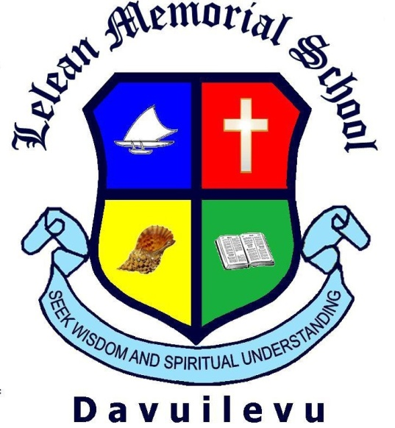

Current Logo of Lelean Memorial School (It was hastily prepared and is too similar to many other schools.) Instead of the four house colours, blue, red, yellow and green, it would be preferred that only the school’s colours of Navy Blue, Royal Blue, Sky Blue and White be used in the logo.

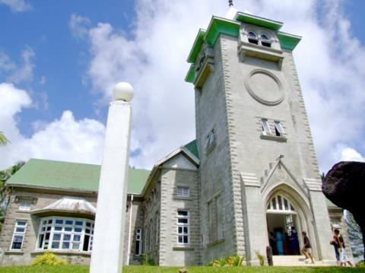

The Baker Hall



Rugby player with Baker Hall as the background.

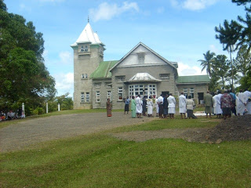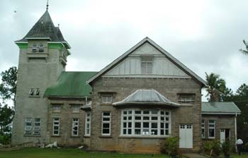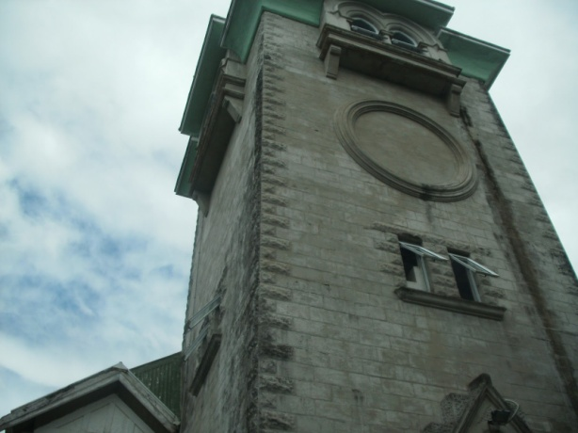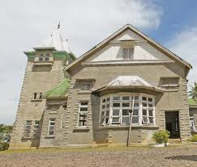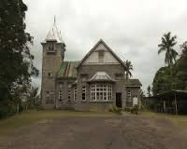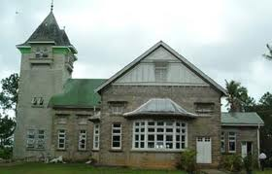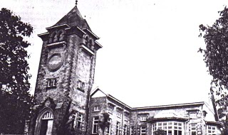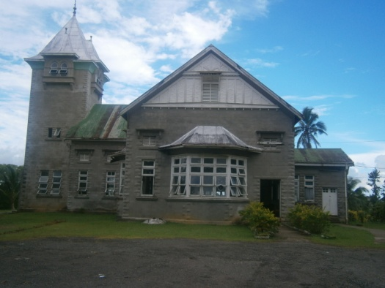

Images of Baker Hall.

