LANDING PAGE – WEBSITE

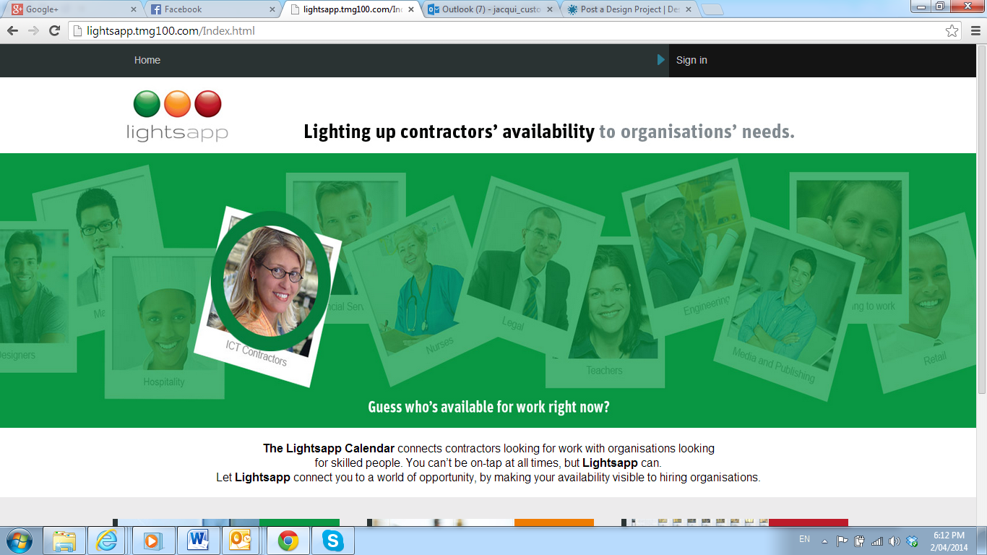

A Unique Marketplace Lighting up Contractor’s Availability

Are you a Contractor looking for more work?

Do you want to maximise your earning potential and minimise your downtime?

Do you wish you had more paid contracting hours?

If you answered YES to any of these questions then you need Lightsapp.

If you are a contractor looking for work or you have available time that needs to be filled then you need Lightsapp. Registration is Simple and it’s Free!

< Contractors Click Here Now to Register for Free >

What is Lightsapp?
Lightsapp is a unique marketplace providing contractors and organisations a platform to connect on a needs basis for Contractors, organisations have instant access to contractor calendars in real-time, allowing organisations to connect directly by matching skills, preferred location and availability.

I’m a Contractor so what can Lightsapp do for me?
Lightsapp helps maximise your earning potential and reduce your downtime between jobs. One major problem for you as a contractor is that potential employers do not know if you are available for a given period or project. This may lead to lost opportunities for you and subsequently a loss of income. By organisations knowing your availability, Lightsapp links you directly to prospective clients, reducing the time consumed to find your next contract, and all subsequent contracts.

After registering with Lightsapp, simply log in, set up your profile (or better still, import key information from your LinkedIn profile) set your availability, and get ready to secure your next project. Lightsapp takes care of calendar automatically. It’s that simple and you remain in control. Reduce your available time by selecting the contracts you approve that fit around your schedule, location and at a rate that works for you.

You can now deal directly with the organisations requiring your services and what they pay is what you charge! No middleman, no agencies no brokering fees. Transparency at last!

< Contractors Click Here Now to Register for Free >

I am a Contractor and I’d like to know more about how Lightsapp works click here
[LINK TO: HOW IT WORKS CONTRACTORS - WEBSITE PAGE]

[HOW IT WORKS CONTRACTOR – WEBSITE PAGE]
I am a Contractor and I’d like to know more about how Lightsapp works

If you are a contractor looking for work or you have available time that needs to be filled then you need Lightsapp. As a contractor, time is money so you need to maximise your earning potential and reduce your downtime. By linking you directly to prospective clients, you’re in control of the negotiation process.

- (Red): I am Happy because I am working
- (Yellow): I am available to still field offers but am in negotiation
- (Green): I am available to work

Here’s how it works…

- You Register and create your profile with Lightsapp
- Express register for FREE click here <CONTRACTOR REGISTRATION LINK> to access an on-line real-time calendar to show potential clients your availability.
- Add a photo (optional) for a more personal touch or why not a video profile?
- Import your relevant LinkedIn Profile details (we recommend you maintain your LinkedIn profile so clients have the most current information about you – particularly your experience)
- Outline your core skills profile (this is one of the most important bits! Don’t worry, it’s really easy)

- Set up your calendar which immediately tells your potential clients of your availability
- Start out by blocking out your existing commitments. This will show up in your calendar as Unavailable in RED.
- You will quickly realize where you have some available time and may wish to fill it with more work in order to maximize your earnings. Available time will show up in your calendar as GREEN.
- YELLOW means that you’re still available but you are in negotiation (don’t worry, Lightsapp sets this automatically when you connect with a potential client)

- Ready to work
- Once you have registered and set up your calendar, Lightsapp will automatically set any idle time you have as green meaning you are available for work. . Your profile and availability will be accessible to potential clients. You can sit back and wait for contracting offers to come your way.
- You negotiate the contracts that best fit your schedule, skills and rate. This is fun and simple

MY BENEFITS OF USING LIGHTSAPP FOR ALL MY FUTURE CONTRACTS
- • Future clients know when I can workI choose where and when I work
- I don’t need to rely on agencies or anyone else to find work for me
- I’m in control to accept or reject offers
- My calendar is managed for me and updated automatically
- I can overwrite my calendar by setting my availability if I want to take a break
- I don’t need to maintain yet another online profile as Lightsapp just uses my LinkedIn Profile
- You are in control as you can Accept or Reject job offers based on your preferences and Lightsapp will update your calendar automatically.
- Through a rating system you can earn priority placements in the marketplace. You will build this up over time with customer testimonials.

< Contractors Click Here Now to Register for Free >

Share this link with your peers and if they register with Lightsapp you will be in the draw to win a iPAD. Link to Share via social media (twitter facebook email etc) or email….

REFERRAL PROGRAM IDEAS:

A Unique Marketplace Lighting up Contractor’s Availability

Are you an Organisation looking for contractors available to work now?

Do you want to minimise your cost to resource and maximise talent pools for your projects fast?

Do you want to reduce your search efforts a few clicks of a button?

Alternative questions to consider:

- Are you missing out on getting the right people for your next contractor because you are wasting time contacting people that are already working?
- Sick of placing ads in a desperate attempt to find people?
- Are you over reviewing a pile of resume’s and rather shortlist candidates online?

If you answered YES to any of these questions then you need Lightsapp.

If you are an organisation looking for contractors or you have projects coming up that need to be resourced then you need Lightsapp. Registration is Simple and it’s Free!

< Organisations Click Here Now to Register for Free >

What is Lightsapp?
Lightsapp is a unique marketplace providing contractors and organisations a platform to connect on a needs basis. It gives hiring organisations instant access to view contractors’ calendar in real-time, allowing them to connect with contractors and to book themagainst their “free” time with just a few clicks. Simple search criteria where skills, location, availability and rates can be defined. It’s a booking system showing Contractor availability in real-time!

What can Lightsapp do for my Organisation?

Today, contractor and temporary employees are a critical part of many workplaces. Companies commonly rely on temporary workers and contractors to meet opportunities created by project work, periods of peak demand, annual leave and system updates.
Lightsapp is ideal for urgent “just in time” access to Contractors to fill a position immediately or as a planning tool.

Plan for future projects where contractors can be booked well in advance. . No more advertising, no more wasting time ringing people in your database or networks and being told they’re busy. Accommodate for future market conditions ahead of time to maximize your company's value per hour and dollar, even in difficult financial conditions. Give your projects the green light with certainty.
All this for a low monthly subscription fee. (link to rates)

Real-people, real-time, real-smart.

After registering with Lightsapp, you can check out the search capability for free. Once you see someone that fits your criteria then you need subscribe to Lightsapp on either a monthly, quarterly or annual basis via PayPal then you’re free to connect.

When you negotiate with a contractor the rates you settle on is what you pay. No middleman, no brokering fees.

Once you have registered, simply log in, run a search for skills & availability to secure your next projects’ needs, as well as booking for future projects as they come up. Those candidates that are the most available in the date range you set will be displayed at the top of the list. It’s that simple. Save time and effort accessing resources availability in real time and avoid advertising costs and overload of CV qualifying & filtering as well as agency phone calls to find the right contractors.

< Organisations Click Here Now to Register >

I represent an organisation looking to hire contractors and I’d like to know more about how Lightsapp works click here

[LINK TO: HOW IT WORKS ORGANISATIONS - WEBSITE PAGE]
[HOW IT WORKS ORGANISATION – WEBSITE PAGE]
I represent an Organisation and I’d like to know more about how Lightsapp works

If you represent an organisation looking to hire contractors across any of the nominated industries, you can search for resources available in the desired timeframe with the mandatory skills required all in one simple query through Lightsapp.

No need for costly advertisements to find the right people for your projects. No need to source skilled people through multiple channels: your one stop shop for contracting talent always ready to take your query 24x7 for when you need it…

Here’s how it works…

- Organizations can register with an authorized company email in 3 simple steps to get immediate access to search engine functionality across industry categories and functions. Simple colour coding notifies if a contractor is working (red), is in negotiating an offer but is available to work and open to more offers (yellow) or is available to work (green). The number under each colour represents the number of days available or busy within the date range you set.

- A search can be queried by; availability, role, region and/or rates. Lightsapp will deliver the closest ranked match to your specification depending on mandatory and/or optional skills and list you candidates to consider from highest availability (GREEN) AMBER (under offer) or RED (busy)

- At first glance a list will appear with summary of information to compare all the available (GREEN/AMBER) candidates, if you should want to “connect” with the candidate and have already subscribed to Lightsapp, then an “invitation to connect” be initiated.

- The “Connection” status will provide you with

  - Photo/video (if included)
  - List of skills
  - Past history experience
  - Location and distance parameter willing to travel
  - Rates
  - Contact details – email (mobile phone, home phone and location if available)
  - Ability to add to your favourites’ list

- To subscribe to Lightsapp, we use PAYPAL as our partner service of choice for security, ease of verification and currency conversions. This registration process will take only a few minutes should you have an existing PAYPAL account.

- Once membership is established any 5 members of your organization can use the Lightsapp services at any one time. The membership entitles an UNLIMITED amount of searches, connections and calendaring updates without any extra hidden costs per month – just a simple monthly fee.

The cost of one membership subscription will pay for itself with only few connections per month as you will save on unnecessary advertising costs or agency fees now that Lightsapp is doing all the legwork for you! <See our subscription model and licensing agreement>

SEARCH > CONNECT > OFFER it’s that simple!

Real-people, real-time, real-smart.

< Organisations Click Here Now to Register for Free >

