Here is my old Logo. I feel it is dated, and my focus is not so much on Data or global services anymore, so I don’t feel it applies. But, I kind of like how a graphic is embedded in the name of the company – not to say that is necessarily what I’m looking for, but it’s what I had before (and my tagline has changed to ‘Discover Your Business’ True Potential):

I browsed through the general logo portfolio and really like the following designs:

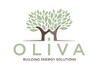 I really like this one!! The idea of hands supporting growth is intriguing. I also like the colors (by the way, the color palette I suggested is just one that I like. If You come up with something that you just feel is right, but has different colors, please do not hesitate to submit it).

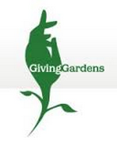 I like this as well – not so much the color, or even the shape, but it kind of looks like a flower opening at first and it’s only when you look again that you see the hands. Kind of like the Olivia logo above – where you don’t notice they are hands forming the trunk until you think about it. I like things that make you think twice!
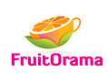I just like this logo – the orange that is a cup. Creative. And the colors are fresh and inviting – make you think ‘fruity’. Perfect for what it does.
 Again this sort of has a plant theme with hands, but I like how it’s circular, showing movement.

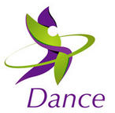LOVE this one. Just the movement and colors and abstractness of it, is great for a dance company.
These are interesting because of the colors and the white symbol embedded, kind of cool.
 This took me a moment to figure out it was a p and a d and how nicely they fit together. I like the swoosh feel to it.
 This was just clever and well balanced.
 I love how they incorporated the flag into the bag. It really says what it is – what the company is about. I like logos that when you look at them, you know what the company is about.

This is just interesting because of the way the FIT stands out, and I like the person part of it. I don’t know that something like this could work with my logo, but again, there are a couple of ways to look at this logo and I like that.

Growth of the mind is an interesting concept here. The book with hands faded out lets you know what they are about even though the name is not so obvious.

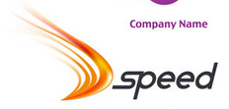 I like the movement of this logo. Which is perfect for speed.

 I like how this looks 3D.

I just like it!

