Brief for Chaplin’s Circus ‘Programme’

Format: 8-page brochure, stapled.

Bleed: 1mm all-around. Leave an additional 7mm clearance on left- and right-hand margins.

Style: Brochure will look like a newspaper from the 1920s. Old fonts should be used and an effect should be applied to all of the photos to make them appear older.

Notes: The following format is just a guideline. We have included a range of ‘features’ such as adverts and weather reports etc. which can be used to fill up space.

Page 1:

Headline: “The Circus Times”
Tag line: “Chaplin’s Circus Special Edition”
Date: “23rd August 1924”
Content:
- Primary Article: Can Chaplin’s Circus save itself from bankruptcy?
- Secondary Article: The vultures are circling.

Page 2:

Date and Page Number at top of page
Content:
- Primary Article: Spotlight on Orville Wright
- Secondary Article: The Human Cannon; a weapon of mass distraction?

Page 3:

Date and Page Number at top of page
Content:
- Primary Article: Return of The Human Arrow: Pansy Zedora is enlisted to drag Chaplin’s Circus out of the red.
- Secondary Article: Charlie ‘hangs out’ in London.

Page 4:

Date and Page Number at top of page
Content:
- Primary Article: Interview with The Great Baldini
- Secondary Article: The idiot’s guide to erecting a Big Top

Page 5:

Date and Page Number at top of page
Content:
- Primary Article: The future of the circus industry (by the Ringmaster of Chaplin’s Circus)
- Secondary Article: Is the Daughter of Chaplin’s Circus treading a fine line?

Page 6:

Date and Page Number at top of page
Content:
- Full page advert for Chaplin’s Circus (Poster design, attached in separate file)

Page 7:

Date and Page Number at top of page
Content:
- Primary Article: Life as a ring-boy (or girl!)
- Secondary Article: Chaplin’s acrobat picks up Gold… and breaks world-record.

Page 8:

Date and Page Number at top of page
Content:
- Primary Article: Chaplin’s Circus raises funds for Cancer Research UK
- Games: Crossword & Spot-the-difference

Articles:

[1] Headline: Can Chaplin’s Circus save itself from bankruptcy?
[Insert photo #1] They say that drastic times call for drastic measures. Well, measures don’t come more drastic than this: Chaplin’s Circus has commissioned aviator Orville Wright—of ‘Wright Brothers’ fame—to build the world’s first Human Cannon!

Chaplin’s Circus recently decided to sell its animals to rival circus-owner, Mr Barrington Brie, after a season of steadily declining ticket sales. This included their one-time star attraction Bambini the Elephant, whose popularity had been waning with public. [Insert photo #2]

When questioned about the recent sale, Mr. Bottle, head of the Circus Owners Association, commented, “The sale of Chaplin’s animals confirms suspicions amongst the circus community that this small-time family circus is on its way out. The public want to see animals! Chaplin’s Circus is out of touch!”

Chaplin’s Ringmaster, Mark Mergana, had the following to say: “We took a group decision to become the world’s first all-human circus. People don’t want to see animals doing tricks any more, they want danger and excitement. If you thought the Charleston was fast, just wait until you see our human cannonball flying across the Big Top! Do not blink or you’ll miss him! This is going to be the most spectacular circus show on Earth!”

The spectacle does not stop there, Ladies and Gentlemen. Oh, no! Various sources have confirmed that world-famous trapeze artist Pansy Zedora has been recruited in an attempt to get this show back on top. [Insert photo #3] Ms Zedora first made a name for herself as The Human Arrow with the Flying Zedoras. Although she no longer performs as frequently as she once did, Chaplin’s Circus hopes her world-renowned reputation will pack out the Big Top, once more.

So the question remains: Will Chaplin’s Circus’ new strategy pay off? Will they be able to save themselves from the perils of bankruptcy? Well, if acts like these cannot keep this circus alive, nothing can!

[2] Headline: The vultures are circling.

[Insert photo #4] An inside source has revealed that circus owners from across the country are already making arrangements to mount a hostile takeover of Chaplin’s Circus. Spearheading this campaign is Barrington Brie, the fourth-generation owner of England’s largest circus, Cirque du Brie, who hopes to turn Chaplin’s Circus’ Big Top into a touring reptile exhibition!

Mr Brie does not keep his hatred for Chaplin’s Circus a secret: “Over the past few years, I have made a number of generous offers to buy Chaplin’s Circus. When they fail, and they will, my offer will not be so generous. Let this be a lesson to the circus industry… I always get what I want.”

Let’s hope, for the sake of Chaplin’s Circus, that their two newly acquired acts can keep the dogs at bay.

[3] Headline: Spotlight on Orville Wright

[Insert photo #5]

It is not every day one gets to sit down for a cup of tea and a chat with inventor-extraordinaire Orville Wright. Unfortunately for me, today was not that day. You see, Orville Wright never sits down and he certainly does not drink tea. “Coffee,” he exclaims, “keeps the brain-cells buzzing!”

Orville Wright, is of course, one half of the famous Wright Brothers, credited with creating the world’s first successful airplane. You would think a man capable of building a flying machine would be set for life, however, Orville reveals that life isn’t quite the walk in the park (or should we say “clouds”) he’d imagined.

After the death of his brother, Wilbur Wright, Orville found himself in a bit of a tight spot.

“It’s all well and good inventing the first flying machine,” he admits, “but what is a person supposed to do with a giant piece of metal that can only fly for 12 seconds?”

So, Orville took to the circus to see if he could sell them some ideas.

When asked what gave him the idea to approach Chaplin’s Circus, Orville explained: “I read that Chaplin’s Circus had sold off their animals in order to continue as an all-human circus. I figured they would be in need of some unique and highly-original contraptions to boggle the mind—it made perfect sense, really”.

Of course I couldn’t meet Orville without asking him to comment on the eagerly awaited Human Cannon.

“Ah, yes, well,” he says, modestly, “It certainly is the biggest cannon you’ll ever see. It is, without a doubt, the size of a human.”

[4] Headline: The Human Cannon; a weapon of mass distraction? (By Danford Goddard)

Photo of Danford Goddard (include small picture by name of journalist)
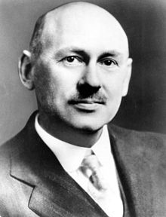

[Insert photo #6]

The latest invention of aviator Orville Wright is proving to be quite a discussion point in the scientific community. Danford Goddard, inventor of the world’s first liquid-fuelled rocket, discusses Orville Wright’s new machine and its implications for mankind.

Orville Wright is, without doubt, a pioneer. What he and his brother did for aviation, in just twelve seconds, will be celebrated for generations. However, Orville’s latest invention, the Human Cannon, not only casts a shadow over his mental capacity, as a scientist, but also calls into question his moral turpitude, as a man.

As a nation we are recovering from war. One must be thankful, I suppose, that Orville’s new invention has been born during times of peace. I can only imagine how the outcome of the Great War might have been affected had the Germans got their hands on this kind of technology. Dodging bullets was hard enough for our poor young soldiers, but if they had had to dodge flying Germans too then things might have turned out quite differently, I tell you.

While I am not privy to the operational mechanisms employed by this machine, I can tell you with some certainty that the quantity of explosives required to propel a human being through the air is substantial; certainly enough to sink a warship or to blow up a large building. Quite how Chaplin’s Circus thinks it will be able to launch this device within a Big Top, is quite a mystery. The heat alone from such an explosion would be enough to vaporize anyone within a 20m meter radius of ground zero (the detonation point).

Yesterday I attended a meeting at the Royal Society in London where myself and a number of my esteemed colleagues discussed the potential ramifications of Orville’s new weapon of mass destruction. It was agreed, quite unanimously, that this public demonstration must be stopped; a petition was prepared, bearing some four hundred signatures, and submitted to our Prime Minister, Mr Ramsey MacDonald, for consideration by his cabinet. One can only hope they heed our advice.

Even if Orville has somehow managed to find a way of containing the explosion within the barrel of the cannon, which seems unlikely in light of the quantities of explosives involved, the poor man who will be shot out of the cannon, whoever he may be, will certainly perish. So long as he was a good man, at least Chaplin’s Circus can truthfully state that he was shot into heaven!

[5] Headline: Return of The Human Arrow: Pansy Zedora is enlisted to drag Chaplin’s Circus out of the red.

[Insert photo #7] In line with its new corporate strategy, Chaplin’s Circus has enlisted world renowned trapeze artist Pansy Zedora to head-up the cast of its 1924 show. In a deal, rumoured to be worth one hundred pounds sterling, Pansy Zedora—now, a rising star of the German cabaret scene—has agreed to return to the Big Top, once more, to amaze audiences with her aerial acrobatics.

[Insert photo #8]
Posters for Chaplin’s Circus suggest that Ms. Zedora will be performing her signature stunt, The Devil’s Twist, a manoeuvre so dangerous that it has actually be banned by German and Austrian authorities, under their respective health and safety frameworks. Ms. Zedora was not available for comment but her agent proffered the following remarks: “The Devil’s Twist is commonly regarded as the most dangerous stunt that can be performed on the aerial trapeze. The reason for this is that it cannot be performed using a regular safety harness.”

Known, off-stage, as Pansy Chinery, she has been described in the press as, “The Crowning miracle of physical and mechanical sensation, surpassing adequate description…the bravest of all living artists.”

Ms. Zedora first made a name for herself as The Human Arrow with a troupe called The Flying Zedoras; Pansy was loaded into a giant crossbow and fired high into the air—through a large, suspended paper target—into the arms of her sister, Adele, who was herself swinging back and forth on an aerial trapeze. Hailed by the media as “A Living Weapon,” Ms. Zedora’s reputation garnered her fame and popularity on both sides of the Atlantic.

These days, Ms Zedora is better-known for her cabaret work with Mars and Mars and The Ritz Trio, in theatres across Europe. However, her agent confirms that she is excited to be returning to the Big Top, once more.

With The Human Arrow and The Human Cannonball, Chaplin’s Circus has acquired a veritable armoury. Rivals, beware! It seems this circus won’t be going anywhere without a fight.

[6] Headline: Charlie ‘hangs out’ in London.

[Insert photo #9]
When he is not travelling with Chaplin’s Circus, Charlie can usually be found pottering around the cobbled streets of central London. Our reporter caught up with Charlie last week, when he was ‘hanging out’ in London’s Covent Garden.

Interviewer: Hello Charlie. Shouldn’t you be back at the winter quarters helping prepare for the new show?

Charlie: (Charlie does not speak, but uses facial expressions and well-timed gesticulations to evidence the fact that he is embarrassed, for having been caught slacking off)

Interviewer: Would you be in trouble with your Ringmaster for taking a vacation with such an important show coming up?

Charlie: (Charlie shrugs and then, after some moments, nods his head to indicate that he would indeed be in trouble)

Interviewer: Would it be more comfortable for you to come down from the railings and conduct this interview in a vertical position?

Charlie: (Charlie clearly does not understand the question and seems quite comfortable in his horizontal position)

Interviewer: You have been a familiar face at Chaplin’s Circus now for many years. Can you tell our readers what it is like to work for a circus?

Charlie: (Charlie suddenly looks terrified and pretends to cry. He gets down from the railings and performs some sort of dance routine which culminates in an impressive back-flip. This reporter does not understand what he is trying to say, but fears that he might be held by Chaplin’s Circus against his will.)

Interviewer: Are you sad Charlie?

Charlie: (Nods vehemently)

Interviewer: Why Charlie? Do they treat you badly?

Charlie: (Charlie starts stomping around with one of his arms hanging down to the ground.)

Interviewer: Ah, I see… you miss Bambini the Elephant?

Charlie: (Nods vehemently and then starts to pretend to cry again. He becomes totally unresponsive to this interviewer’s questioning.)

Interviewer: I don’t know what conclusions to reach or what observations to make.

[7] Headline: Interview with The Great Baldini

[Insert photo #10]

Interviewer: Thank you for taking time out of your busy rehearsing schedule to talk with me today. There is a lot of excitement and debate surrounding Chaplin’s Circus’ new show. Can you give us any clues about what to expect from the Human Cannon, in particular?

Baldini: The Human Cannon is just a machine. Like any other. It is science. Science is not a mystery, it is simply an observation; cause and effect. The magic which I perform is more impressive than anything which science can offer. My miracles cannot be explained, even by science.

Interviewer: Yes, quite. But still, Orville Wright is a very clever man and many would say that his machines are like magic. I mean, who would have thought that a man could be made to fly, during this century?

Baldini: Please. I do not know Mr Wright personally but I assure you that it is he who will be impressed with my wizardry, and not I with his.

Interviewer: So tell us about your show, Mr Baldini. What can we expect?

Baldini: I do not perform a show and it is Baldini or The Great Baldini, but not Mr. Baldini! What I offer is a glimpse into another world where one is only limited by one’s imagination. I have mastered the forces of the universe and what I offer is a simple display of my mastery.

Interviewer: Yes, well, that sounds very exciting. But can you be more specific?

Baldini: One of my demonstrations will involve the metamorphosis of two human beings, in space and time. I defy even Orville Wright to explain the methods of this miracle.

Interviewer: By metamorphosis, do you mean that two human beings will change places, in an instant? I think I had the pleasure of witnessing this miracle in your London theatre show last year.

Baldini: Yes, that is what I mean. However, this time a member of the audience will be invited to participate directly in the performance of this illusion, which should lay to rest all of those slanderous accusations that my methods involve trickery or deception.

Interviewer: Fascinating. We must draw this interview to a close but really I could talk with you all day.

Baldini: I do wish you wouldn’t.

Interviewer: Would you be prepared to comment upon the future of Chaplin’s Circus? As you must know, it is rumoured that this will be Chaplin’s Circus’ last season. What are your thoughts?

Baldini: Don’t be distracted by conjecture. Let our work speak for itself. I would not work for a failing Circus, not now, not ever.

Interviewer: And there you have it Ladies and Gentleman, the defiant words of Europe’s leading conjurer! By all accounts, Chaplin’s Circus will need some magic if it is going to stave off bankruptcy and survive another season. Good luck boys!

[8] Headline: The (unofficial) idiot’s guide to erecting a Big Top

[Insert photo #11]

I attended a performance of Cirque Du Brie on Wednesday evening. I must say, I was very impressed; not, however, with the show—which was at best, mediocre, and, at worst, down-right boring—but rather with the construction of their Big Top.

In all fairness, it was the horse act which caused me to contemplate this magnificent erection; if that ‘act’ hadn’t been so utterly disappointing (nay pathetic) then perhaps my brain would not have been compelled to drift, in the way that it did, onto loftier matters. For this, I shall be eternally grateful.

The Big Top is a wondrous thing. I am an intelligent man—or so I like to think—and, perhaps, more importantly, an educated man—or so my editor likes to think. And it therefore beggars belief that I could not, in the 30 minutes or so that I was gazing upwards, towards the star-clad canopy of the Cirque Du Brie Big Top, figure out how it was possible for meagre man to erect this magnificent super-structure.

I therefore decided that the next time a circus comes to town, rather than booking expensive ringside tickets (which, quite frankly, members of the free press should not be made to purchase!) I would instead secure for myself a free seat, upon a grassy knoll, to witness the erection of their Big Top. And this is what I did, thanks to Chaplin’s Circus and their rather timely arrival in my otherwise sleepy town.

In lay mans terms—for I am a lay man—there appear to be five steps that must be adhered to, in sequence, in order to construct a Big Top.

Step 1. Lay a large canvass sheet upon the ground, marking the foot-print of where the Big Top ultimately will stand.

Step 2: Insert into the ground, three hundred metal stakes at two metre intervals around the perimeter of the tent plane, using the largest sledge hammer you can find and a team of at least five fully-grown men.

Step 3: Clamber underneath the sheet, armed with three hundred iron rods and carefully position these stilts around the perimeter of the canopy, again at two meter intervals. It is at this point that the Big Top will first start to assume a three-dimensional character, although the central part of the tent will still be trailing on the ground.

Step 4: Attach ropes between the top of each supporting rod and that part of each stake which is still protruding from the ground, and proceed to tension each of the ropes, using a horse-driven pulley system.

Step 5: Ride, horse-back, underneath the tent, grasping—as if t’were a joust—one metal pole, twelve meters in length. Attach one end of this pole to the central part of the canopy (the roof of the tent) and ride forwards, at a canter, until said pole has assumed vertical alignment in the centre of the Big Top.

Step 6: Repeat step four for the remaining ‘King Poles’.

The entire process should take you no more than three full days, with a team of twenty-or-so strong men. If it does, then I fear you may have done something wrong.

And so, next time you have the pleasure (or displeasure) of attending a circus show, spare a few moments to appreciate not only the marvellous construction that is the Big Top but also the loyal men and women responsible for its erection.
[9] Headline: The future of the circus industry (by the Ringmaster of Chaplin’s Circus)

[Insert photo #12]

These are indeed challenging times for circus. For generations, the business model of our industry was predicated upon the idea that the people had nothing better to do than to attend a circus. And, in large part, this was true. The annual circus was, for many people, the only form of entertainment that they were able to access.

This monopolistic state of affairs allowed circuses to become complacent. While new posters would give hope of a ‘new show’, in reality patrons were forced, each year, to watch the same tired acts perform the same tired routines, perhaps wearing slightly different—but nevertheless tired—costumes.

The emergence of new forms of entertainment, such as cabaret theatre and jazz music, have given citizens a whole range of new and exciting ways of spending their hard-earned cash; and, consequently, circus ticket sales have slumped.

The circus I work for, Chaplin’s Circus, is no exception. Last year, it was not uncommon for us to be performing to an audience comprising a handful of loyal circus fans. I recall one show where we were forced to suspend the performance, to wait for one patron—our only patron—to return from the lavatory!

It is time to sink or swim. The truth is that no one knows how to entertain better than circus folk; it is all we do, day in and day out. We might not have been doing it very well since the end of the War, but that doesn’t mean we have forgotten how to do it. The challenge before us is a rebranding exercise; we must pull out all of the stops, put on the best shows that we can muster, and, in so doing, remind the public that circus is the best form of entertainment on earth.

Circus owners must listen to the public. They must be prepared to adapt and to evolve. They must be prepared to lay everything on the line each year and to take risks if they are to expect success. Success is not an entitlement, it must be earned. Chaplin’s Circus has learned this, the hard way. But, it is a testament to our character that we have not given up or sold-out. Circus is in our blood and we have the passion and tenacity to make this work. Most of our employees have agreed to work for free until we have got back on our feet and that shows you the kind of loyalty that we have fostered among our team.

Chaplin’s Circus has found what was, for so many years, lacking; namely, a vision. We plan to become the greatest show on earth, or we will die trying.

[10] Headline: Is Daughter of Chaplin’s Circus treading a fine line?

[Insert photo #13]

It appears Miss Sarah Jane has been “picking up the slack” over at Chaplin’s Circus—literally.

The 19-year old daughter of Chaplin’s owner, was spotted putting her balancing skills into action, performing a slack-rope routine, yesterday evening. For those unfamiliar with the act, it is similar in principle to the tight-wire, however, rather than balancing on a tightly-stretched wire, the artist performs tricks on a rope, hung loosely between two fixed points.

It is general knowledge that Mr. Chaplin has always forbidden his daughter from appearing in the show, no doubt for fear that she will injure herself or be swept away by the charms of one of his charismatic performers.

Some might say that this latest development is a clear sign of desperation, from the Chaplin’s camp and that Mr. Chaplin has only allowed his daughter to perform in this year’s show to save money, that would otherwise need to be spent on outside acts. This is a distinct possibility; after all, Chaplin’s Circus is near-enough broke and has had to sell a substantial proportion of its already over-leveraged assets in order to afford the professional services of Orville Wright and Pansy Zedora.

However, this reporter is rather more optimistic. I firmly believe that Sarah-Jane’s presence in this year’s line-up signals something rather more symbolic: That Chaplin’s Circus is holding nothing back in its final fight for victory.

[11] Headline: Life as a ring-boy (or girl!)

[Insert photo #14 & 15]

The Circus Times takes a moment to speak with Ruth Etting and Jack Beaver about what it’s like to work behind the scenes at Chaplin’s Circus.

Ruth Etting:

Ruth Etting is costume designer and general stage hand for Chaplin’s Circus.

Interviewer: What is it like seeing your creations sparkle in the lights of the Big Top?

Ruth: It’s incredibly gratifying—to see a garment hanging lifeless on a mannequin be brought suddenly to life in the glow of the ring is a wonderful feeling.

Interviewer: What are some of the challenges you face when designing a costume?

Ruth: While visual aesthetics are key to any costume, comfort and freedom of movement are essential. The trick is getting the balance between beauty and comfort just right. From a professional standpoint, the job itself is incredibly challenging—if a costume needs repairing or a performer is in need of a new piece for a new act they want to perform that night—I have to work fast. But also, you are never just one thing in a circus. My job role includes many things, and keeping the back stage area clean and tidy, is a big part of my job.

Jack Beaver:

Jack is the newest ring-boy of Chaplin’s Circus

Interviewer: How old are you Jack?

Jack: I’m 18 years old.

Interviewer: Are you a josser?

Jack: No, my uncle is married to one of the Collin’s. I was raised as a traveller.

Interviewer: Are you enjoying working for Chaplin’s Circus?

Jack: Not really, but you have to start somewhere in this business. I want to be a juggler, one day. I practice a lot in my spare time.

Interviewer: Describe an average day on the circus so our readers can get a feel for life ‘behind-the-scenes’.

Jack: I wake up at 6am and feed and clean all of the vehicles. Then Ruth and I clean the Big Top from the night before and prep the concessions for the afternoon performances. I then spend most of the day helping the acts to set up their rehearsal rigs in the Big Top and lunging for the aerial acts.

Interviewer: What is lunging? Can you explain to our readers?

Jack: It is holding the safety rope for the aerial acts. If they fall, it is my job to make sure I catch their weight, so they don’t injure themselves. It is very tiring because you have to follow their movements precisely, and know when to slacken off and when to tighten up.

Interviewer: Thank you for your time Jack and good luck for tonight’s show.

[12] Headline: Chaplin’s acrobat picks up Gold… and a world record!

[Insert photo #16]

He’s only gone and done it again. Robert Kelvin, Chaplin’s very own ring-boy turned acrobat has just picked up another gold medal, this time at the 1924 Summer Olympic Games. Scoring an impressive average of 9.2 for his floor-work, Robert pipped German rival Leonard Blitznitchenko to the post.

As if Gold wasn’t enough, it has transpired that Robert’s acrobatic routine, comprising a succession of 68 back-flips, broke the world record for the most number of back flips performed, consecutively, by either man or woman (previously set at 53 by fellow Englishman Jeremy Briggs of Preston, Lancashire).

[13] Headline: Chaplin’s Circus raises funds for Cancer Research UK

[Insert photo #17]

Chaplin’s Circus is proud to support Cancer Research UK. We invite our patrons to make a donation to this charity by placing a coin or two (or even a banknote!) into our collection bucket, which is situated in the foyer tent, next to our circus organ. We will match any contributions which are made by our patrons, pound for pound.

All of our donations are given in the name and memory of circus legend Jeff Jay, who died in January of this year. Jeff was a committed ambassador for Cancer Research UK. We remain indebted to Jeff for all the help that he gave to us when Chaplin’s Circus was just an idea. We will be eternally saddened by the fact that he was not able to join us in making Chaplin’s Circus a reality. However, we will always remain true to the core values which made this project an exciting prospect for Jeff, and one of those values is a genuine commitment to improve the lives of others around us.

Crossword

The crossword must be made to look like a standard newspaper crossword (see image below)

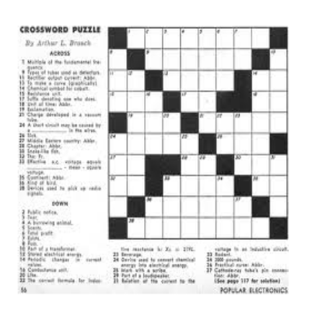

Below is the lay-out for this crossword puzzle.

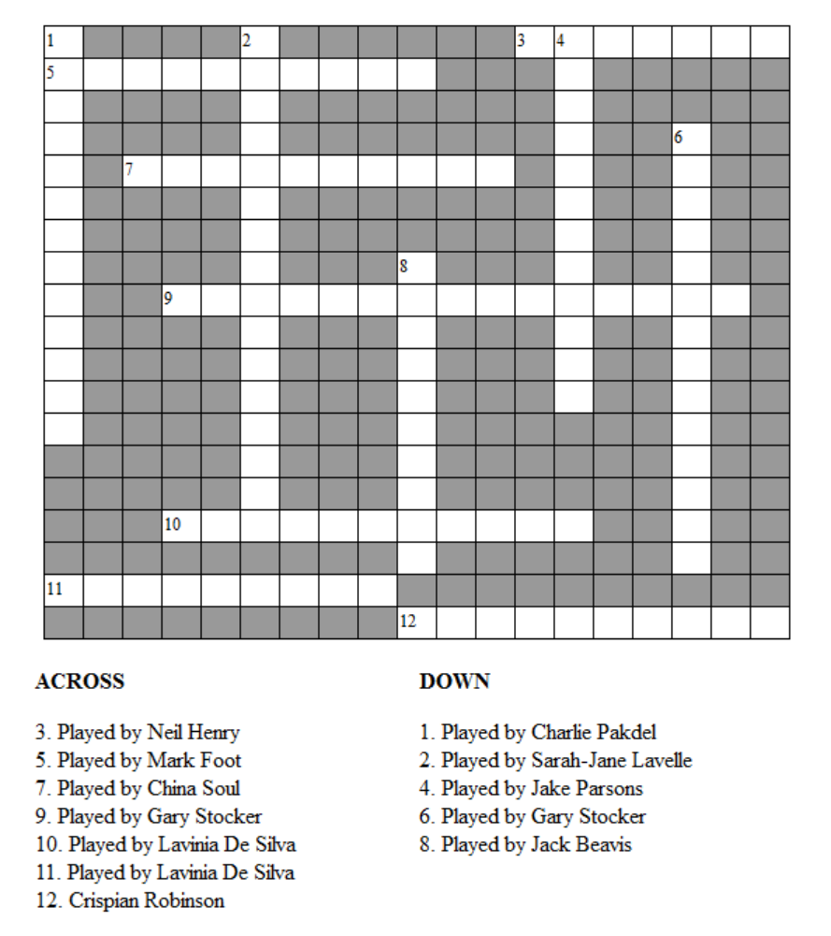
Spot-the-difference

Headline: What a couple of Charlies!

Can you spot five differences between these two Charlies?

Instructions to designer: Take the following photo and make five differences between them, and put them side by side.

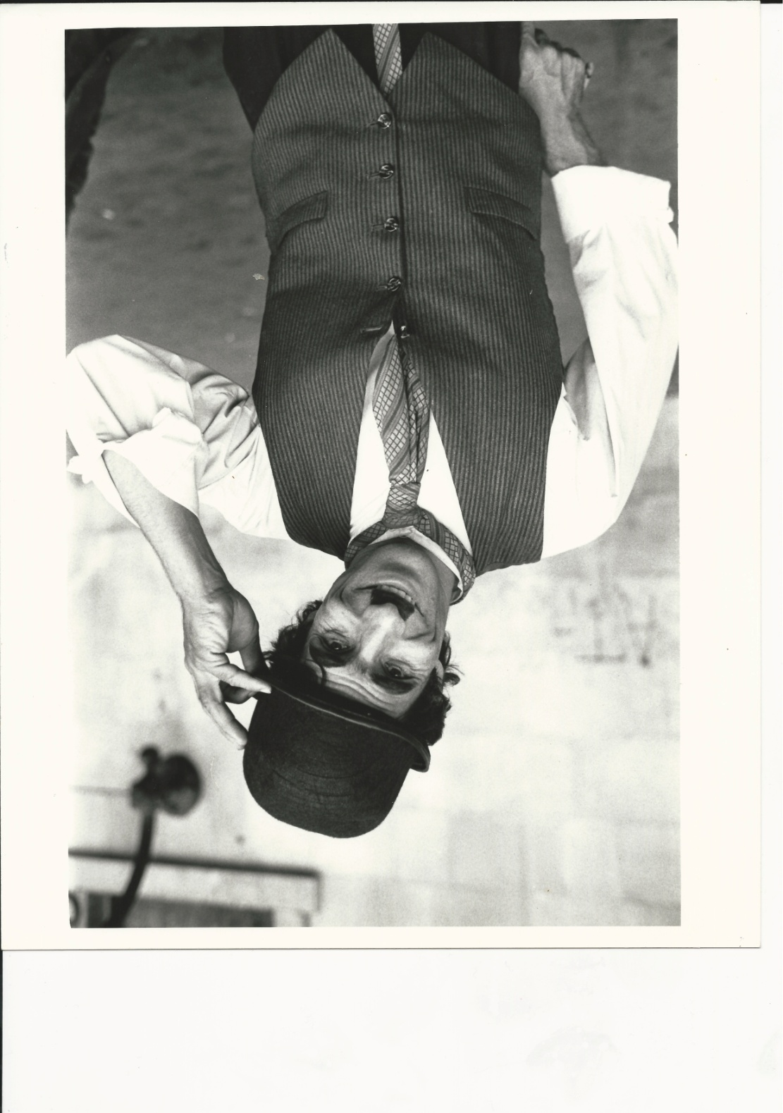

Photos:

Photo 1: Chaplin’s Circus Troupe
Photo 2: Bambini the Elephant
Photo 3: Pansy Zedora (head shot)
Photo 4: Gary in old man mask (representing Barrington Brie)
Photo 5: Orville Wright
Photo 6: Diagram of human cannon
Photo 7: Pansy Zedora (Large)
Photo 8: Image of Panzy Zedora doing the ‘Devil’s Twist’)
Photo 9: Charlie holding rails horizontally in Covent Garden
Photo 10: The Great Baldini
Photo 11: Diagram of Big Top
Photo 12: Ringmaster
Photo 13: Sarah-Jane Chaplin
Photo 14: Jack Beaver
Photo 15: Ruth Etting
Photo 16: Robert Kelvin
Photo 17: Cancer Research UK Logo

Items that can be used for filling space around the articles:

[1] ‘Looking for love’
CLERK (London, S.W.) would like to meet sincere, honourable man, tall, 30-35. London preferred.
BOHEMIAN GIRL (London, S.W.) 24, in digs, interested in most things, educated, lonely, desires man pal, here or abroad.
ANON (London, S.E.) Would jolly working girl, 20-30, who enjoys good laugh, chum up together, evening and weekends! Quite homely, working girl please.
ANON (London, W.) Tall, dark, 32, would like to meet sincere gentleman, same age, as true love, very lonely. All letters answered. Photos required.
WIDOW (Essex), 50, upper working class, good appearance, domesticated, wishes meet businessman, 46-55, honest, homely, tall dark. Someone write.
YOUNG WIDOW (London, S.W.) very good standing, nice appearance, bright, musical, like meet cultured man, 30-40. Presentable.
WIDOW LADY (N. Wales), middle-aged, very bright and sociable, feeling very lonely, wishes to correspond with gentleman (or not-so-gentle man!). Please write.
[2] Adverts are contained in a separate zip file entitled adverts.zip. There are 11 in total. (You can use any of the adverts, but make sure that they are sufficient resolution for print (minimum of 200 dpi))

[3] Reward for missing elephant

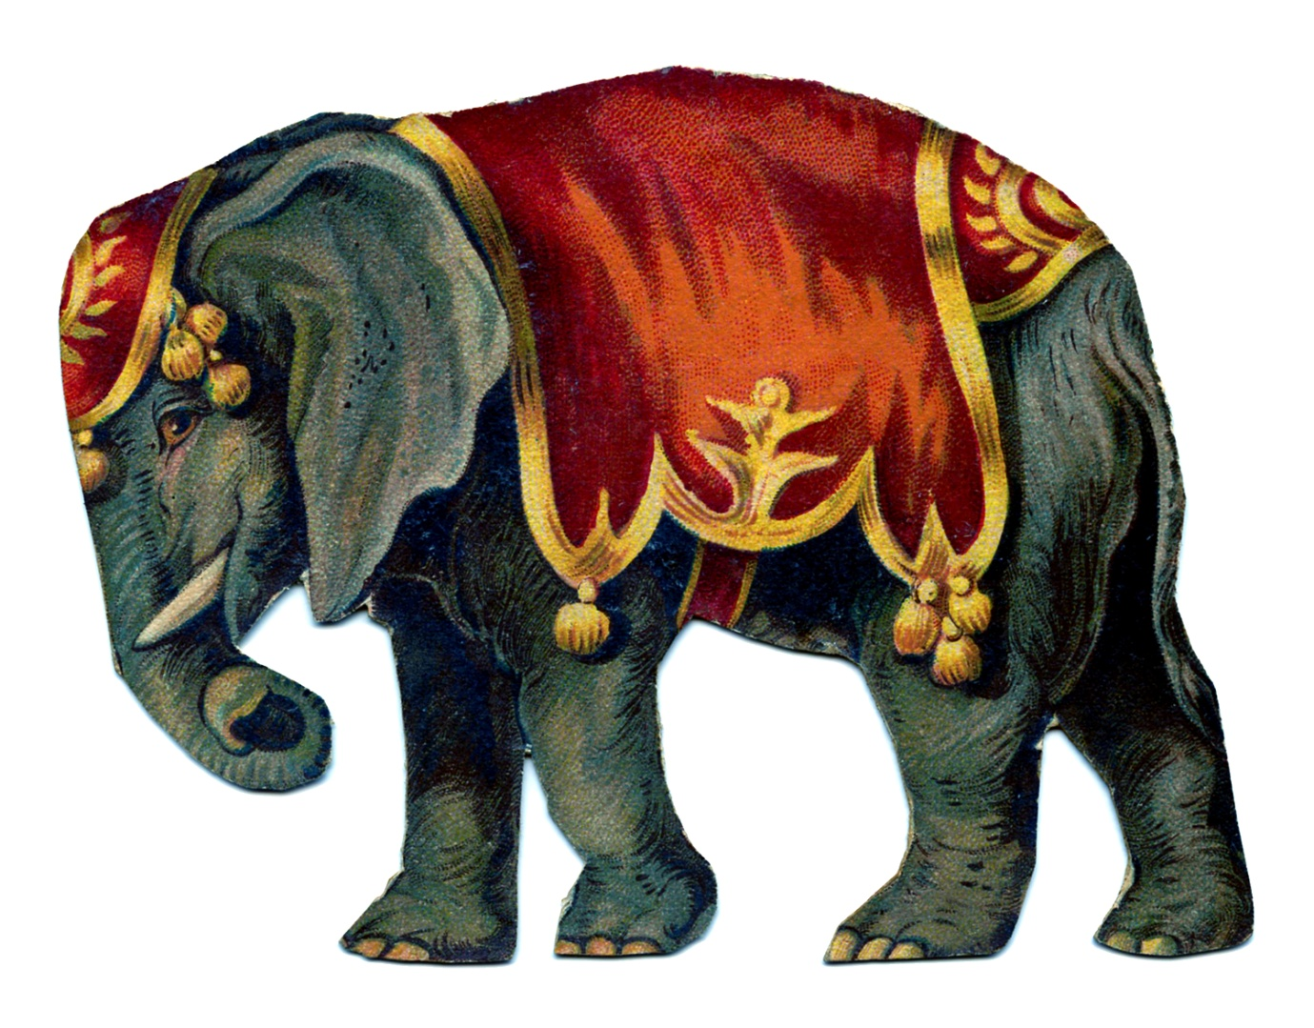

Barrington Brie has posted a reward of £5.00 for any person who can provide him with information about the whereabouts of his missing elephant. The animal is large and grey with the following distinguishing features: He is wearing a red jacket and hat.

Contact the office at Cirque Du Brie for more information or to claim your reward.

