 | FIXPAN |  | Stationary kettles
 | 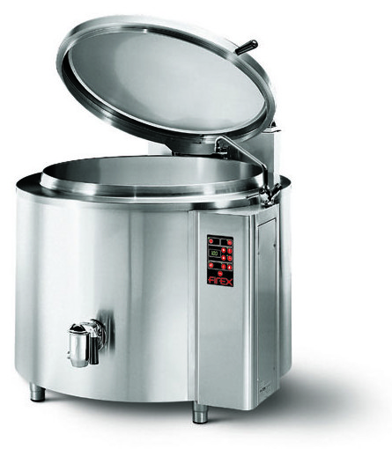 | 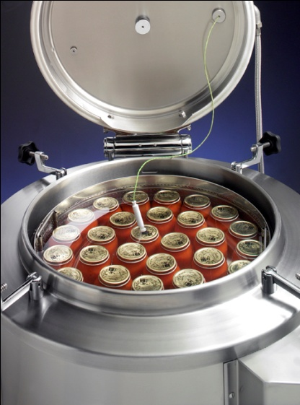 | Capacity 100, 150, 200, 300, 500 and 550 lt – Electric, Gas and Steam heating  PF…100A  PF…150A  PF…200A  PF…300A  PF…500A  PF…510A
 |  | temperature is reached.  GAS VERSIONS  • Heating by means of high  efficiency stainless steel tube  burners. Automatic ignition and  flame control system without  pilot burner. Heating controlled by electronic board, with  automatic activation of minimum  2 °C before the SETPOINT,  and by the pressure switch.  STEA M VERSIONS  • Heated by steam, introduced  into the jacket from an external  mains supply, and fitted with  a control valve which provides  infinite variable heat input. | Applications  Stews  Goulash  Sauces  Karamell  Onions  Jams  Stuffings  Meat  Beans
  Constructive Features
  • Pans bottoms are constructed in AISI 316 quality stainless steel and are even suitable for boiling food products with a high acidity content.
  • Exterior cladding, in 1 and AISI 304 quality stainless steel.
  • Carrying structure, in heavy gauge stainless steel.
  • Lid is insulated (optional extra ), spring loaded counterbalanced type.
  • Automatic power operated water filling device for the pan.
  AUTOCLA VE (pressure lid versions)
  • Counterbalanced lid fitted with 0,05 bar safety relief valve: an air tight seal is assured by means of screw down clamps and silicone gasket.
  INDIRECT HEATED VERSIONS
  • Jacket walls are in AISI 304 quality stainless steel.
  • Jacket pressure is controlled by a
  pressure switch, a (0,5 bar) safety
  valve and pressure gauge.
  • Automatic water filling into the double jacket
  ELECTRIC VERSIONS
  • Heated by means of armoured
  “Incoloy-800” elements, fitted inside the jacket.
  • High heating capacities, in
  accordance with CE DIN 18855 Standards for “Fast cooking equipment (see
  technical data chart).
  • Power economiser device: cutsin
  automatically when selected
  Panel Board - Functions
  - ON/OFF switch
  - setting of operating temperature
  - setting of cooking temperature
  - cooking cycle start/stop
  Display/Signal
  - failure autotest system
  - heating operating visual alarm
  - product temperature and set temperature display
  - time to end of cycle display
  - end of cooking sound alarm
  Safety System
  - emergency button
  - blocking of heating for excess of temperature with manual resettable safety thermostat.

Mod. | Overall dimensions mm |  | Useful capacity | Electric versions |  | Gas versions |  | Steam versions
PF…A | LxPxH | H1 | LT | V/Hz | KW | V/Hz | Kw | V/Hz | Kg/h
100 | 1025x850x900h | 1650 | 102 | 400/50 3N+PE AC | 16 | 230/50 1N+PE AC | 21 | 230/50 1N+PE AC | 15
150 |  |  | 139 | 400/50 3N+PE AC | 18 | 230/50 1N+PE AC | 21 | 230/50 1N+PE AC | 23
200 |  |  | 200 | 400/50 3N+PE AC | 32 | 230/50 1N+PE AC | 34.5 | 230/50 1N+PE AC | 31
300 |  |  | 300 | 400/50 3N+PE AC | 36 | 230/50 1N+PE AC | 48 | 230/50 1N+PE AC | 46
500 |  |  | 455 | 400/50 3N+PE AC | 36 | 230/50 1N+PE AC | 58 | 230/50 1N+PE AC | 77
510 |  |  | 500 | 400/50 3N+PE AC | 54 | 230/50 1N+PE AC | 60 | 230/50 1N+PE AC | 77

