We are a real estate video production company specializing in California luxury properties. You can see some of our videos at walkthroughestates.com. We make walkthrough videos of homes in order to sell them to global buyers—starting with a focus on Chinese buyers wanting to move to California.

We need a logo for an online TV channel we are building at this URL: liveincalifornia.tv. It will feature high-definition videos about life in California and all the reasons people should move here! (Sunshine, beaches, fresh air, palm trees, quality education, tennis, golf, surfing, swimming, yoga, great food and wine, culture and music, etc.)

Logo should promote the California Lifestyle.

We want a very simple logo that can work without words. We want it to suggest clean air/ocean breezes, blue water, carefree happy life, luxury.

Should be positive, aspirational, bright and happy.

Target audience is 30 to 45 years old.

Some possible images to combine might be:
- Sunshine
- Waves
- Palm trees
- Houses (roof, door, window, keys, etc.)
- Flip flops or sandals
- Sunglasses
- Beach umbrella

Colors should evoke a sunny day, sunrise, blue water, warm sand, etc. (But on a personal note we love deep greens and purples.)

Logo should convey a sense of:
- Quality
- Luxury
- Warmth
- Friendliness
- Trust
- Home
- Happiness
- Fulfillment
- Fun
- The good life

Also keep in mind we will be animating this logo in the future and it has to work with high-definition video as well as in print and online.

Below are some examples we found.

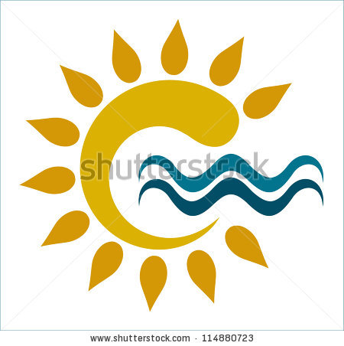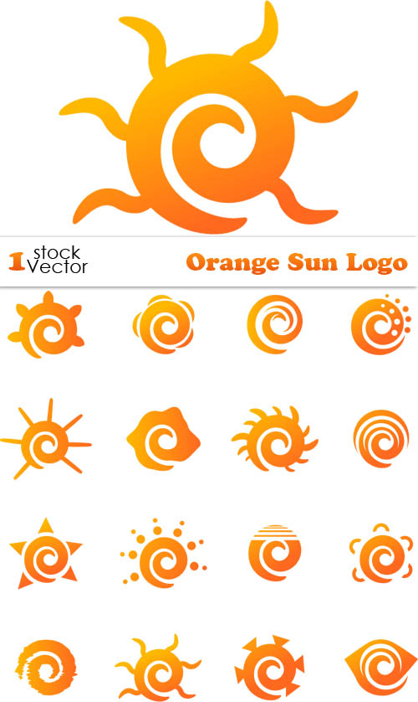
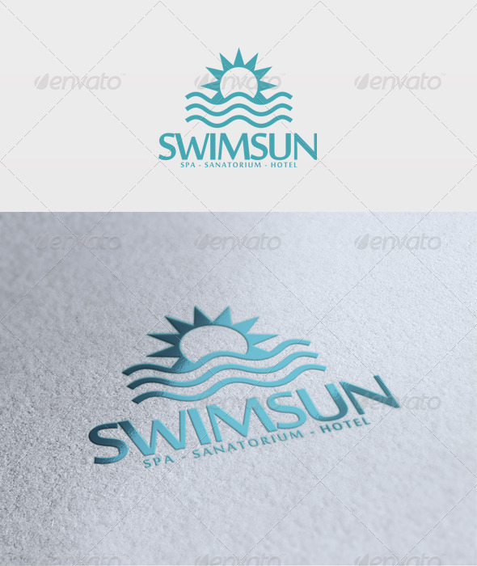 - What if you added a palm tree or mansion style house?
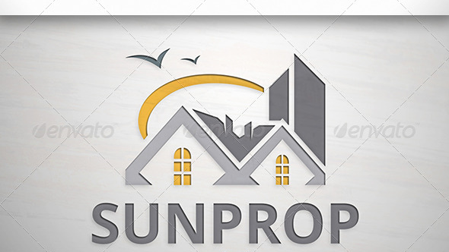
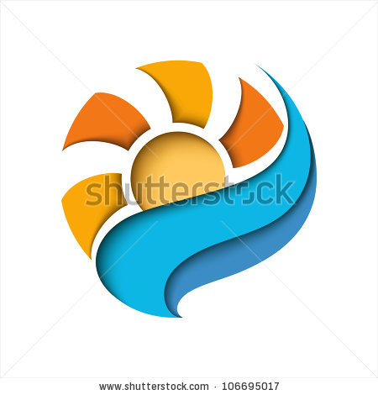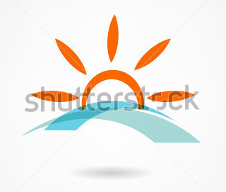

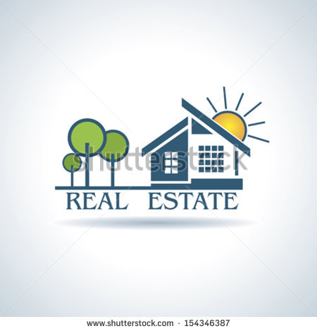 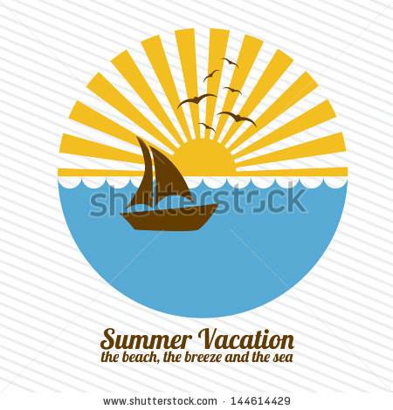 Replace boat with house? 
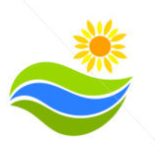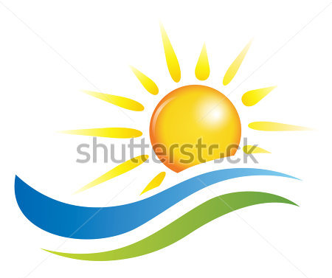

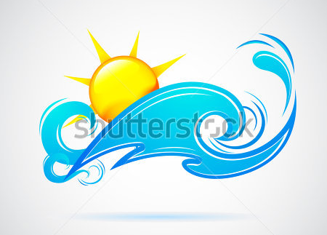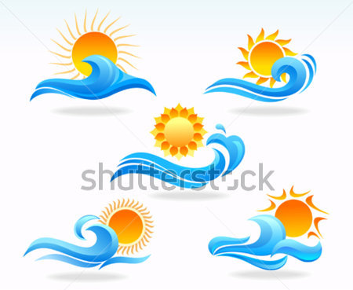

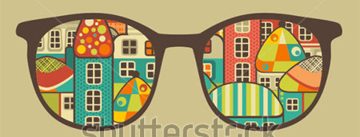 Sunglasses with reflection of house, sun, waves, palm trees (California lifestyle)
 Sunglasses on a house. Not cartoony like this.

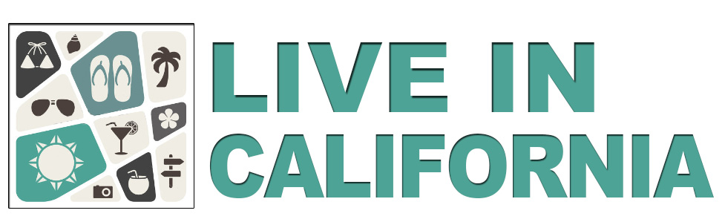 What if logo was like this? A square with several items that make up the California living experience? Beach, sun, house, sunglasses, cars, Hollywood, etc.

