

hello.

STOCK IMAGE

Overview
EY Partners Group Pty Ltd (EY Partners) is a boutique accounting firm based in Melbourne with a strong focus on building long lasting relationships and partnerships with our clients.

EY Partners Philosophy
At EY Partners, our philosophies are simple to state:
- Alignment
- Informed decision making

Alignment
It is vital that the philosophies and values between our clients and ours align. Our clients see eye to eye with us and share a drive for success and building a solid financial foundation for their futures.

Informed decision making
We firmly believe in educating and consulting our clients to assist them in making informed decisions. Rather than receiving a lengthy document full of technical jargon, our clients are engaged regularly and presented with research, industry insights and expert opinions, empowering them with the ability to make the right investment decisions.

What this document contains
The remainder of this document will cover:
- Our flagship strategy – “Converting your home loan into a tax deductible debt”
- EY Partners’ key focus areas
- About us

Pay down your home loan faster..
Create and grow an investment portfolio..
Convert your home loan into tax-deductible debt..

Converting your home loan into a

tax deductible debt
This strategy uses a three-pronged approach, utilising existing assets to fast-track wealth creation, consisting of:
- Paying down your home loan faster
- Creating and growing an investment portfolio
- Converting your home loan into tax-deductible debt

1.1 How does the strategy work?
The strategy involves:
- Accessing the equity in your current home to set up an investment loan
- Investing the borrowed money in income producing assets (e.g. shares, property, managed funds, etc.)
- Direct the investment returns, tax benefits and surplus cash into your home loan offset account
- Re-borrow the equivalent amount that has been directed into your offset account at the end of each year plus any additional equity and repeat steps 1 to 3

1.2 Why adopt this strategy?
- Convert your inefficient (bad) debt into efficient (tax deductible) debt, reducing your tax liability each year;
- Reduce the total amount of non-deductible interest paid over the life of your home loan; and
- Create an investment portfolio sooner and potentially accumulate greater wealth in the long-term.
Recognising that you already have the resources and assets to commence this strategy is the first step. Oftentimes, investors wait to clear their personal debt before they consider investing. Considering that a standard home loan takes 30 years to pay down, the modern day investor is almost at retirement age by the time this occurs.

1.2.1 Converting inefficient debt into tax-deductible debt
Inefficient (or “bad”) debt is debt where the interest you pay is not deductible for tax purposes – typically this is the home loan on your primary residence. On an average $500,000 loan for example, the total interest you will have paid to the lender over 30 years is $567,842 based on today’s interest rates. None of that interest is tax deductible.
Let’s now assume that same $500,000 now were to be used for an investment property instead with the same interest rates and loan term. The $567,842 of interest you pay is fully tax-deductible in this instance, yielding tax savings of greater than $210,000 (for an individual earning a $100,000 salary). This debt is efficient (or “good”) debt.
By adopting this strategy, we commence a process of restructuring your finances to turn your bad debt into good, tax-deductible debt.
This yields year on year tax savings which are used to further the debt restructuring and wealth creation process. See the example case study below to see how this works in practice.

1.2.2 Paying down your home loan faster
The standard life of a home loan is 30 years. Reducing the amount of the time it takes to pay down your home loan not only reduces the amount of interest you’ll have to pay to your banking institution, but gives you time and money to focus on other investments once your loan has been paid off. This is achieved by paying more than the minimum required payment per period.
Take the above example of a $500,000 loan. By contributing an additional $1,400 per month towards the loan, the loan is paid off in 18 years rather than 30 years and saves the home-owner $230,169 of interest repayments. See the example case study below to see how this works in practice.

1.2.3 Creating and growing an investment portfolio
As the old proverb goes, “you’ve got to be in it to win it”. With the power of hindsight, we’d all be wealthy and happily retired and most likely have our funds invested in the correct properties, shares and businesses. History has shown us that long-term investments in property and shares pay off, provided we can stomach the short-term volatility.
Inefficient (or “bad”) debt is debt where the interest you pay is not deductible for tax purposes..
we commence a process of restructuring your finances to turn your bad debt into good, tax-deductible debt.

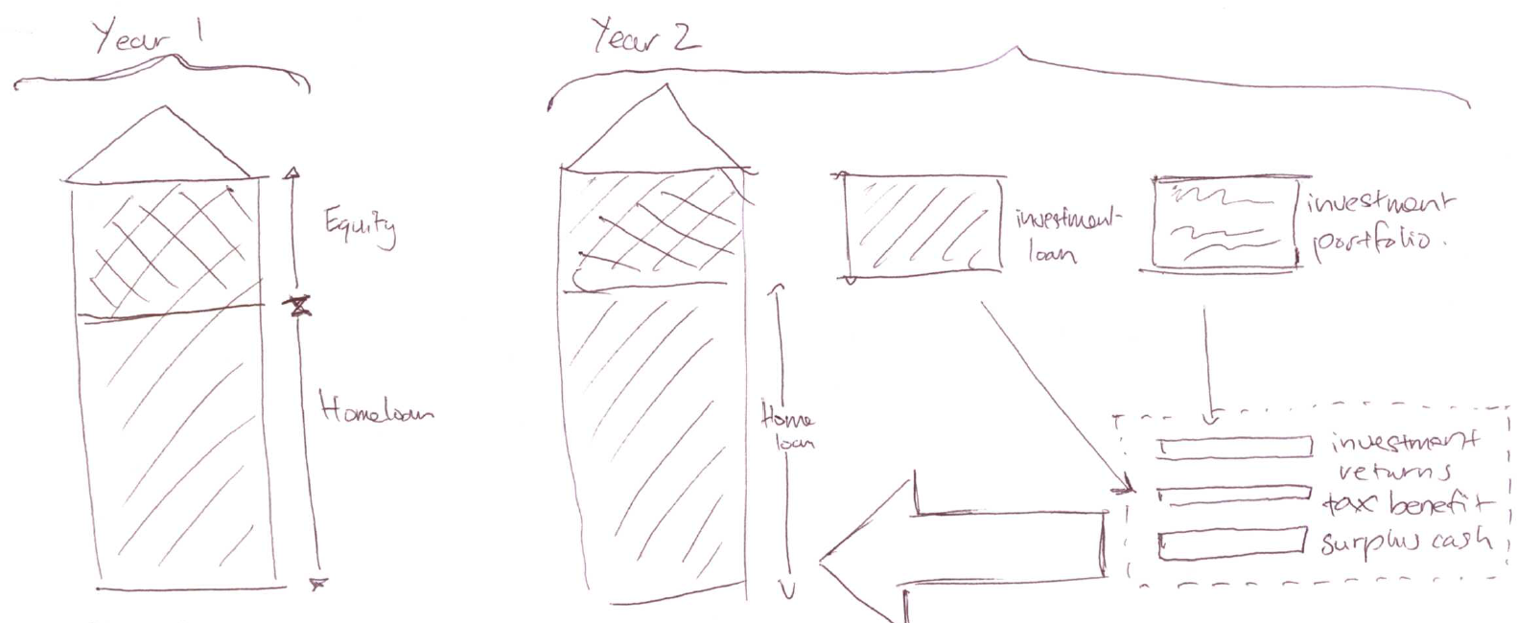
Consider if you had purchased an investment property in Glen Waverley or Toorak 20 years ago; or if you had bought into Apple or Commonwealth Bank shares 20 years ago.
If, like the majority of conservative investors you choose to wait until your personal debt is cleared before you decide to invest your surplus cash, you may unfortunately only be a matter of years off retirement, leaving you little to no time-frame to invest. Alternatively you may fall into the camp of those who have started investing, but may be doing so sub-optimally.
Executing this strategy allows you to enter the market earlier or increasing your portfolio value, giving your portfolio ample time to create capital growth. Most importantly, this then enables you have options to achieve your lifestyle goals and hopefully retire the way that you plan to. See the example case study below to see how this works in practice.

1.3 What are the investment options?
There are several classes of assets that carry varying levels of risks and return, including but not limited to shares, property and private equity opportunities. EY Partners work with our clients to determine which investments align correctly with their lifestyles.
STOCK IMAGE

1.4 Example client
James, 35 owns a home worth $500,000 with a $420,000 mortgage. He earns a salary of $100,000 per annum and his living expenses are roughly $3,400 per month.
James decides to implement the strategy to convert his home loan to a tax deductible debt and establishes a $40,000 line of credit for investment purposes to invest in ASX listed shares. The share dividends, tax benefits from the investment loan and surplus cash are directed towards the home loan offset account, whilst the interest for the line of credit are drawn from the offset account.
At the conclusion of year one, James has reduced his home loan by $22,115 and accordingly increases the line of credit to further purchase investments and repeats this process at the end of each year.
A snap shot analysis of James’ situation at year 10 yields the following:
10 year snap shot | Tax deductible home loan | Minimum repayments on home loan only
Home value | $775,664 | $775,664
Remaining home loan | ($124,449) | ($429,259)
Investment portfolio value | $364,910 | $0
Investment loan value | ($261,956) | $0
Net position | $754,169 | $429,259
Tax benefit | $27,629 | $0
Home loan interest paid | $142,430 | $196,704
Assumptions: Investment return is 4.50% and investment growth 7% per annum. Home interest rate and investment loan interest rate 5.10%. Tax rate for James is 32.5%. All rates assumed to remain constant over the period.

The example above illustrates how an average employee with a $420,000 mortgage who chooses to implement this strategy can reap a net position $237,061 better off than someone choosing to simply pay off their mortgage. In the above example, James also enjoys an additional $18,945 in tax savings and has paid $37,823 less interest on his home loan.

Pay off your mortgage in 5 years
Note that the example has James invest his funds in shares only for illustrative purposes. Those with greater risk appetites (and thus seek higher returns) should speak to us about the various business investment opportunities we offer. These investment options, when used in conjunction with the home loan restructuring strategies can fast-track the down-payment of the mortgage as well as the wealth creation process.
Pay off your mortgage in 5 years.

Buying an investment property or adding to an existing property portfolio has no doubt crossed many an investors’ mind. Our clients seek our assistance in determining how much to set aside for an investment property, where to buy and what type of property to buy.


EY Partners’ Key Focus Areas
Our flagship strategy to convert your home loan into a tax deductible debt (see section 1) may not suit all investors (especially if you are renting or have already paid your home loan in full). This section details the other key areas we assist our clientele in, namely:
- Self-managed super funds (SMSFs)
- Family trusts
- Investments
- Taxation and accounting services

2.1 Self-managed super funds
SMSFs, the largest and fastest growing superannuation sector have many potential benefits including:
- Complete control over how your money is managed
- Increased investment options (including residential property)
- The ability to borrow to finance investments within an SMSF
- Transparency of transactions
- Reduced overall fees
At EY Partners, we assist our clients in SMSF set ups, exploring the broad range of investment options available within, the potential for better tax outcomes, lesser fees and tax, audit and compliance needs.

Family trusts
Clients often engage us in setting up family trusts to reap the benefits of distributing income for more favourable tax outcomes as well as asset protection. Whilst family trusts are useful when used correctly, there are traps that many inexperienced investors fall into which can have the ATO poking around your affairs unpleasantly.

Investments
The world of investments is broad, complex and can be a nightmare to navigate without the correct information. Clients engage us to assist them in making the correct investment decisions across a number of asset classes, including shares, property and private equity.
STOCK IMAGE

2.3.1 Shares
Our specialist investment analyst engages our clients regularly to provide research reports, recommendations and insights into the equities market. Tying in with our philosophy of “informed decision making”, our research and analysis allows you to decide which shares to buy and when to buy, hold or sell. This is overseen by the board, including an independent director with over 8 years’ experience in equities, fund management and corporate finance.

2.3.2 Investment properties
Buying an investment property or adding to an existing property portfolio has no doubt crossed many an investors’ mind. Our clients seek our assistance in determining how much to set aside for an investment property, where to buy and what type of property to buy. An investment property can often mean a greater initial outlay than other types of investments and the information we provide our clients can better assist them with their cash flow, increase their portfolio growth potential and maximise their tax savings.

2.3.3 Business Opportunities
This asset class offers opportunities for investors seeking greater returns to significantly fast-track the wealth creation process. Our business valuation experts focus on identifying business opportunities that are sustainable, have growth potential and are most likely to produce returns for investors.

Taxation and accounting services
Everybody wants to pay less tax. In fact the success of any financial endeavour depends on it. Our carefully structured advice is targeted at maximising your tax return, putting more money back in your pocket to make your financial dreams a reality.
Our accountants specialise in:
- Providing tax advice catered to your individual circumstances
- Preparation and lodgement of individual, sole-trader, company, SMSF and other non-individual tax entities
- Reducing your tax payable or increasing your tax refund
Clients choose to work with us as all our financial services are available in-house. Because of this, we’re able to assist in the wealth creation process for our clients to ensure the most tax effective investment strategies are implemented. The EY Partners’ experts will work collaboratively to ensure any strategies prepared are in your best interests of building your wealth and improving your situation.
Everybody wants to pay less tax. In fact the success of any financial endeavour depends on it. Our carefully structured advice is targeted at maximising your tax return, putting more money back in your pocket to make your financial dreams a reality.

About Us

Amron D’Silva
Specialist investment analyst
Amron spent the earlier years of his career at Pricewaterhouse Coopers and Ernst and Young, before making a switch to investment banking house Macquarie Group for 5 years… Magellan Financial Group in early 2013. Amron specialises in equities and financial modelling and assists clients in blah blah

Sheridan Asuncion – Financial planner and Mortgage Broker
Profile here…

Eu-Gene Yeap
Founder and Managing Partner
Eu-Gene has over 9 years in the finance field, starting his career with ANZ in 2005.
Eu-Gene works closely with clients in family and business structuring with a focus on asset protection, succession planning and tax minimisation.

Giang Pham
Chartered Accountant
Profile here…

Henry Taikulswat
Accountant and Strategy Specialist
Upon completing his Masters of Accounting, Henry spent 4 years with Deloitte and a short tenure with the Victorian government before being brought over to head the tax arm of EY Partners.

Strategic focus
Industry expertise
Aligned goals

Personalised service
Peace of mind
Knowledge
EY Partners have a dedicated in-house team of experts to design and cater this strategy to work for your individual needs. Even if you lack the expertise or simply the time to focus on creating and building your wealth, you can rest assured that our integrated approach will leave you time to get on with your life, knowing that your team at EY Partners will take care of the rest.
Working with EY Partners, you can expect our relationship to extend far beyond that of just purely accountant-client. With your best interests at heart, our conversations are strategy-based, not product-based – we prefer that you treat us as a trusted advisor.

EY Partners?
WHY

let’s begin.


www.eypartners.com.au

