Automated Wealth
The road to financial freedom made easy

EY Partners Group Pty Ltd


What is Automated Wealth?
Automated Wealth is a solution designed to take the hassle out of the wealth creation process for individuals and families. It was specifically designed to be the solid foundation upon which financial freedom can be achieved by people from all walks of life, whilst also addressing lifestyle and family priorities.
Consider the typical working professional’s situation:
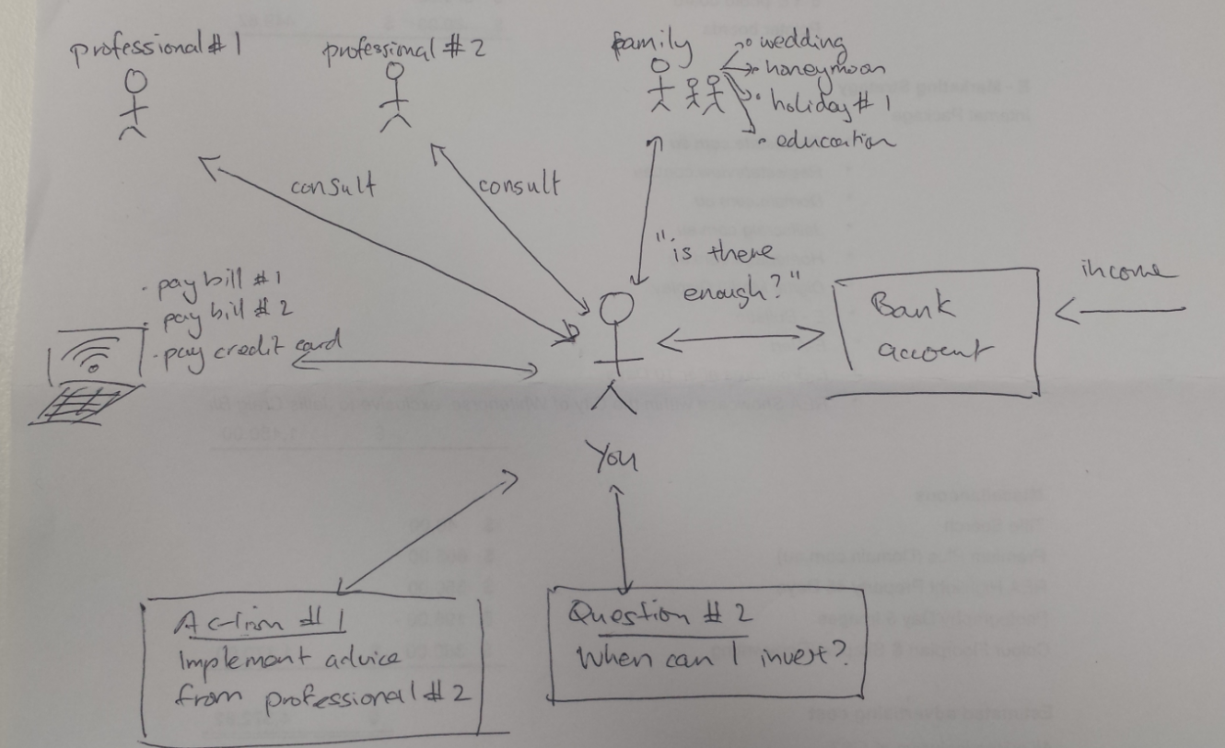
Each individual is faced with a myriad of decisions to make on a daily basis. With so much to think about, it’s not surprising that at the end of each day, we have little to no time left to think about finances and the future.


The Automated Wealth solution puts a cash flow management system in place to take care of your finance-related needs so you can enjoy life, whilst knowing the important things are being looked after behind the scenes.
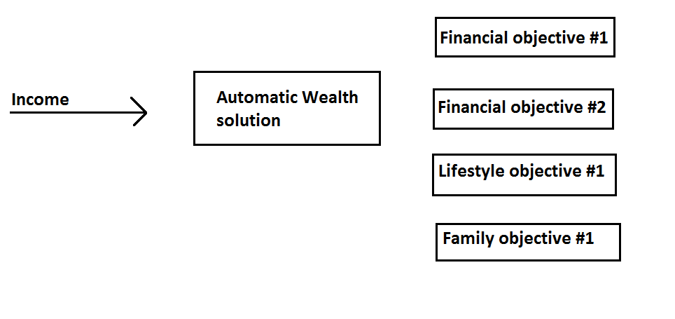How it works
1 | Identify your goals  A one-on-one meeting will flesh out all your goals – this includes your financial goals as well as your lifestyle goals.
2 | Analyse your current situation  During the same series of one-on-one meetings, we’ll breakdown and analyse the situation you are presently in.
3 | Propose, revise and finalise your Automated Wealth solution  Based on the information collected through the one-on-one meetings, a proposed Automated Wealth solution will be presented to you. This is revised until we are all happy with the solution.
4 | Implement the Automated Wealth solution  The structure as recommended in the final solution will be put in place.
5 | Regular quarterly meetings to monitor, review, update goals and your solution  Once in place, we’ll meet with you quarterly to check how everything is tracking along. At these meetings, we’ll discuss whether goals need to be amended or whether the solution needs revising.

Who uses Automated Wealth?
Individuals and families from varying life stages are able to take advantage of the Automated Wealth solution. Whether your goal is to save for the first home or pay down your home quicker, invest in property or equities, retire comfortably or combinations of these, there are numerous benefits to be gained.

Key benefits
Get into your first home faster
It’s the Australian dream to own our own home. Automated Wealth fast tracks the deposit saving process, but also teaches you the discipline that is required when you eventually are required to start making mortgage repayments.
Automate your finance and save time
There is only so much you can achieve in 24 hours. With more time, you’d be able to get to the gym more often, learn another language, pick up more hobbies or get more sleep. The reality is that by the time you get home from a full day of work, you’d like to put your feet up and wind down with a good book and your favourite bottle of wine - the last thing you want to think about is your finances.
Automated Wealth affords you that luxury to relax after a tiring day at the office, whilst knowing your financial goals are being looked after.
Financial peace of mind
Clients often describe the feeling of unease and even guilt following a sporadic purchase, a splurge on an overseas holiday and the lack of proactivity in thinking seriously about their finances. Automated Wealth allows you and encourages you to reward yourself because your system is quietly working hard to achieve your goals in the background.
Built-in accountability
The quarterly reviews build in an additional layer of accountability over your finances. Having additional sets of eyes look over your financial situation four times per year greatly increases the chances of reaching your goals by keeping you on a disciplined path.

Additional Benefits
Empowered decision making
Knowledge and data are paramount in the modern world. Clients who work with us enjoy the additional benefits of having access to our data and subscriptions. Property and stock reports enable our clients to make informed decisions during both the buying and selling stages.
Access to professionals
At EY Partners Group, our professionals all sit under the one roof. Our clients are able to access their accountant, finance broker and financial planner at the one location. A by-product of having your professionals centrally located is the ability to provide our clients with well-rounded strategies which holistically take into consideration all their circumstances.

Next Steps
Contact us today or visit our website to organise an appointment.
www.eypartners.com.au
887 Springvale Road,
Mulgrave, VIC 3170
1300 881 326
The information contained within this booklet is for general information purposes only. EY Partners Group Pty Ltd does not accept any liability for any decisions made on the basis of this information. This booklet does not constitute financial advice and should not be taken as such. All examples, figures and data are for illustrative purposes only.

