MacquarieView – Mobile Phone Version

Overview
- Designed for the IT manager away from his desk
- Used on the train, at the shops, at the pub. They may have limited visibility or be distracted.
- Used for dealing with important alerts/events that may need to be actioned either by MT or by his own staff
- Event driven in version 1.0. Most usage of the mobile version of MacView will be in response to an event from the application or from receiving an SMS.

UI Principles
- Similar look and feel to new macquarieview.com
- Minimise scrolling – fit most relevant information on current screen
- Buttons/Sliders large enough to use on the move/in dim light – follow Apple’s minimum 44 x 32 pixel guidelines.

Alerts

Ticket Created or has Changed Status
In response to the event, the user will navigate to the details of the ticket. The most likely actions by the user are:
- Phone Macquarie Telecom (HUB/HMC/CSM).
- Contact a colleague (phone/email/SMS)
- View service details
- View Inview graphs
- Add a ticket note
- View ticket attachments
- Perform a service test – ping, URL test etc. (future)

Order Created or has Changed Status
Events will be received when online orders have been created or any customer visible order completes.
The most likely actions by the user are:
- Phone Macquarie Telecom (CSM/Order Owner).
- Contact a colleague (phone/email/SMS)
- View order details
Out of Scope:
- Online approval of orders – It would be useful for alerts to be received by order approvers when an order is pending approval. The user should be able to view order details and approve the order online.
- Customer notes on Orders – Not implemented internally at this point in time.

Inview Alert/Warning
Events will be received from Inview when services are down or a threshold has been reached. Application events should only be received if the user is not subscribed to SMS alerts.
The most likely actions by the user are:
- View alert details
- View service details
- View Inview graphs
- Log a trouble ticket
- Phone Macquarie Telecom (CSM/Order Owner).
- Contact a colleague (phone/email/SMS)
- Place service into Maintenance mode
- Change a Threshold
- Perform a service test (future)

Internal Email received about Issue
The customer may receive an email with additional information about an incident and wish to add that email or an attachment to an open ticket. They may also want to create a new ticket that includes this information.
- Create a ticket
- Add a note to a ticket
Out of Scope – Adding emails/attachments to an existing ticket is out-of-scope for the initial release.

Out of Scope
The following items are out-of-scope as they are better performed using a rich UI (tablet/PC) and more likely to be performed while the user is at their desk. The use case for the mobile device is the IT Manager on the move.
- Creation of orders
- Viewing invoices/billing information
- Self-Service applications – DNS/Patching
- Reporting

Screen Flow
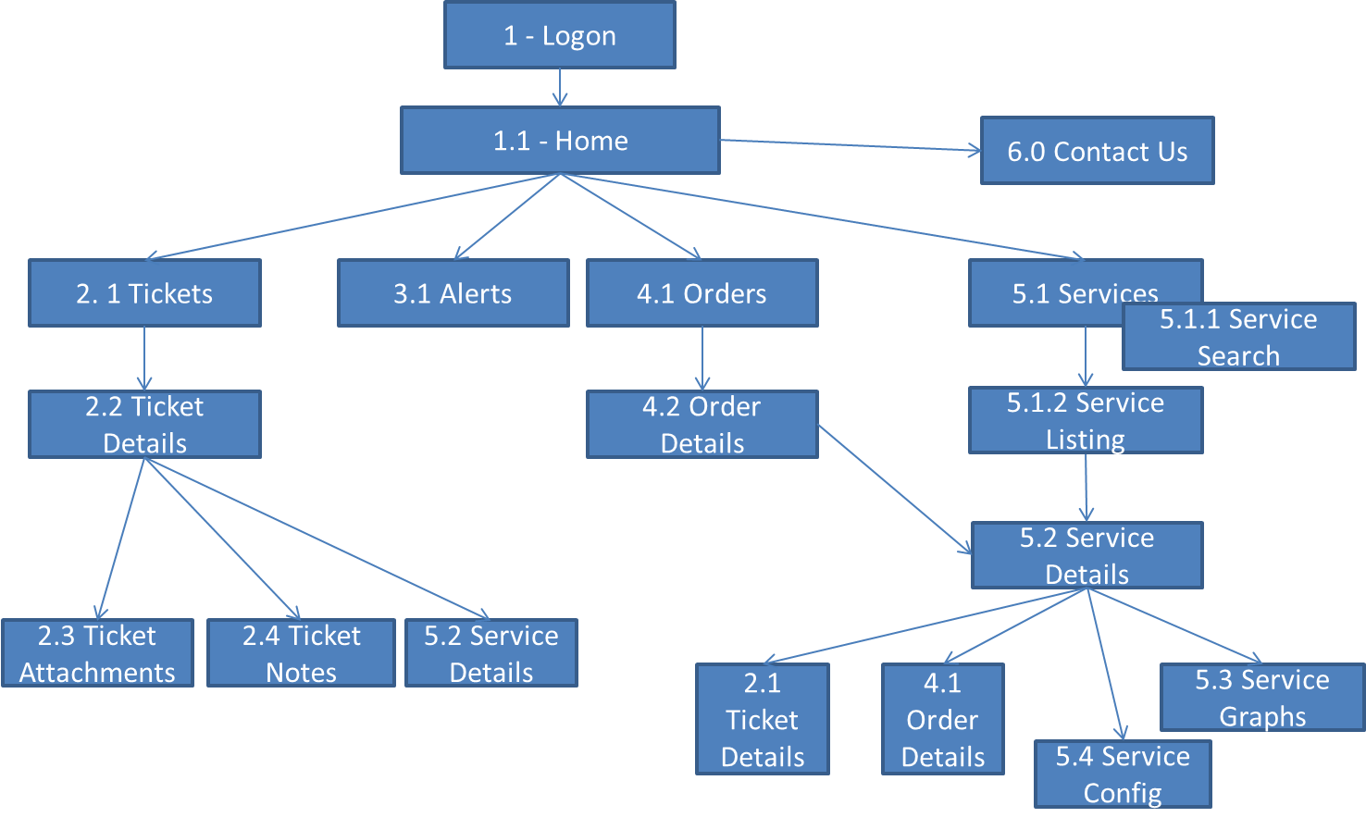

Wireframes
- These wireframes are indicative of content and screen flow only.
- Alternative methods for displaying the same information will be viewed favourably.

1 – Logon
The logon screen allows the user to enter a username and password.
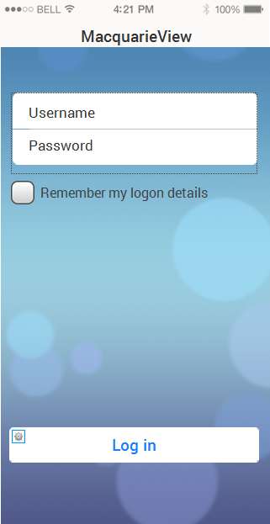
Notes:
- Standard logon screen. Password is to be hidden from the user.
- Clicking Remember My Logon details will cache the username/password locally. The logon screen will not be bypassed though. The screen will appear, showing the user name and with the password appearing as asterisks.

1.1 – Home Page
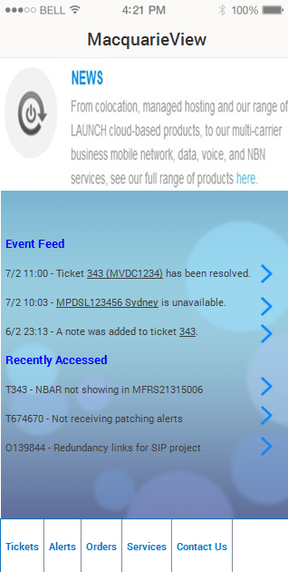
Notes:
- The top “News” section of the screen is a HTML control delivering news provided from macquarietelecom.com.
- The Event Feed displays new or updated tickets, orders and alerts, with a quick link to more information. This section could be empty.
  - Ticket updates will navigate to Ticket Details screen
  - Order updates will navigate to Order Details screen
  - Alerts will navigate to Service Details screen
- The Recently Accessed section displays the most recently accessed Orders or Tickets, allowing the user to navigate quickly to them.
- It is preferable if this screen does not scroll. Events displayed should be limited in number to fit on the screen.
- The five sections on the bottom toolbar are quick links to the other main screens of the application (as shown in the Screen Flow). This toolbar is present on the bottom of every screen. Each tab in the toolbar should be displayed as an attractive icon with text below.
- A UI element to return quickly to the Home Page from all other screens would be considered if designed elegantly.

2.1 - Tickets
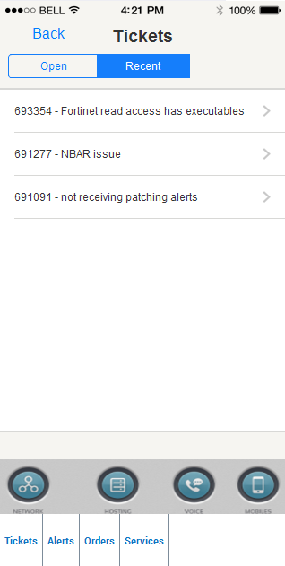
Notes:
- This screen displays trouble tickets (incidents) the customer has logged with Macquarie Telecom. The two tabs “Open” and “Recent” show either open tickets or recently closed tickets depending on what is selected.
- The “Recent” screen should not scroll. Only the number of tickets that can fit should be displayed. “Open” is unlikely to scroll as most customer do not have a large number of open incidents, but the UI must handle it.
- By default, tickets for all lines of business are displayed. The list can be filtered by clicking on one of the four lines of business icons at the bottom of the screen (Network, Hosting, Voice, Mobiles). These line of business filters are present on a number of screens. The icons in the mock-up are a sample only.
- Selecting a ticket navigates the user to the Ticket Details page.

2.2 Ticket Details
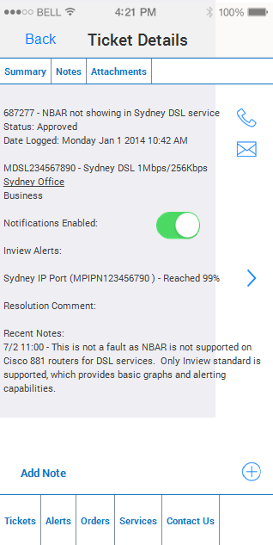
Notes:
- This screen shows the “Summary” tab of a trouble ticket. Fields are:
  - Ticket ID – Description
  - Status: Status description
  - Date Logged
  - Service ID – Service Description
  - Solution/Site Name
  - Service Level
- The user can enable/disable email alerts for this ticket by changing the Notifications Enabled control.
- Any Inview alerts for any of the services on the ticket will be displayed (there may be none). The user will be able to navigate to the Service Details screen of the service causing the alert if any are present.
- Resolution Comment will only be displayed for Resolved or Closed tickets.
- Recent notes will display only the most recent two Customer notes.
- The user should rarely have to scroll, and if so, only to see the notes.
- There must be an option to quickly call or email the relevant contact centre (HUB or HMC – depending on the line of business of the ticket).
- The Add Note button will open a model dialog for entering a new text note to the ticket.

2.3 Ticket Attachments
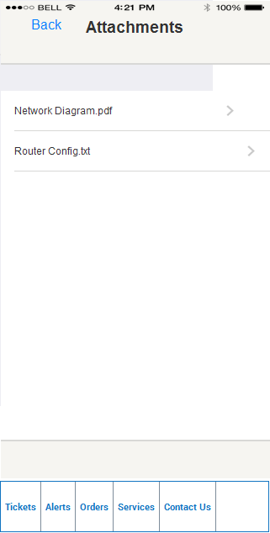
Notes:
- The Ticket Attachment page is for viewing any files attached to the ticket. Selecting the attachment will launch it if the phone is capable of viewing the file type.

2.4 Ticket Notes
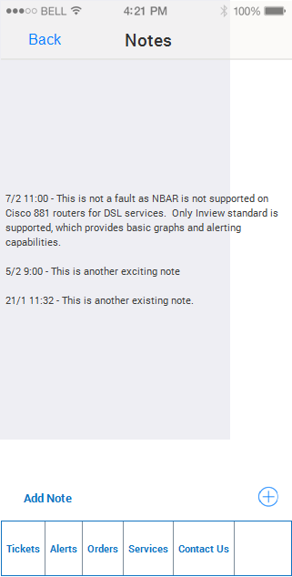
Notes:
- The Ticket Notes screen displays all Customer notes from the top of the screen down.
- The Add Note button displays a modal dialog allowing a new note to be added.

3.1 Alerts
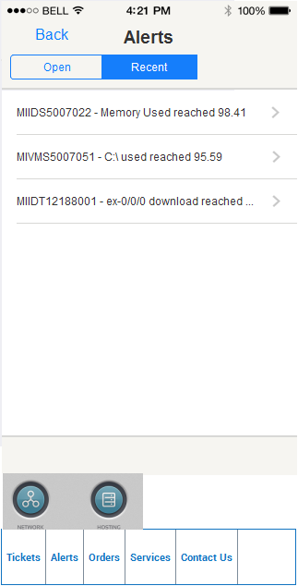
Notes:
- The Alerts page displays Errors, Warnings and Information messages.
- The alert text is system generated and can be long. The UI should show as many characters as possible with a … more indicator once it become impractical to show more.
- It should be clearly displayed whether an alert is an error, information, or a warning via a UI mechanism (not shown in Mock-up). There should be a way of filtering the display to only show errors, warnings, or information messages.
- It should be possible to filter Alerts by LOB – Data or Hosting are the only current applicable options.
- Selecting an alert will take the user to the Service Details screen of the service that generated the alert.
- Open shows currently active Alerts. Recent shows closed alerts from the past month (up to a manageable limit).

4.1 Orders
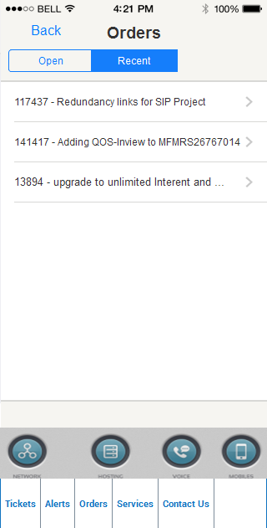
Notes:
- The Orders screen shows either Open orders or recently Completed orders.
- The only fields displayed are the Order ID and the Order Description. It may be useful to indicate the line of business for each order. However, an order can encompass more than one line of business and there may not be screen real estate to do this.
- The user can filter the view of Orders by Line of Business by selecting one of the icons.

4.2 Order Details
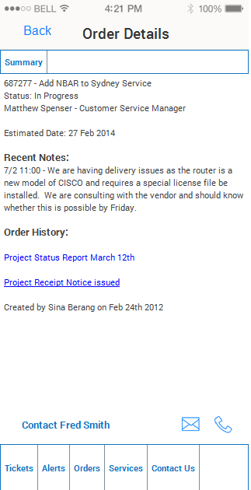

Notes:
- The Order Details page shows a summary of a single Order. The fields displayed are:
  - OrderID – Description
  - Status – Status Description
  - Name and Title of who the order is assigned to (hidden if not applicable)
  - Estimate Completion Date
  - Order History – a list of events. Events are either a short text description but can also include a link to a PDF attachment (receipts, completion notices, status reports). All events have a timestamp.
  - An option to phone or email the person whom the order is assigned to (hidden if not applicable)

5.1 Services
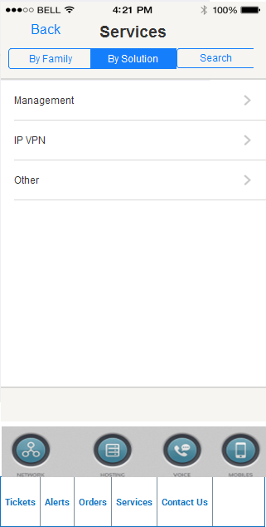
Notes:
- The Services screen allows the user to view services grouped by Product Family or by Solution based upon which tab is selected.
- One line of business must always be selected – Data/Hosting/Voice/Mobiles. The user will only see the LOBs that they have purchased from Macquarie Telecom.
- Selecting a row representing a group of services will take the user to the Service Listing screen.
- The search tab replaces the screen content with the Service – Search screen, allowing the user to search their list of installed services.

5.1.1 Service - Search
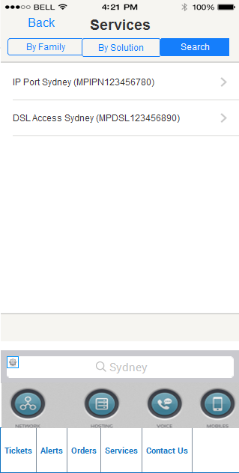
Notes:
- The Service – Search screen allows the user to search by Service ID or Service Description for a service. A wildcard match will be applied to the customer’s services.
- Selecting a service navigates the user to the Service Details screen.

5.1.2 Service Listing
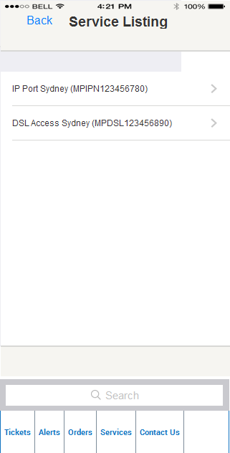
Notes:
- The Service Listing screen shows the services in the selected group. It displays the billing description with the service ID in brackets. The screen will scroll if there are more services than fit in the displayable area.
- Selecting an individual service will navigate the user to the Service Details screen.

5.2 Service Details
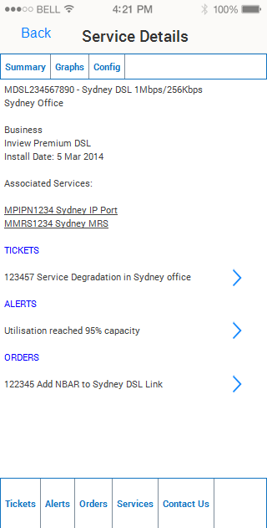
Notes:
- The Service Details page displays details of an individual service. It displays the following fields:
  - Service ID – Description
  - Solution Name
  - Class of Service
  - Inview Level (if service has Inview) – one of Inview Standard, Inview Premium, Inview Premium DSL.
  - Installation date
  - Associated Services (optional) – these should be links to the Service Details screen of these services.
- The Tickets section shows open tickets with the ability to navigate to the Ticket Details screen.
- The Alerts section shows any open alerts. Navigation will take the user to the Graphs tab.
- The Orders section shows any open orders with the ability to navigate to the Order Details screen.
Out of Scope:
- Service specific details from the Service Inventory are not in scope for version 1.0 of the application.

5.3 Service Graphs
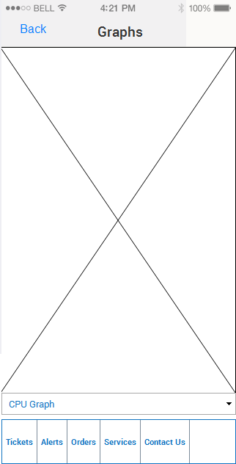
Notes:
- The Graphs tab shows Inview graphs in landscape view (for readability). The graphs may be interactive or a static JPEG (to be determined based on technical evaluation).
- The screen display should automatically switch to a landscape view when displaying graphs.
- There should be the ability to email or SMS a graph as an image using the phone’s in-built capabilities.
- The user can change the graph viewed for a service from a dropdown list. E.g. CPU Graph, Memory Graph, Utilisation Graph, etc.
- On most graphs it is possible to change the time range for the data displayed. e.g. Day, Week, Month, Quarter or Custom Date Range.
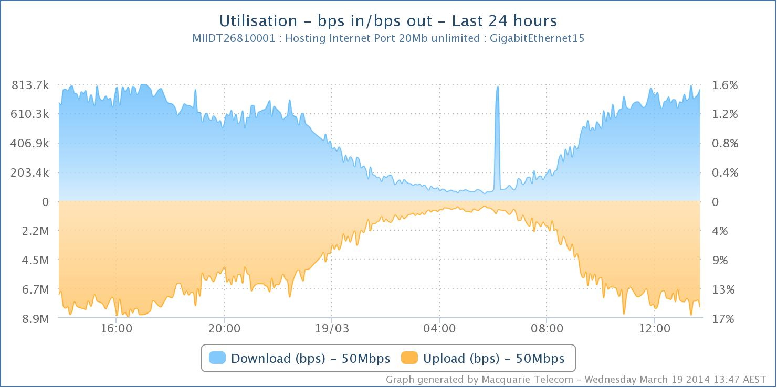
A sample chart from our existing web site.

5.4 Service Config
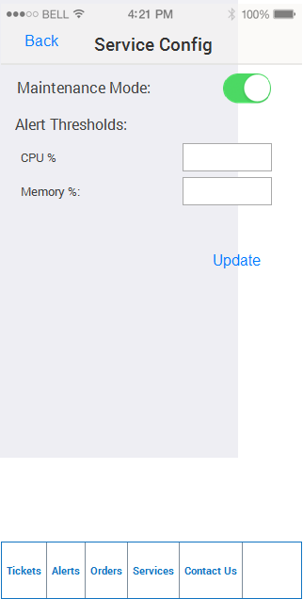
Notes:
- The Service Config screen allows the user to put a service into Maintenance Mode (turn off alerts).
- The Service Config screen allows the user to change alert Thresholds. The Thresholds displayed will depend on the type of service. There may be up to six of these values.

6.0 Contact Us
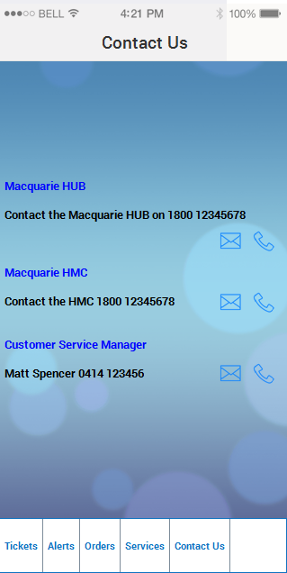
Notes:
- The Contact Us screen allows the user to quickly phone or email the Macquarie HUB (main contact centre), Hosting Management Centre (Hosting LOB only contact centre) or their Customer Service Manager.
- The Macquarie HUB will always be present.
- The HMC will only be visible if the customer has Hosting LOB.
- The Customer Service Manager will only be visible if the customer has a CSM allocated in Macquarie Telecom’s CRM.

Future:
- A Test tab on the Service Details screen for performing Inview tests
- Ability to log Tickets from certain screen, copying in service/graph/alert details.
- Share object (alert, ticket) with a colleague via email/SMS.
- Service specific details from the Service Inventory on the Service Details page.

