Branding & Marketing - Agenda v. 2.0!

We need to redo our logo because we are pursuing the topical heat therapy market and not EMTs or hospital. So we need to figure out the logo + website.

Why is the Warmilu heat pack/set of solutions, ideal for giving warmth
Problems: Warmth or keeping warm is a universal problem.

Mission + Company tagline: Spread the warmth.

<- Company tagline, it is very social mission-y and ties in a lot! It does not automatically scream social mission. (GH: Agreed!) Still know spread the warmth to me the consumer. Warmth is the fact that it is a heat pack.

Colors = Oranges and yellows both the blue and red can be too severe and represent polar opposites on the heat spectrum.

Grace liked some of these logos, try tweakin the w, r, m, and l! Or if you could somehow, like the fact that we have the warm and ilu as separate colors. We can definitely try red on the warm side and then move to orange. warm (italicized) and ilu (blocky).
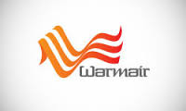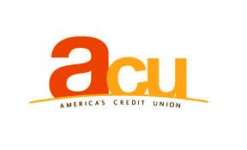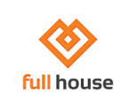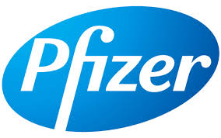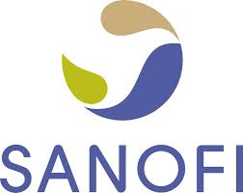 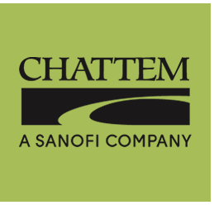<- Parent companies, so not super directly affiliated with heat/warming market.

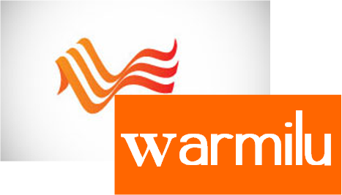
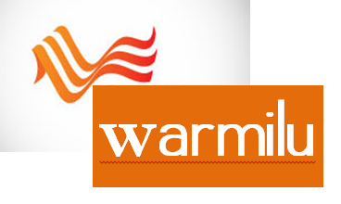

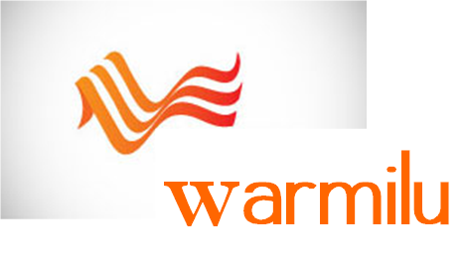



Squiggles on the top and bottom? Squiggles off front part of W, italicized warm bold ilu, cursive warm. Orange warm, redish orange ilu
We need to have more than 2 squiggles and they need to be sideways and not vertical, because it looks like fire. 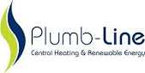

- Who are the audience segments?
  - Account Managers for retailers
    - Background - marketing & shelving
    - Education - certification & experience in stores
    - Careful about engineering talk
    - Goal: We want them to purchase or ask about purchasing
    - Need own market
  - Investors
    - Want $ from them
    - industry information
    - Mergers & acquisitions
    - how much to raise in what time period
    - IP
    - Savvy and educated
    - Goal: want them to partner, invest and give contacts
    - Don’t need their own websites
  - influencers/partners
    - people who will want to spread word
    - Goal: Spread the word and like us on FB and go to the blog and go to Twitter, get in touch with team and point us to helpful people
    - Need own markets
  - Can have a mission page + website
    - Social Cause http://www.gecitizenship.com/
    - Business http://www3.gehealthcare.com/en/Global_Gateway
      - Brief, social mission
      - If EMT they can go there to social one and it isn’t hard to maneuver
      - Can put About + Social Mission
      - 2 web pages, one is very medical like with pictures and the other is colorful and happy for social mission.
- What are our asks for them?
  - E.g. subscribe to our newsletter, donate, join, buy, these kinds of asks should be immediate and obvious on the home page
- What differences, if any, in our messages to each of these segments?
  - Are these enough to split into two lines?
  - If so, what are our audiences for either of the lines?
  - Based on these differences, which colors do we want to use for either of the lines?
  - Is two websites confusing?
    - Could be - to mitigate that, be conscientious about splitting them and focusing attention
- Do we have key themes we want to convey?
  - Distill these down to key language, phrases, words
    - MedLine (for-profit)
      - technical data sheet
      - SAFE, Reliable, instant, nonelectric, comfort, and easy to use
      - Team - professional, support
      - Medical device
      - More details
        - Profitable/economies of scale, ISO certifications
        - Sustainable
        - Revenue generating
  - Language should be as straightforward and simple as possible – we don’t have time for
- What kind of feeling (friendly, professional, etc.) do we want the audiences to get from the team page?
  - For-profit
    - Need more fun bios!
    - Just go with Warmilu Solutions medline logo
    - Red and black

- How much do we want to differentiate ourselves from the other top heat product companies?
  - Maybe we do want the Warmilu logo and the product brand name to be featured on our packaging. Unlike other companie whether it is really the brand/product name and not the company name.
  - Pros & cons of differentiation?
- Moving forward, how can we make sure to get feedback on at the very least our visual branding?
  - During or after Fall Break
  - Go and ask everyone to check out website and give us feedback
  - Awards we’ve won

