No. | Mockup | # of votes | Emotions
1 | 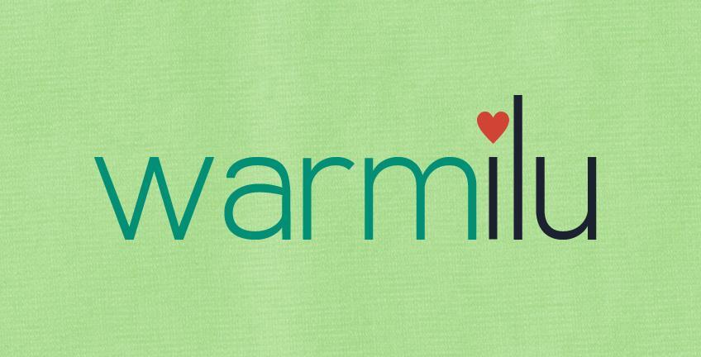 | 10 | Sustainable, eco-friendly, fresh, young, calm, natural, calm, warmth, cold, rain-forest, pure, friendly, soft, watermelons, comfort, soothing
2 | 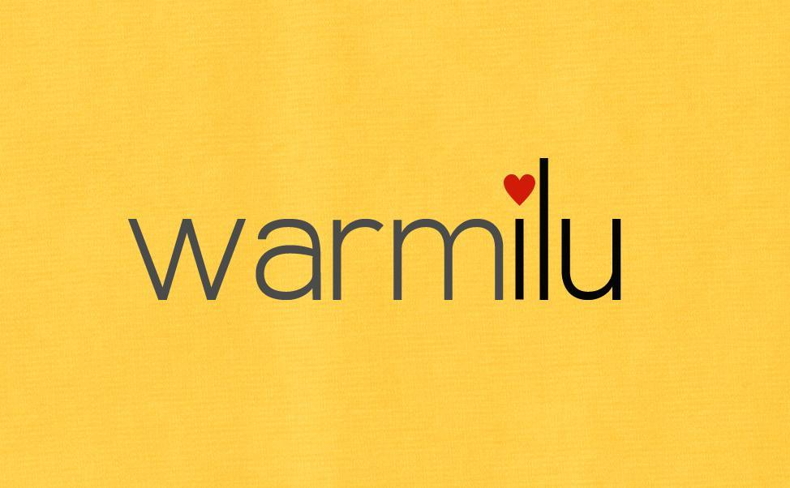 | 16 | Brightness, warmth, African, exotic, eyecatching, happiness, coziness, cheerfulness
3 | 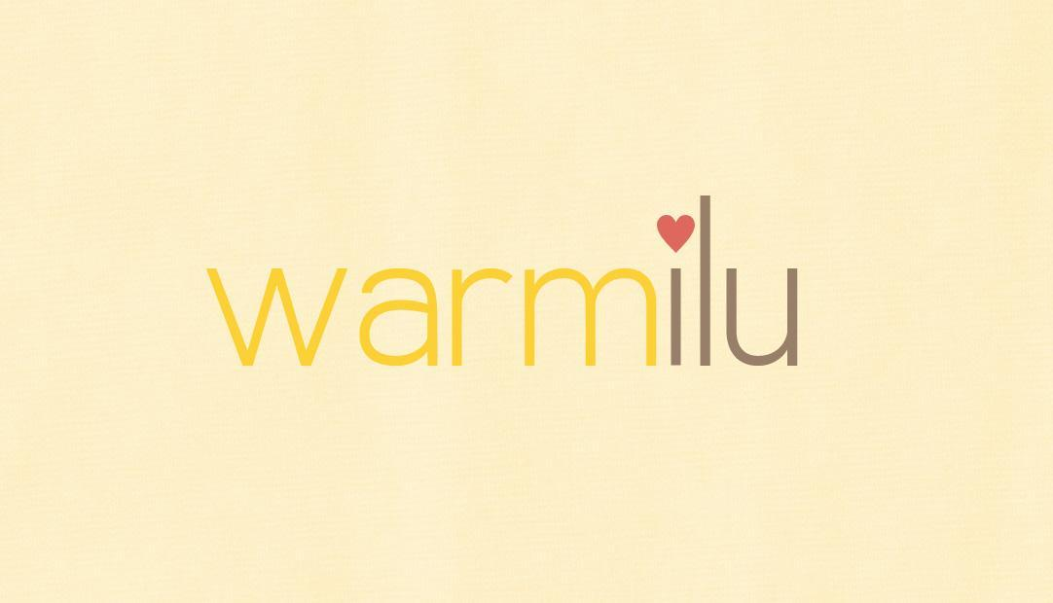 | 10 | Warm, but faded, distant, happiness, nonthreatening, youthful, baby, friendly
4 | 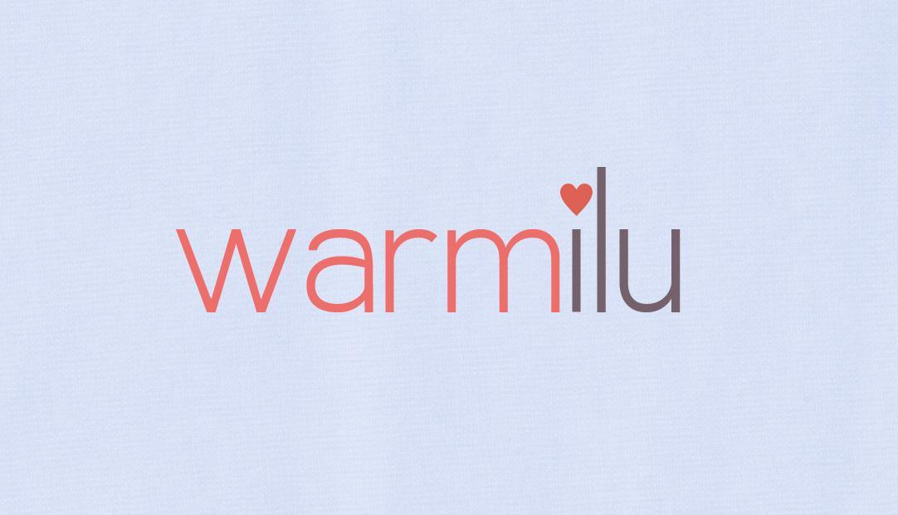 | 7 | Gentle, warmth, calm
5 | 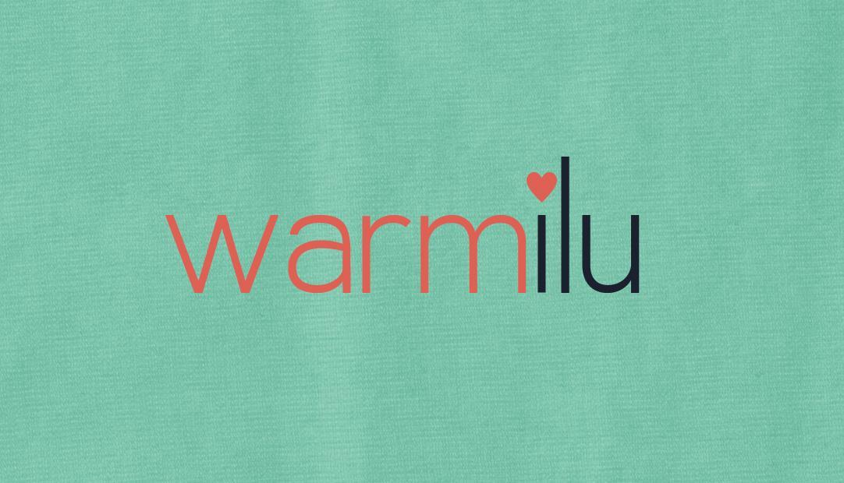 | 5 | Calm, eco-friendly, still a baby company (very similar to Elephant Ears), comfort, professional
6 | 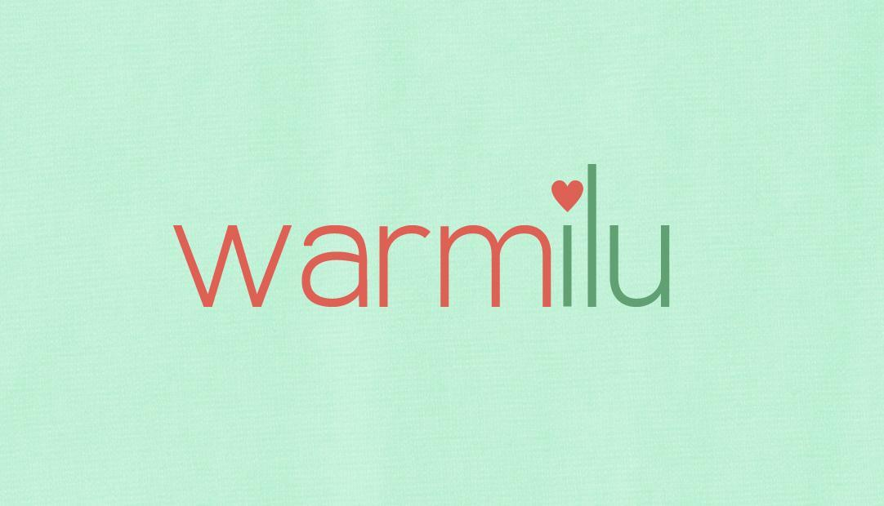 | 6 | Calm, eco-friendly, warmth, soft (like a baby company)
7 | 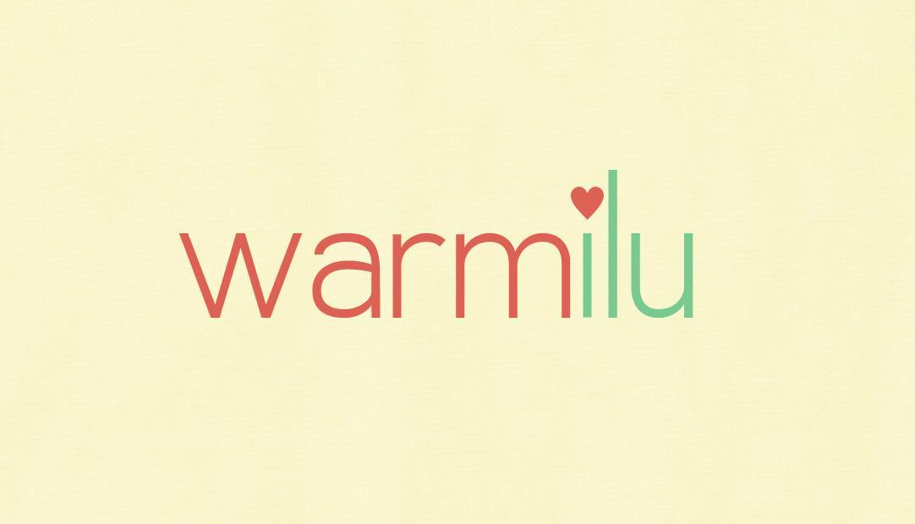 | 9 | Comfort, warmth, ease, watermelon, summer, graphic design firm, fresh, young, soft
8 | 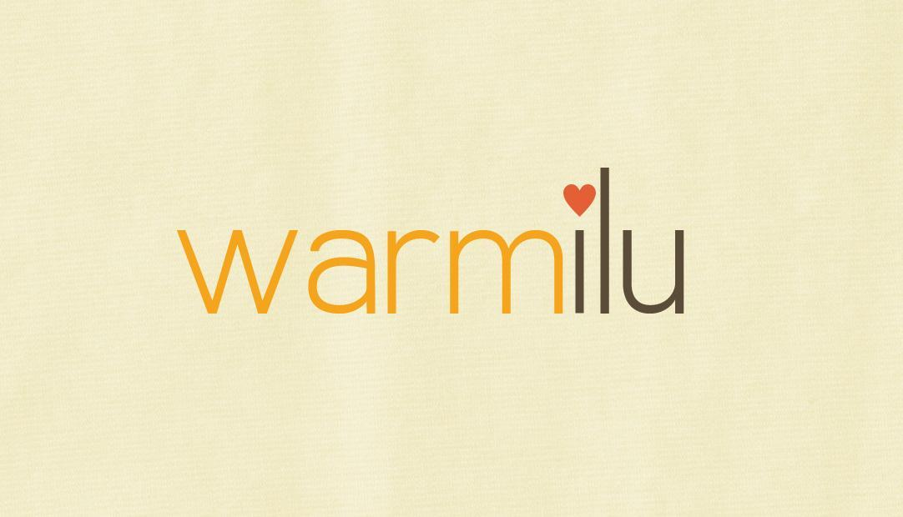 | 4 | Warmness, sincerity, happy

Top three vote-getters: 2, 1/3

Comments:
- Very pale backgrounds looked washed out
- No. 2 was too dark and too light
- Cool colors didn’t convey warmth
- Feminine logo might deter unisex projects i.e. military use of heat technology
- Red of heart in many are too strong – makes it aggressive

