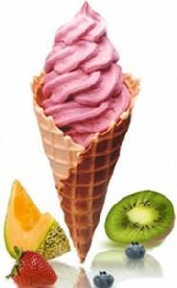
The ice cream we will be selling

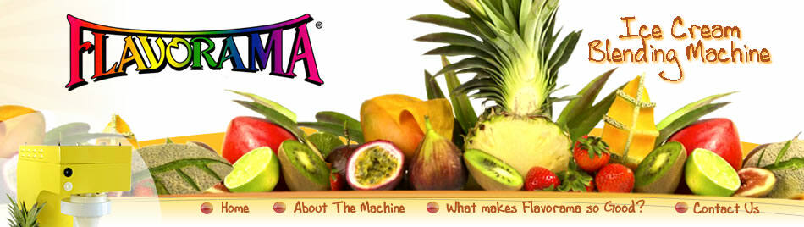
The company we will be buying the ice cream machine from

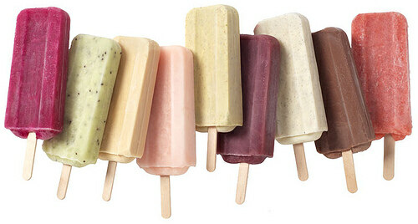
The types of home made, fruit-based popsicles we will be producing.

