

Welcome!
At Babblebrooke Day Nursery I want all my team to exceed your expectations in providing you the best quality childcare service we can. My focus is on high quality staff, all of whom are well supported, motivated and ready to meet individual families’ needs, to the best of their ability.
Babblebrooke is individual in its approach to staff well-being, after all, we all want to know that our children are being looked after by people who want to be at work and enjoy their job. We aim to ensure that we respect all of our staff as the professionals they are and unlike some child-care settings; our staff are rewarded for their hard work with salaries which have added bonuses and sick pay.
I hope you find all the information you are looking for in the prospectus, however if there are any questions we have not answered for you and you would like to come and see our wonderful nursery, please do not hesitate to contact the nursery, we are always here to help!
My team and I are looking forward to meeting you and your child!
Kelly Hutton, Nursery Manager

Helping children to love to learn and have fun!
As an Ofsted registered setting, we use the Early Years Foundation Stage (EYFS) to help us to plan and ensure that the nursery environment, staff practice and our policies and procedures work for your child.
Each child has an individual learning journey, which we will document with photos, observations and little bits of art work which will create their very own learning journey.
We aim to ensure that each child’s development is fully catered for, preparing them to become bright, independent learners who are able to begin their school education with confidence and eagerness!
Kelly’s children, as well her child-minded children had a lot of involvement in the planning of resources and layout of the nursery, so right from the beginning, the nursery has been planned with and by the children. This is something that is actively encouraged by the nursery staff, with resources and activities planned around the children’s interests and ideas.
These ideas and interests will be displayed around the nursery all of the time, as well as shared with the families at the nursery through discussion with the key person and through email. You can see all of our planning of activities and resources in the hallway, along with each child’s individual next steps, which are on display so that you see the process in which your child influences the activities and resources available within the nursery
Our Nursery
We have 3 children’s rooms in the nursery; these are the Little Room, Green Room and Big Room. At Babblebrooke, we name our rooms purely to ensure that each child has an age appropriate area with resources available to them however we aim to create an environment in which the children can explore and find various other activities that are available to them in each room.
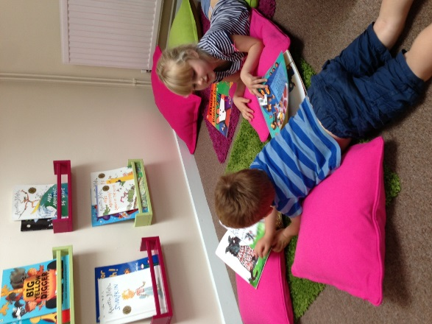
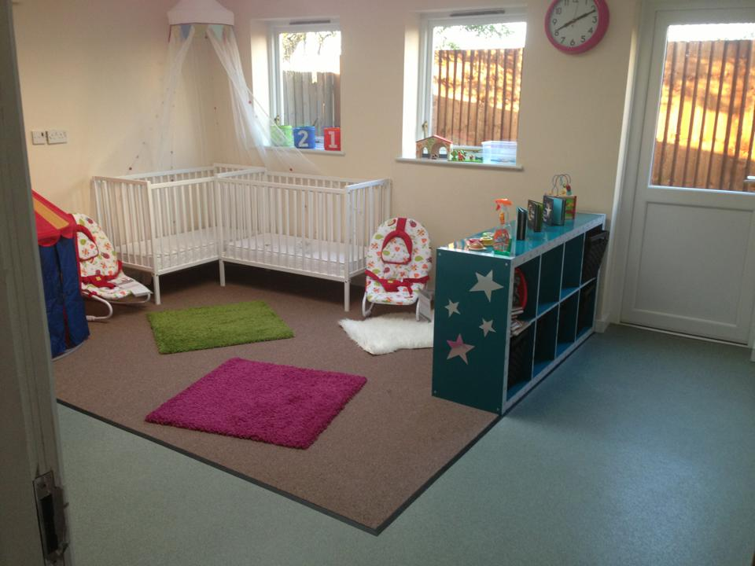
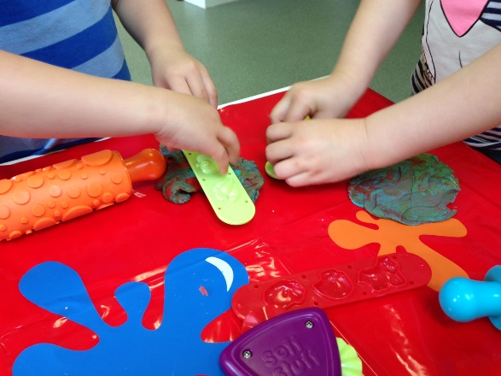

Each room is set up to provide an accessible environment for children to access resources which will enrich their creative, language, mathematical, physical and social development whilst letting them extend their knowledge about the world. They will have the opportunity to play, have fun or be quiet and snuggle in with a book depending on their mood. We aim to ensure that every aspect of your child’s care, learning and development is catered for.
Freshly prepared for your child..
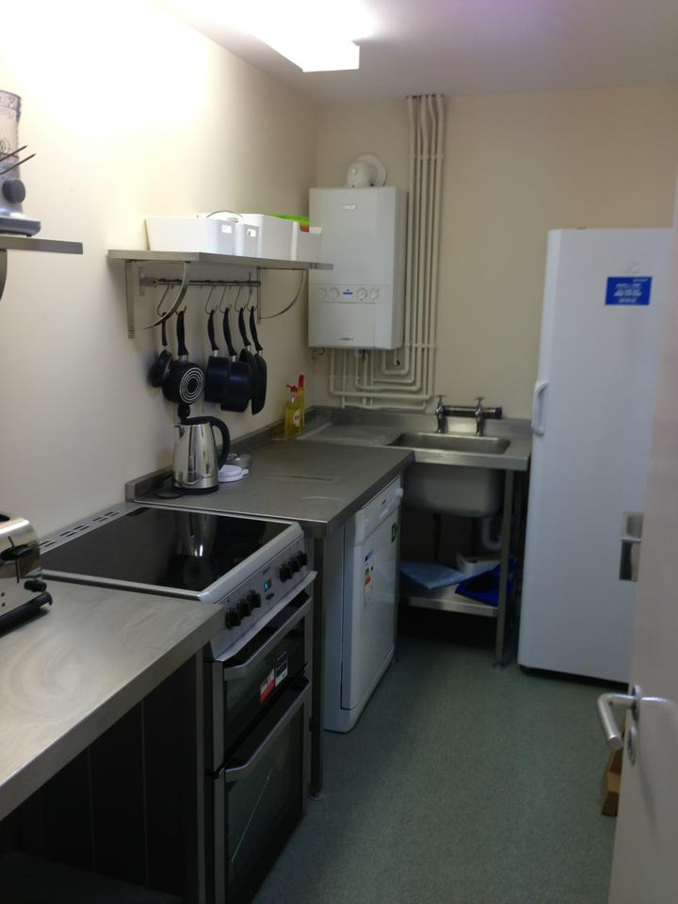
All of the nursery meals are prepared on site, fresh on the day and planned to ensure that your child has a healthy and varied diet. We use a 4 week menu system which we change every 3-4 months to ensure that the children have the opportunity to try new things, as well as old favourites. All the meals are included in the price of the fees, each day the nursery provides:
- Breakfast, of fresh fruit with cereal or toast
- Snack, of fresh fruit or a healthy alternative
- Lunch, a freshly prepared 2 course meal
- Afternoon snack of fresh fruit or a healthy alternative
- Tea, a lighter, 2 course meal

We try to ensure that all meal times are a time where children can connect with the staff team and are encouraged to create a sociable environment. The lunchtime routine is staggered, where children can choose when they are ready to eat and are encouraged to set their place, wash their hands and sit and eat with the staff team, as well as their friends so that table manners can be encouraged.
Working with families
Our services aim to reduce the stress of parenting, on at least some level, so our fee’s are fully inclusive of all meals, babies milk (if bottle fed) and we use own brand disposable nappies and wipes for children that are yet to be toilet trained. We also welcome the use of cloth nappies by ensuring that our nappy changing procedure caters for them. If you have a specific brand of nappies and wipes that you prefer your child to use, you can leave these at the nursery for their use only.
We also like to encourage families to take part in nursery life as much as we can, so we have activities available for you take home to do with your child, times for you to come into the nursery and do them with us, as well providing you with a wealth of information about what we have been doing with your child through email, CD Rom and in paper format.
We also appreciate any and all the information you can give back to us, so on our website and in paper form in the welcome porch, you can find contact forms which help us to ensure that the level of service to yourselves goes above and beyond your expectations.

Pricing schedule
September 2013: A non-refundable £50 Retainer Fee is charged to secure all bookings (after October 31st 2013)
Under 3 year olds:
Session | Time | Price
Morning | 7.30am-12pm | £22.00
Afternoon | 1pm-6.30pm | £22.00
Full Day | 7.30am-6.30pm | £40.00
Full Week | Full Day/5 Days | £180.00
School Day | 9.30am-4.00pm | £37.00
Full School Week | School Day/5 Days | £170.00
Additional hours (ad hoc)* | 7.30am-9.30am | £9.00
Additional hours (ad hoc)* | 12pm-1pm | £4.50
Additional hours (ad hoc)* | 4.00pm-5.00pm | £4.50
Additional hours (ad hoc)* | 5.00pm-6.00pm | £4.50
*Ad hoc hours are subject to availability
Over 3 year olds
Session | Time | Price
Morning | 7.30am-12pm | £20.00
Afternoon | 1pm-6.30pm | £20.00
Full Day | 7.30am-6.30pm | £38.00
Full Week | Full Day/5 Days | £170.00
School Day | 9.30am-4.00pm | £36.00
Full School Week | School Day/5 Days | £160.00
Additional hours  (ad hoc)* | 7.30am-9.30am | £7.00
Additional hours  (ad hoc)* | 12pm-1pm | £4.00
Additional hours  (ad hoc)* | 4.00pm-5.00pm | £4.00
Additional hours  (ad hoc)* | 5.00pm-6.00pm | £4.00
*Ad hoc hours are subject to availability
FEEE Funding (3 and 4 year olds only)
Terms and conditions
FEEE session | 9.00am – 12.00am/1.00pm-4.00pm Term time only (no registration fee required, but subject to availability)
OR | FEEE can be used over our normal sessions at a specified time of a minimum of 2.5 hrs or up to 10 hours per day for a maximum of 15 hours per week, term time only (normal prices apply outside of the 38 weeks and registration fee required)

Terms and Conditions of care
- All spaces are allocated on first come first serve unless siblings are already attending.
- For your required sessions to be held, a non-refundable fee of £50 is required.
- Hours of care are provided between 7.30am – 6.30pm and we reserve the right to apply additional higher charges should care be provided outside of these hours without prior arrangement.
- Monthly fee is expected to be paid via cheque or standing order on the 1st of each month in advance for that month i.e. care paid for the month of March will be paid on the 1st March. Should this payment not be received and cleared by the 7th of the month then service will be suspended until the arrears is brought up to date.
- Parent’s book set sessions each week as a part of the contract. Extra sessions on top of these may be booked dependent upon availability.
- Any extra care hours over the contracted amount will be invoiced at the time of booking and will be expected to be paid either before or on the day of the booking.
- Parents must still pay for any sickness/days absence/holidays which children must take in accordance with the sickness and absence policy.
- You agree to notify us if your child is absent.
- You agree to provide a change of clothes, suitable clothes for the weather and any other necessary items which are required.
- You agree to arrive and collect your child on time
- You agree to inform us if your child has been ill in the last 24 hours and if your child has been involved in an accident since their last visit to us.
- You agree to ensure that you adhere to the nurseries policies and procedures which are available to you in the welcome pack and in more detail on the nurseries website: www.babblebrooke.co.uk
- You understand you need to give 4 weeks’ notice to terminate the contract.

So what do you do next?
If you have decided that Babblebrooke Day Nursery is right for your child and yourself, then the next step is to register with us...
You can rest assured that you will be welcomed into our nursery at a pace which suits you and your families’ needs.
Start by returning the registration form to us, along with some dates of which you can visit the nursery to begin the settling in process and complete the necessary forms that we need.
It really is that easy!
However, if you feel that a nursery environment isn’t what your family needs right now, don’t worry, please ask us about other childcare settings and we will be happy to recommend somewhere which will match your needs and we thank you for enquiring with us.

Contact us at,
7 Limehurst Avenue
Loughborough
LE11 1PE
01509263930
Enquiries@babblebrooke.co.uk

