Contact Us  Sabrina Bow, Ed.D.  [t] 626.695.5362  [f] 626.225.8121  sabrina@evergreenca.org  www.evergreenca.org  
  School leadership is 24/7/365

Evergreen Associates provides just-in-time support to schools and school leaders.  Schools along the continuum of organizational growth—from startup schools to developing or mature schools—can benefit from specialized expertise to complete a time-sensitive special project or develop strategies and processes to take their program to the next level of excellence.   |  |  |   How do I develop a high-functioning board?  What policies do start-up schools need to have on day one?  Is my meal program optimizing revenue?  We want to refinance our property. How do we tell our story to a lender?  How can we increase parent engagement?  What do we need to do to increase visibility (and enrollment)?  My assistant principal is going out on extended leave… can I get someone to step in while he’s out?  Do these questions keep you up at night? If so, we can help. |  |  | 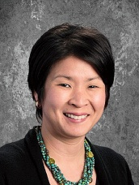  Sabrina Bow, Ed.D.  Founder & CEO  My 10-year experience as an executive director of charter schools in the two largest school districts in California gives me a unique “education + business” perspective in addition to a network of on-call, expert associates who are ready to assist your school in a variety of key areas.  Our areas of expertise include:  - Board Training  - Budget and Operations  - Charter Development  - Communications  - Leadership Coaching  - Lender Negotiations  - Fund Development  - Placement of interim administrators

