Information for designer
Please use theme colors that complement the company logo.
4 pages: Home, Register, Packages, Contact

Home (page 1):
#Please use attached jpeg for page 1 image#
Page 1 Text:
Imagine immediate access to highly trained Cisco engineers, without the cost and expense of paying them for a site visit.
CUTECH is a Canadian based consulting and distributor of Remote Cisco technical services.
Are you or your customer’s network running slow; is there a switch or WLAN issue that needs looking at? Need to deploy a PBX with tight deadlines or when your resource scheduling doesn’t allow?
A remote cisco expertise is the answer! Cost efficient, fast and you won’t be paying for travel times and lunch breaks.
CUTECH is the sole distributor of Rymote remote services in Canada. Rymote is a UK based leader in providing remote technical services.
A remote Cisco engineer is better for your budget and ICT infrastructure. Efficient network optimization ensures you are getting the most out of your Cisco network technology, ensuring your communications are always up to date, and up to speed.
We guarantee immediate, efficient service, anywhere in the world

REGISTER (page 2)
#comment to designer: Please include 3 images below which have been included in the request to this page in a format that you feel best#


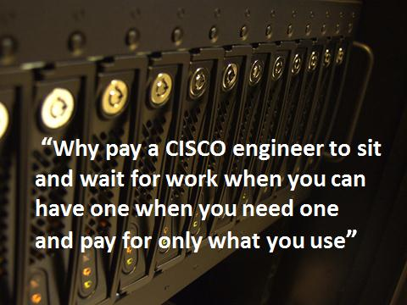


Include the form below from this link: https://rx154.infusionsoft.com/go/PartnerForm/CAR1/

(See image below from section of link we require in the webpage. We want users to be able to register directly from the link embedded in our website, but only the form section of the link). Please only show the image below from the link in my website.
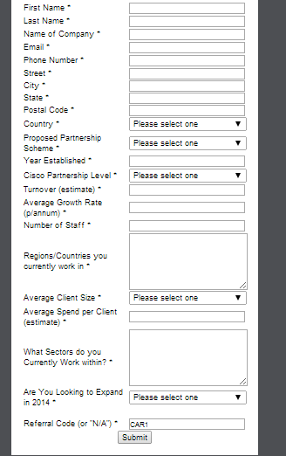

Package (page 3):
Page 3 Text:
Services can be bought based on the skillset of engineer required (CCNA, CCIE etc) paid on an hourly basis or bought as a package for a fixed project
Associate offering
Cisco Certified Network Associate (CCNA) engineer.
What it means: CCNA qualified engineers can install, configure, operate, and troubleshoot medium-size routed and switched networks, including implementation and verification of connections to remote sites in a WAN.
Textbox: register
(hyperlink to: https://rx154.infusionsoft.com/go/PartnerForm/CAR1/)

Pro offering
Cisco Certified Network Professional (CCNP) engineer
What it means
CCNP qualified engineers can plan, implement, verify and troubleshoot local and wide-area enterprise networks and work collaboratively with specialists on advanced security, voice, wireless and video solutions.
Textbox: register
(hyperlink to: https://rx154.infusionsoft.com/go/PartnerForm/CAR1/)

Expert offering
Cisco Certified Internetwork Expert (CCIE) engineer.
What it means
Cisco CCIE engineers are accepted worldwide as the most prestigious and highly qualified networking certified engineers in the industry. The CCIE qualification, introduced in 1993 is held by only the top 3% of all Cisco professionals worldwide.
Textbox: register
(hyperlink to: https://rx154.infusionsoft.com/go/PartnerForm/CAR1/)

If you require cost for fixed projects, please contact us

Contact us (page 4)
Thank you for your interest in our offering. If you have any questions or would like to know more about us, please get in touch.
By email: info@cutech.ca
By Phone: 1-416-816-5610

