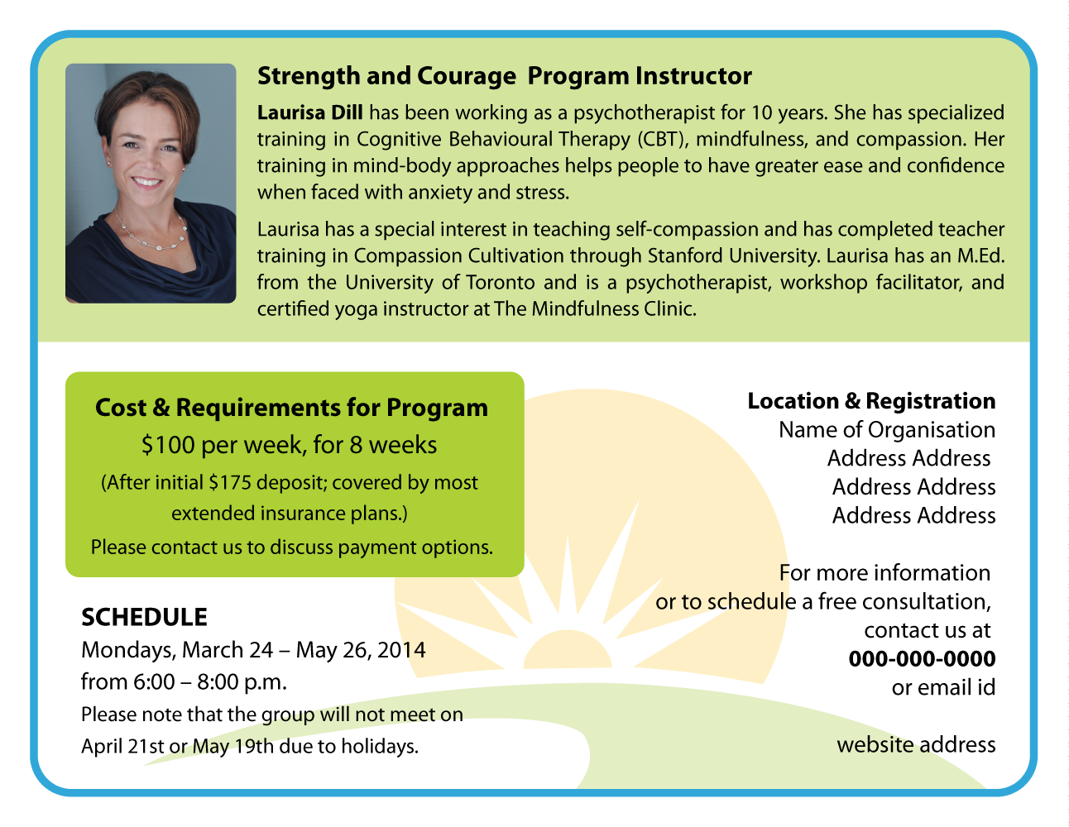
Make this Light blue transparent fill (see new color pallet selection in brief) – use same for border but not as transparent)
Change the content to this:

Program Instructor:

Laurisa Dill is an educator and a psychotherapist with graduate training in psychology and 15 years of experience. She has specialized training in Mindfulness and Yoga.

Laurisa is currently completing Teacher Training at The Stanford Centre for Compassion and Altruism Research and Education. She coaches and provides tools to help people reach their maximum potential for living with confidence, vitality and meaning
Make the green more transparent -
Change the content to this:

Location and Cost :
Classes are held in downtown Toronto once a week for 8 weeks. Each class is 2 hours long. The cost of the program is covered by most health insurance plans with Psychological Benefits .
Change the content to this
For more information or to schedule a free consultation contact Laurisa Dill at laurisa@compasstionpathways.com
Change the content with this (No heading)

CCT is proven to support health, happiness and well-being. The skills you learn will help you long after the course has ended

EMPTY Sticker BOX - at least 3 inches x 1
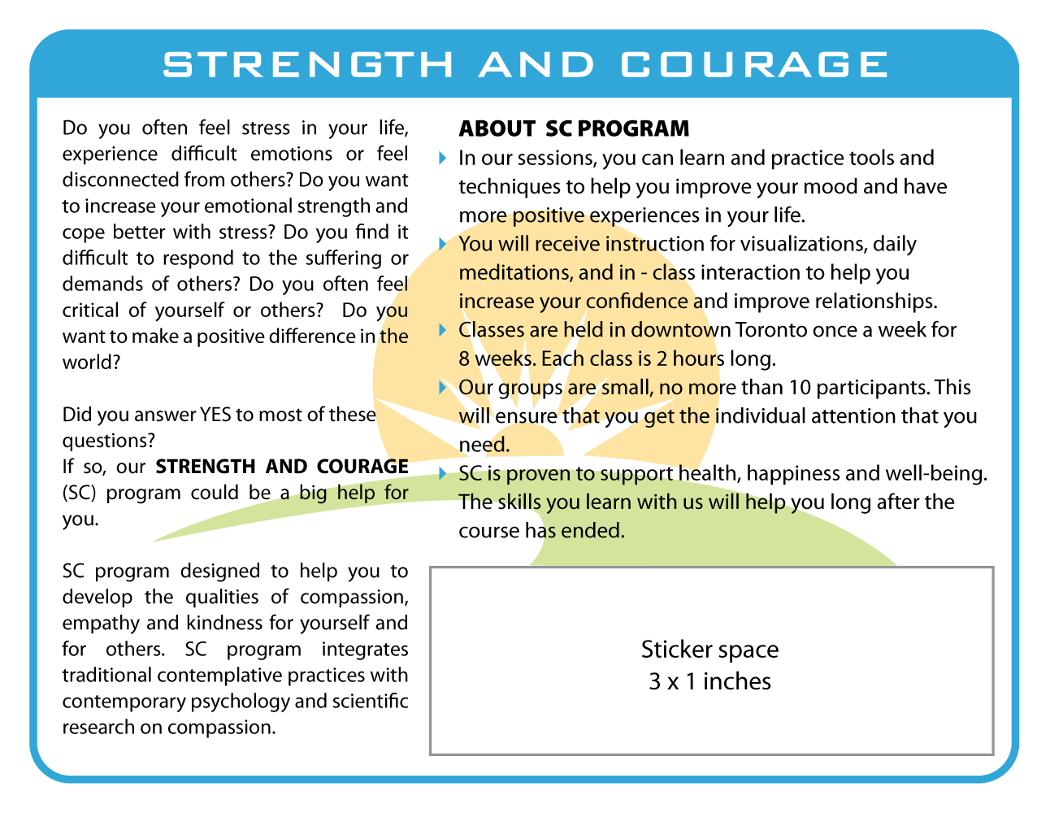
Change to Strengthening the Heart
Make the font tighter and bolder More like font in the rest of the card
Change the content to this (with blue bullet points )
A compassionate attitude can greatly reduce the distress people feel in difficult situations and can become a profound personal resource in times of stress.
Compassion Cultivation Training (CCT) is an 8-week educational program designed to help you improve your resilience and feel more connected to others—ultimately providing an overall sense of well-being., confidence and clarity.

Remove this sticker box
(See other side )
Change the content to this (use blue bullet points )
About the Program
CCT was developed at Stanford Medical School. The program combines traditional contemplative practices with contemporary psychology and scientific research to help you lead a more compassionate life.
Through instruction, daily meditation, mindfulness, and in-class interaction, you can strengthen the qualities of compassion, empathy, and kindness.
Learn how to train your mind to intentionally choose compassionate thoughts and actions and develop skills that help you relate to others—and yourself.

WHAT FILE FORMAT WILL THIS BE IN ? I WILL NEED TO CHANGE TEXT AND CONTENT LATER ON

