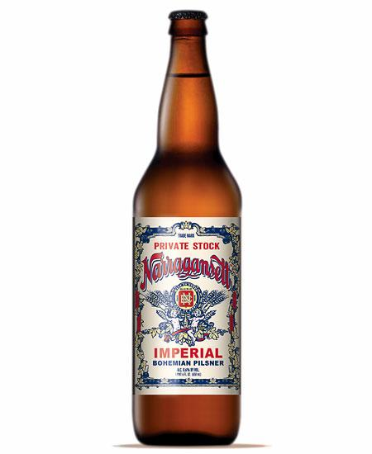

D: like the borders and the “old fashioned” look.
M:like the fonts used for the most part. Label Looks very busy/cluttered though.

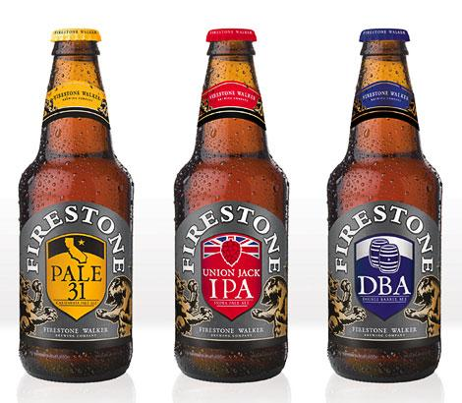

D: Good “family”; color coded by recipe. Do not like the fonts, but like the graphic
M: Like the color scheme. Do not like the fonts
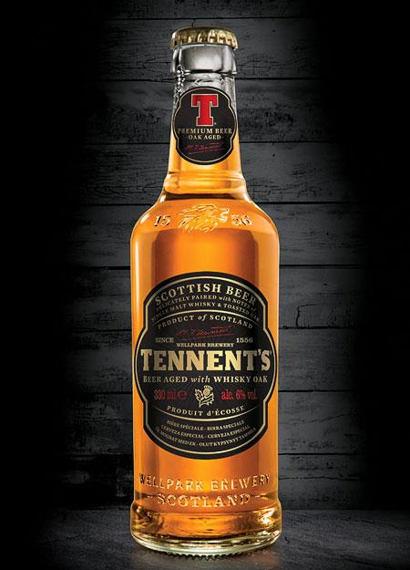

D: Like the shape of the label and the color scheme. Like the Logo on neck and the fact that the label does not wrap all the way around
M: Like the colors and the shape. Don’t like the font and how it looks like a whiskey label.
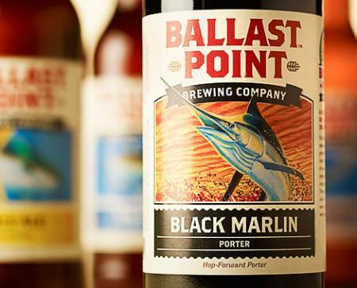

D: Like the fish theme for all their beers
M: Like the layout of the label. Want better font and more distinctive shape in the label.
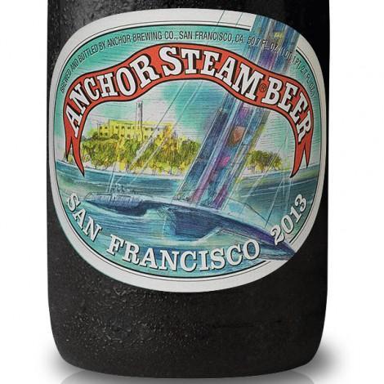

D: Good label. I like the artwork and the commemoration -- useful for seasonal brews
M: Like the label, shape, and layout of the label. Not really the colors of the artwork though

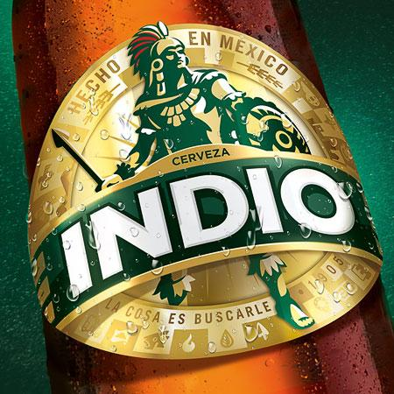
D: the warrior looks cool even though stylized like a woodblock print
M: I agree the warrior looks cool. Like the shape of the label. Don’t like the font.
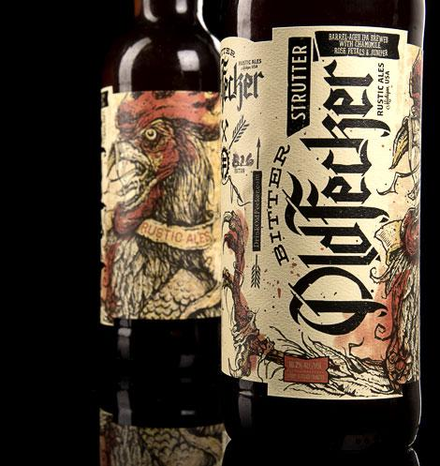
D: Liked the artwork but the font is hard to read.
M: Like the art, font, colors. Wish the shape was more unique
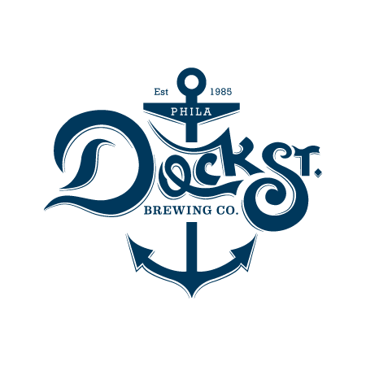
D: A simple logo that could be incorporated in a family of labels
M: Simple but can’t have an anchor because of anchor steam in the area.
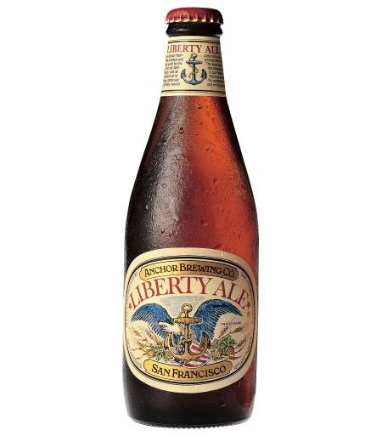
D: Like this a lot. Signature anchor logo captured on neck and in the label
M: Really like the shape and layout of the beer. Has that vintage older look to it that I want to see our labels having.
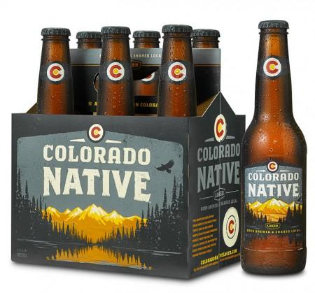
D: Memorable. Logo on neck and labe
M: Don’t particularly care for this other than the color scheme is just ok.
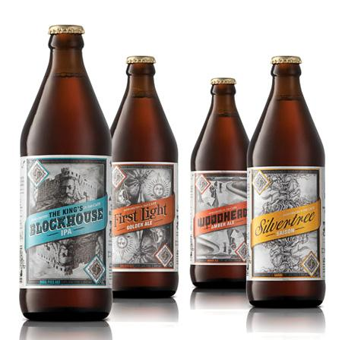
D: Excellent example of a family of logos. We could have the Schooner’s logo be the backdrop for all, with the forefront message identifying the kind of beer.
M: Agree with the above. Would like to see a more interesting shape however.
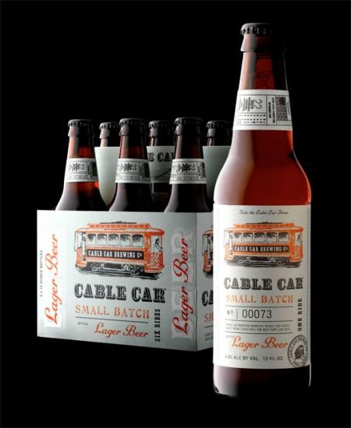
D: Memorable logo with the right level of “old fashioned”
M: Meh
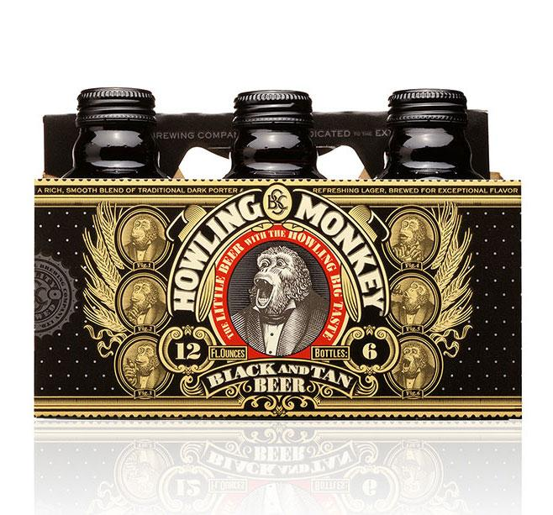
D: Forget the monkey but I liked the design otherwise
M: Like the colors and flexibility this type of label. Could have fun with the random side art.
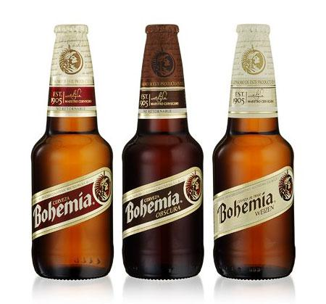
D: another good example of a family with an unconventional angular label
M: Like the distinctive label.
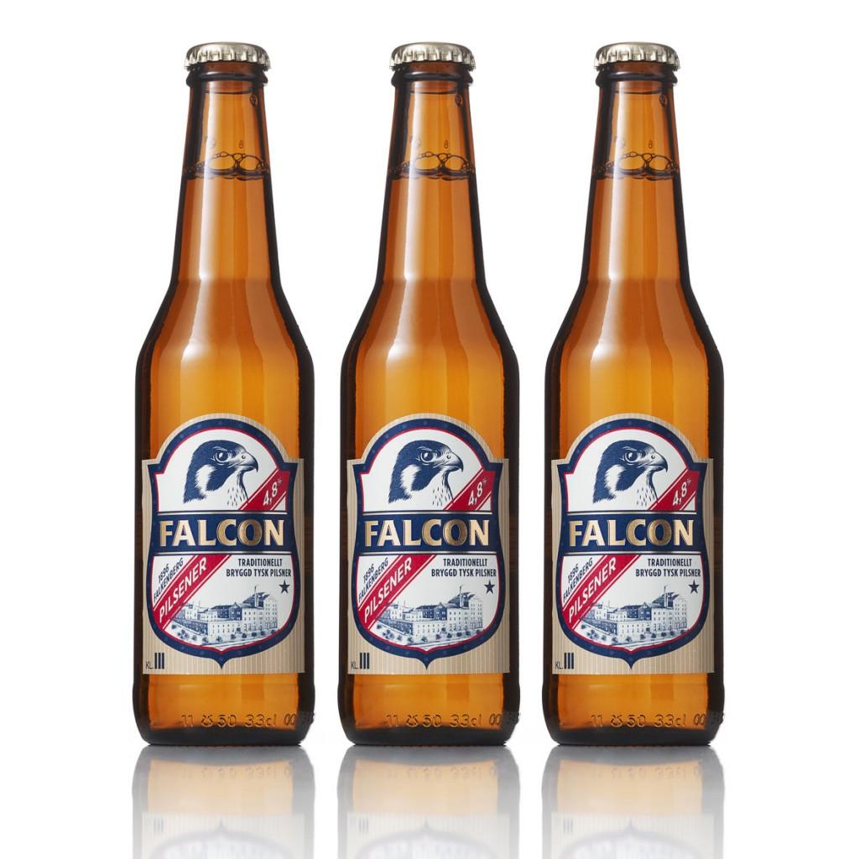
D: Liked the label shape and it had the right amount of “busyness”.
M: Agree with the above but would like older looking font.
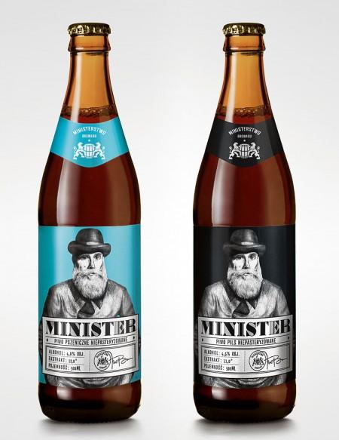

D: Another “family” idea with our Schooner replacing the man?
M: Not a fan
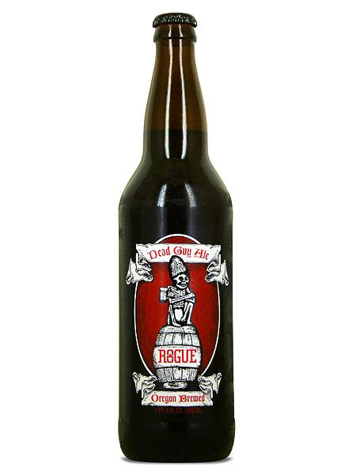

D: Liked the border treatment; not too cluttered; memorable
M: I agree. Has an older look and font to it.
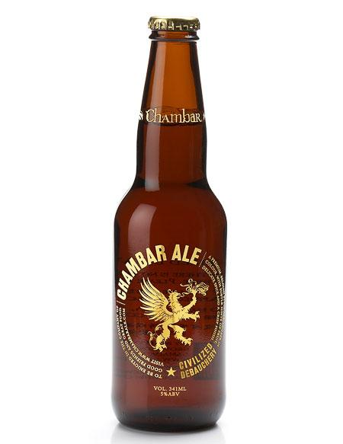

D: Liked the flying dragon in the center. Brewery noted on neck and in the text of the label
M: I really like the logo a lot. Screen printed not a label. Funny writing.
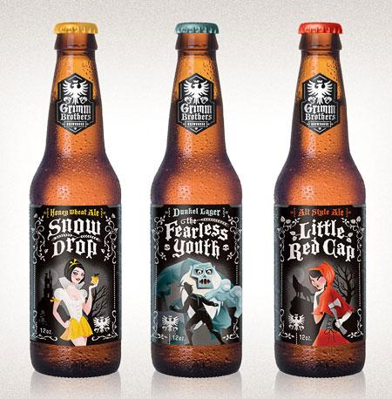

D: Reasonable family; liked the logo but but really don’t like the style of the artwork.
M: Not a fan. Logo is actually incorporated into the mail logo in the bottom corners of the beer.
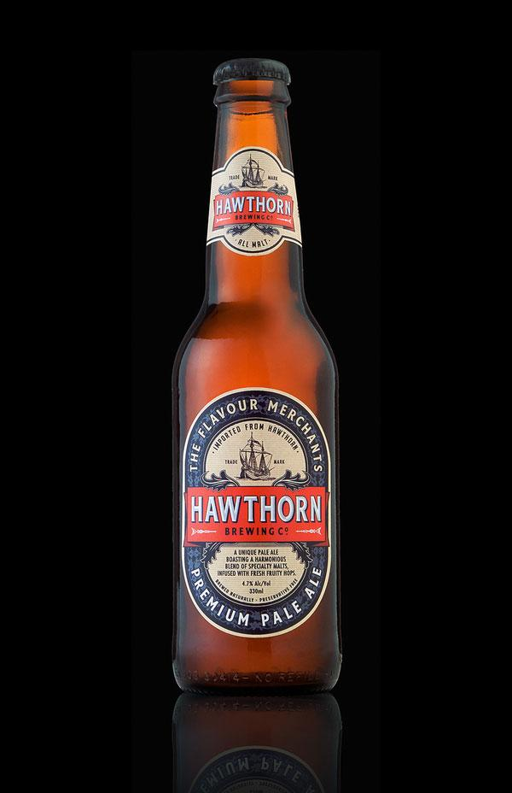

D: Liked most of this -- color scheme, logo in both; not too cluttered. Ship could have been more dramatic
M: One of my favorites. Only thing that I would modify it the font to try and give it an older looking font.
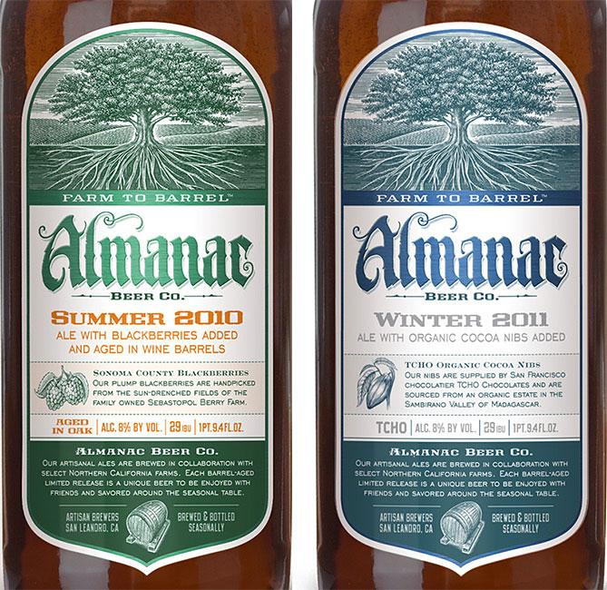

D: Good family. Logo graphic and text on top and bottom. Beer particulars in the middle
M: Good Shape. Simple but effective.
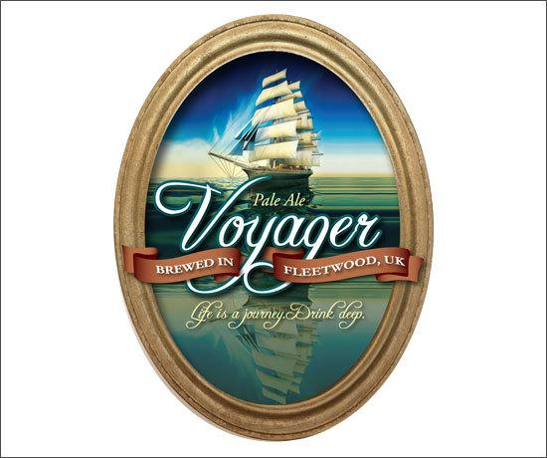

D: Liked the ship even though it’s not a schooner
M: Like the reflection of the ship on the water. Like the ship. Would like a more vintage/older look to the logo and art.

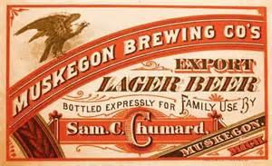

D: Ambivalent
M: Like the style not the colors.

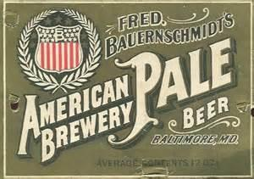

D: Fonts for both of these are too early 1900’s
M: Like the style and font colors. Vintage look

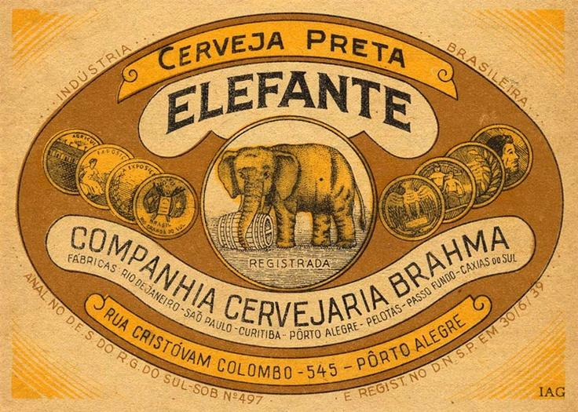

D: Ambivalent
M: Like the vintage look and color scheme

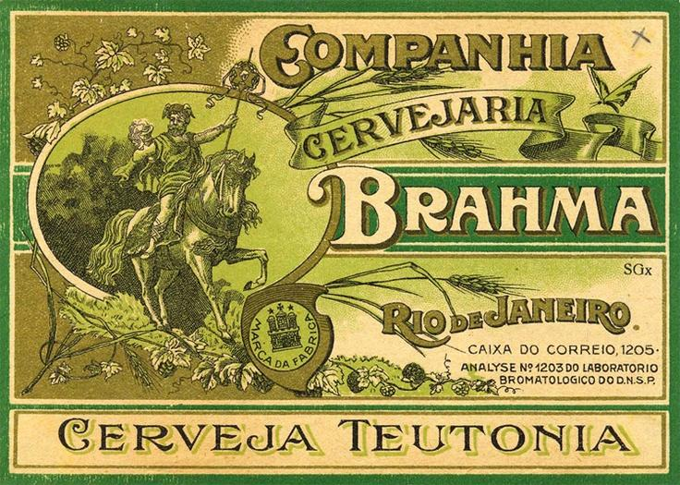

D: Reasonable, but don’t like the shape
M: Like the vintage look. Just the right amount of business. Like the font. Like the layout.

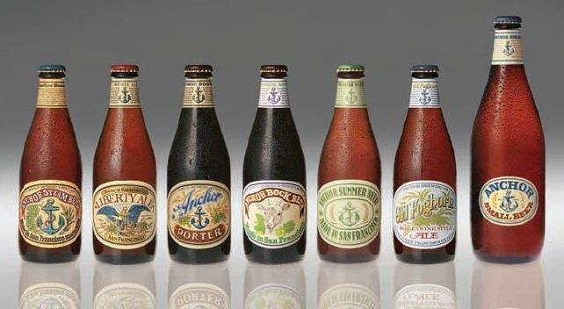

D: One of the best families. Labels need the right balance between consistency, and the ability to differentiate the beers
M: Really like this family of beers. Like the vintage look, logo placement, art, font, color scheme, label shape.

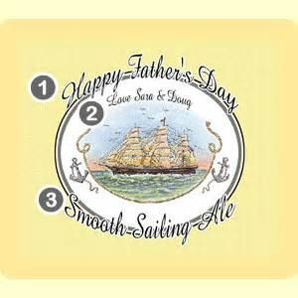

D: Agreed, but would like our Schooner doing something dramatic.
M: Forget the writing, could be a start for a logo.

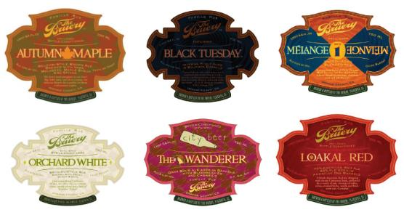

D: Best shape - it defines the brewery as much as the name logo
M: I really like the shapes of these labels. Laid out well. Would like to incorporate some art somehow. Some of my favorite labels though.

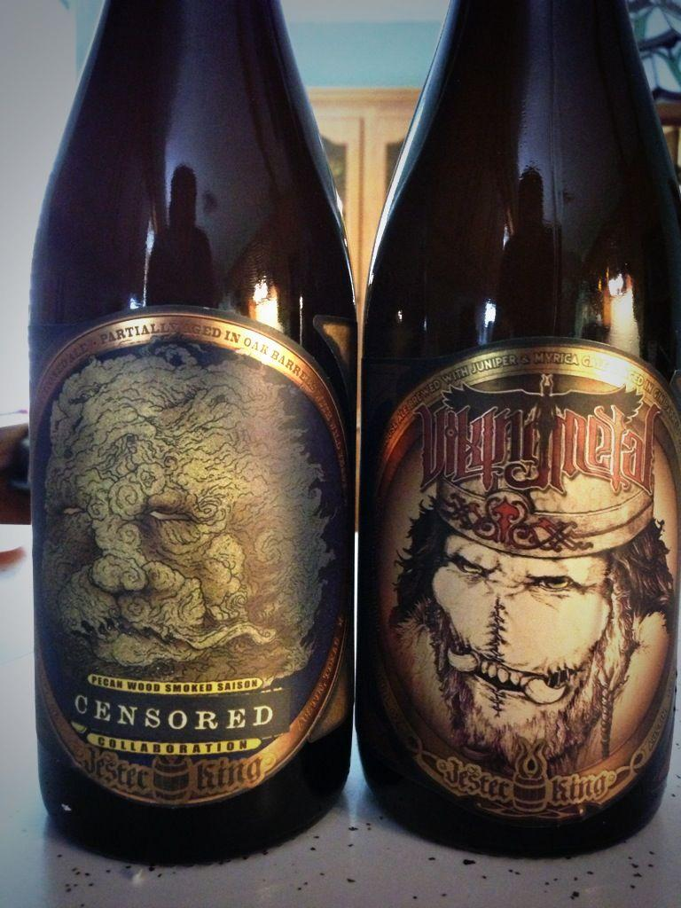

D: There is sort of a consistent look and feel, but it requires pretty extensive artwork for each label.
M: Like the color schemes and the location of the brewery label. I like the writing around the “frame” of the art. Can have some creative fun with what to write in the border.

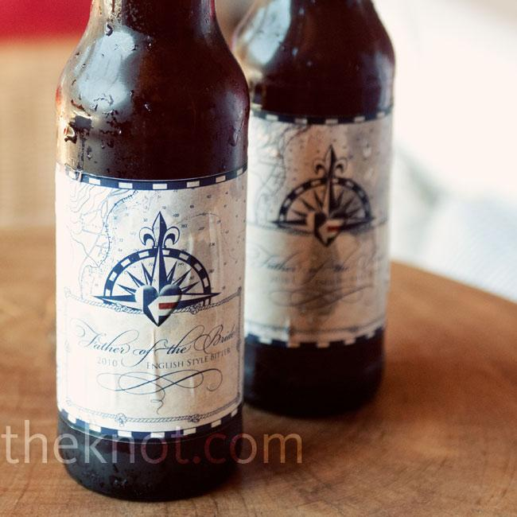

M: Not the best label I’ll admit, but I really like the idea of having a map of some sort in the background. Like the old script font, and havn’t seen a compass incorporated into any labels yet.
D: Agreed. A fancy compass would go nicely with a schooner. In fact, a really cool compass might be an alternative to the ship.

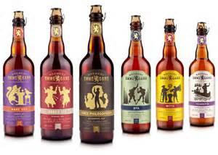

M: Great family of beers with a very flexible label. Just insert new art into the middle. Good shape labels.
D: Agreed. Neck logo is distinctive



M: Like the colors; treasure map type look.
D: Ambivalent, but agree with the idea of a treasure map

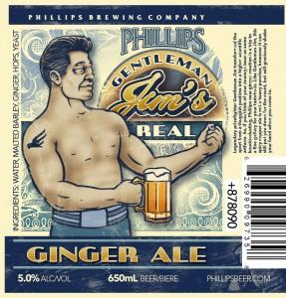

D: Ambivalent
M: Like the color scheme a lot. Just the right amount of business to the label.

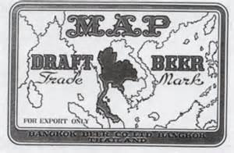

M: OK this label sucks. The only thing I like is the idea of the map being in the background though in this case the map in the background distracts from the overall label type.

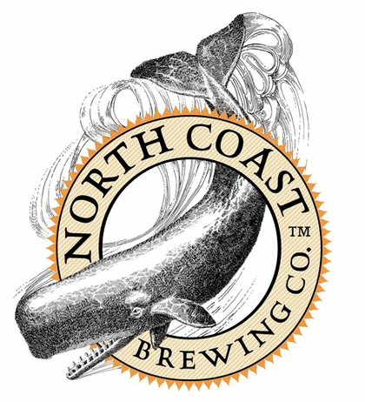

M: Throw a ship in there rather than a Whale? Would change the font to an older looking one.
D: Agreed

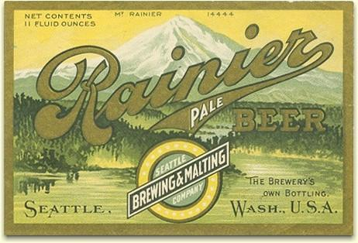

M: Really like the vintage font in the bottom corners and color scheme.
D: Too early 1900’s for me. Should look older, but with more catchy graphics

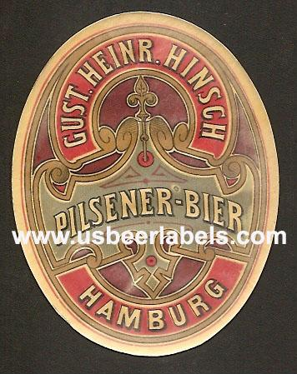

M: I really like this for a logo.Vintage look and color scheme.
D: Agreed

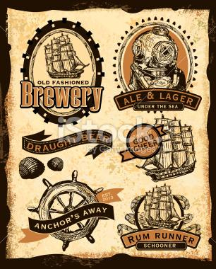

M: Think I want the background to be the same as on here. Just some ideas. Like the ships better that the other things.

