TO GO ON THE FRONT PAGE:
1. LOGO
2. CONTACT DETAILS
Ph: 1300 781 824
Email: info@pillarproperty.com.au
Website: www.pillarproperty.com.au
Facebook https://www.facebook.com/PillarProperty

3. PROMOTION:
“FREE property management for 2 months!”
4. INFORMATION ABOUT US

For over 10 years Chris White and his team have been looking after property investors throughout Sydney. As a Pillar Property client your benefits will include:

REDUCED VACANCY!
OPTIMAL RENT!



REDUCE REPAIRS & MAINTENANCE BILLS!
LEASE YOUR PROPERTY FASTER!

Making a change is easy! We contact your current property manager on your behalf, with no inconvenience to you.
5. CALL TO ACTION
Make the change to Pillar Property Management specialists TODAY on 1300 781 824.

ON THE REVERSE SIDE:
- Logo
- 2 Testimonials (see below)
TESTIMONIALS:
“Chris found the ideal investment property for us. He also coordinated the renovation which provided us with a substantial increase in rent. He now manages all of our properties. Whist we were both working overseas it was imperative that we had someone looking after our properties that we could trust.”
Peter and Ann Hutchins

“Chris has been providing us with advice and guidance on our property portfolio since 2006. The team at Pillar Property do a lot more than collect rent and manage tenants. They have helped us increase the value of our properties through coordination of renovations, maximising the rent and reducing the repairs and maintenance costs.”
Antonis Family Super Fund
- 2 case Studies (see below)
CASE STUDIES:
OUR EXPERIENCE REDUCES CLIENTS PLUMBING BILL BY 50% - Marayong
We managed to reduce the clients plumbing bill by $800 by coordinating an excavator to unearth a problem pipe. This solution was both time and cost effective.
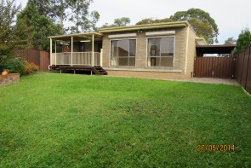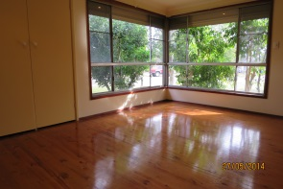
SMART CHANGES TO A UNIT INCREASE ITS RENTABILITY - Bondi
A smart solution to a water heating issue and minor renovations to the kitchen, see a Bondi unit leased in low season faster than comparable units on the rental market.
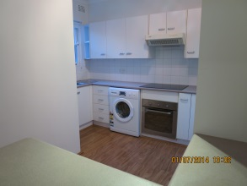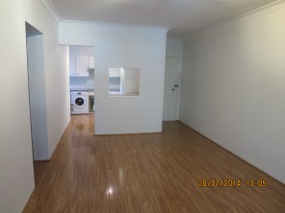

- About Us


Chris White is Pillar Property’s director. He is a respected industry professional with 25 years’ experience in Property and Finance. Chris draws on his experience in property inspections and purchases as well as building and construction and finance to help his clients save money and time.

- Call to action
Call us today to take advantage of our limited special offer on 1300 781 824!

- Uploaded image of Sydney
(same as website –www.pillarproperty.com.au)

- Contact details as on front page.

