TABS Training Website (Jigsaw) brief

11 pages

- Home – (Jigsaw template)
- Learn more
- About
- Free Initial Consult
- Clients
- Contact
- Blog

Centre Jigsaw page links

- Set up (links to “Training” + “Initial Consult”))
- Training - incorporate Booking function – Book Bug (links to “Initial Consult”)
- Support (links to “Initial Consult”)
- Bookkeeping (links to “Initial Consult”)

Home

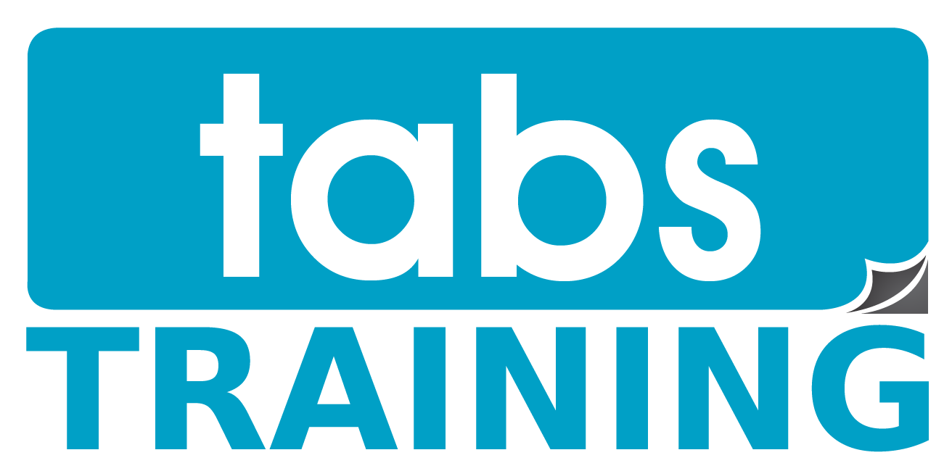

Home, About, Learn More, Initial Consult, Clients Contact, Blog
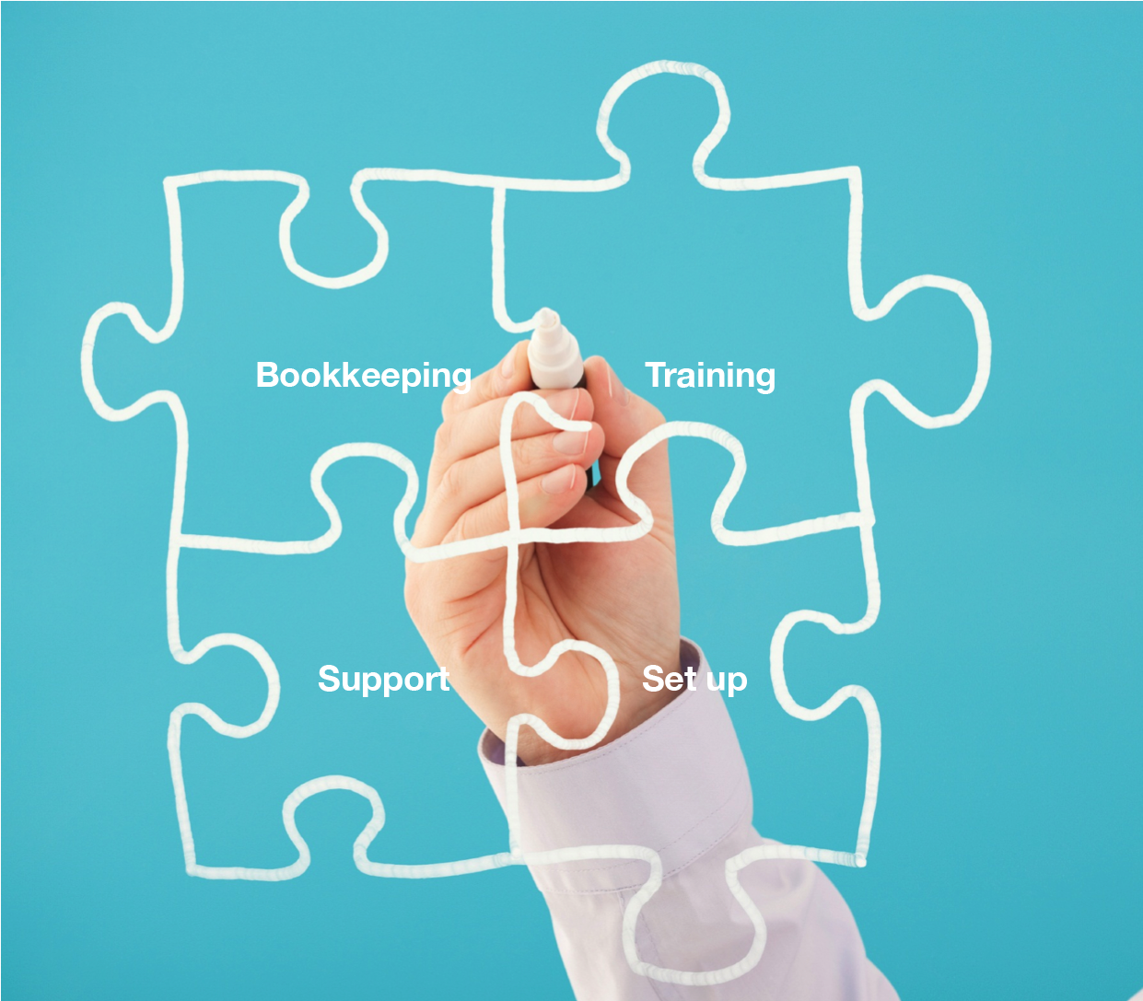

Unleash the power of Xero in your business

Learn More

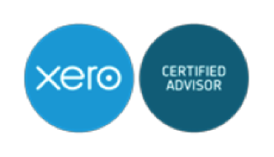

Jigsaws link to pages:
Bookkeeping, Training, Support, Set-up.

(Page 2) Learn More

TABS is an Certified Xero Advisor and accredited Gold Partner.
Bring your existing system across to Xero with TABS and experience:

- The Single Ledger – Your file is stored in the cloud, accessible to your team, bookkeeper and accountant, anywhere online.

- The Dashboard – Instantly view bank balances, recent sales & upcoming bills.

- Effortless Bank Reconciliation – Bank feeds automatically import and categorise your latest banking, credit card and PayPal transactions - Just click OK to reconcile.

- Instant Reports - Clear, concise real-time reporting; Budgets, Payroll, Assets, Expenses, Accounts Receivable – all with quick links to original transactions.

- Connection with your customers – create and send professional invoices, get paid online.

- Mobility – An iPhone and an Android app for business on the go.

- A clean desk – Attach source documents to transactions so all your information is in one place.

(Link to About Us)

(Page 3) About Us

Every business, from sole trader to multi-national, has hopes and dreams – they also have families and communities behind them. TABS is part of your extended family, committed to providing you with the support and guidance to make your business goals a reality.

TABS gets you started, helps you develop and delivers solutions as you grow.
With 20 years experience, we provide a range of comprehensive services from Xero setup, training, bookkeeping and ongoing support.

More than just Bookkeepers!

TABS started out as Radinoff Drew & Associates in 1997 with Cindy Drew providing quality bookkeeping services to small businesses in the Sydney Metro area.

Following repeated requests for Cindy to “clone” herself, Cindy embarked on the task of finding other professionals who were as passionate about bookkeeping and exceptional service.

As the business grew, requests for expanded services created the need for a name change, thus Training and Business Services Pty Ltd evolved.

TABS is now a team of professionals all contributing unique skills and experience to the group.

And yes, we still have the first client we started with in 1997!

Our Team

Cindy Drew
Founder of TABS

Qualifications
- Xero Accredited
- Bachelor of Education
- Graduate Diploma in Information Science
- Diploma of Teaching
- Certificate IV in Financial Services (Bookkeeping)
- Lecturer in Accounting Software at the University of Sydney Education Centre since 2004.

Memberships
- Institute of Certified Bookkeepers
- Australian Bookkeepers Network
- Bookkeeping Institute of Australia
- Association of Accounting Technicians

Carissa Pritchard
Operations Manager

“ I love Xero because I’m not a huge fan of bookkeeping; Xero is so simple and easy to use. Plus it’s really beautiful; I feel like I’m having fun, even when I’m invoicing!
In my previous position Cindy handled, juggled and made sense of incredibly complex transactions, accounts, intercompany loans and receipts. She always did it all with a smile, perfection and professionalism. I loved working with her so much I joined the company.”

Qualifications
- 15 years experience in Business Development and Operations
- Professional writer, specialising in online writing and Blogging
- Master of Arts (Current)
- Bachelor of Arts

Joseph Zhou
Senior Account Manager

Qualifications
- CPA
- Masters of Professional Accounting and International Business
- Bachelor of Financial Management

Membership
- CPA Australia

“I like working at TABS because I’d hate to be an old-school bookkeeper. My boss is the friendliest I’ve ever had in my career. I love the office atmosphere because we work together as a family. Last, but not least, I can contribute so much to TABS’ clients and help them operate their business.

Blake Radinoff
Office Management & International Client Support

Qualifications
- Certificate IV Bookkeeping

“My job is to support the staff so they can concentrate on providing high level service to our customers”.

(Page 4) Free Initial Consultation

Would you like to transform your business with the complete Xero solution?

Whether you’re an established company wanting to take your business further or just starting out, TABS is here to help.

TABS offers a free 30-minute strategy session to understand your business issues, identify solutions and create strategies for success.

To begin, call us on (02) 8014 2030 or
Email: books@tabs.com.au

(Page 5) Clients

We help an incredibly interesting and diverse range of businesses. We’d love to join your team.

Anything Themeing

If you can imagine it, we can create it.

http://www.anythingthemeing.com.au

Fostered

FOSTERED is a new way of doing things, of strategising an individual’s success by embracing a new era of business. FOSTERED nurtures the collaborative efforts of like-minded individuals, road-mapping an achievable path to overcome the challenges preventing them from reaching their full potential.

http://www.fostered.com.au

Kontented

KONTENTED is a content strategy, creation and development business. That means we dream up, create and produce Australia’s best content and TVC production. Above all, we’re story tellers.

http://www.kontented.com

Integrity Cosmetics

Integrity Cosmetics was born out of a desire to create a company with products that bring healing and restoration to all people without using dangerous unnatural ingredients.

http://www.integritycosmetics.com.au

(Page 6)
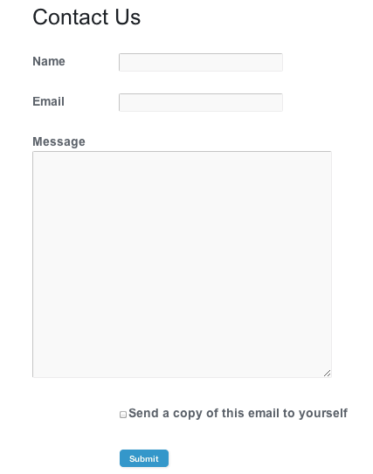

TABS is based in Sydney, Australia.

Contact us anytime Monday to Friday during business hours (8.30 am – 5.30 pm) at the following:

Phone: 02 8014 2030

Email: books@tabs.com.au

Address: Corner of Penrose Street & Johnson Lane, Level 1, 47a Penrose Street, Lane Cove West NSW 2066

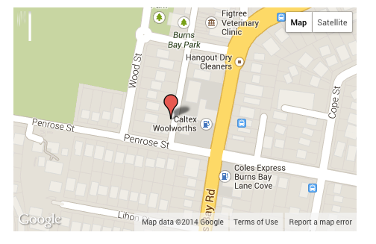

(Page 7) Blog

Making the Most of Xero
(More text to come)

(page 8) Set up
Incorrect account set up leads to inaccurate reports and hours of frustration. Tabs Xero experts ensure accurate, efficient set-up from day one with a system flexible enough to grow with you.

Choose a package, let TABS do the rest.

Basic | Standard | The Works
- Imported Accounts list  - Imported Contacts list  - Established bank feeds  - Account opening balances  $495 | Basic +  - Customised accounts list maximising Xero reporting capabilities  - Imported Accounts Receivable and Payable transactions  - Payroll setup to 5 employees  $695 | Basic + Standard +  - Conversion of all transactions from MYOB to Xero from start of current financial year  - Payroll setup to 10 employees  $1,495

Call us for your Free Initial Consultation (link)

(page 9) Training


TABS founder, Cindy Drew, is a Certified Xero Consultant with 10 years Experience as a Lecturer in Accounting Software at Sydney University.

TABS provides:
- Small class sizes - limited to six
- Practical, hands-on classes
- A computer for every student
- Discounts for booking two or more classes
- Take home copy of training manual and exercise files
- Certificate of Completion
- Morning and afternoon tea

Basic | Standard | Advanced | Payroll
- Navigate Xero  - Reconcile your bank accounts and credit cards  - Create and manage bank rules  - Cash coding; the good, the bad, and the ugly  - Financial reporting  - BAS reporting  - Maintain your file  ½ Day  $275 | Basic Training +  - Create customer and supplier cards  - Set up sale items  - Enter invoices and credit notes  - Create invoicing templates and recurring sales  - Reconcile payments received and made  - Issuing statements  1 Day  $495 | Looking to take your knowledge to the next level? Learn skills to maximise your Xero usage: Create mail merge letters to maximise your sales, export to excel or create your own powerful reports. Your potential is unlimited.  1 Day  $495 | - Understand Legislation and awards  - Set up payroll categories  - Enter Employee details  - Manage Employee portal  - Manage Leave entitlements  - BAS/IAS Reporting  - Report Superannuation liabilities  - Correct errors, enter adjustments  - Prepare annual PAYG Summaries  ½ Day  $275

Customised on site training
Why not let one of our instructors deliver training at your premises?

A popular option with accounting firms who wish to customise course content and minimise staff down time.

Please call 02 8014 2030 or email us for a quotation.

Insert:
Photos of training room
Map

(page 10) Support
Get ongoing support to maximise your TABS Xero set up.

Checking, Reporting and BAS | Basic Bookkeeping | Consulting
- Check reconciliation of your expenses and account  - Check Employee management  - Monthly reporting conclusions (Budget to actuals Monthly Profit and Loss YTD report )  - Monthly BAS Running Estimate  - Two Help desk chats (10 min each)  - Quarterly Lodgement of BAS / IAS  From $350 | - Reconcile and allocate bank account and credit card expenses  - Manage Employees  - Manage Accounts Receivable  - Manage Accounts Payable  - Analysis of Monthly reports  - Quarterly Lodgement of BAS / IAS  - Four Help desk chats (10 min each)  From $550 | - With 20 years experience we can review your reports,  offer suggestions and develop strategies to maximise your business efficiency, cash flow and growth.  $160.00 per hour

(page 11) Bookkeeping
Customise your bookkeeping services by choosing any or all of the services we provide:

Creditors
- Raise and transmit purchase orders
- Reconcile delivery dockets to purchase orders
- Maintain Creditors Ledger and reconcile to General Ledger
- Reconcile bills to supplier statements and deal with discrepancies
- Upload creditor payments to online banking system upon authorisation of payment
- Preparation of cheque payments as required
- Reconciliation of Cabcharge dockets to statement

Banking
- Enter direct deposits, efts and other payments
- Reconcile bank account(s) weekly/fortnightly/monthly
- Reconcile credit card account(s) weekly/fortnightly/monthly
- Reconcile loan account(s) weekly/fortnightly/monthly
- Reconciliation of clearing accounts
- Maintain a petty cash system and reconcile monthly
- Reconcile merchant receipts to statements

Administrative
- Establish and maintain a filing system for source documents
- Establish and maintain an insurance register
- Establish and maintain an asset register

Debtors
- Reconciliation to external debtor’s system
- Reconcile timesheets to billing
- Generate and transmit invoices
- Review outstanding debtors weekly/fortnightly/monthly
- Send statements weekly/fortnightly/monthly
- Follow debt collection policy

Reporting
- Profit and Loss
- Balance Sheet
- Job Profit & Loss
- Cash Flow projection
- Budget to actual report
- Debtors reconciliation
- Creditors reconciliation
- Inventory reconciliation
- WIP reporting monthly/annually
- Track and report to accountants for FBT
- Prepare reports for Workers’ Compensation

Payroll
- Enter timesheets weekly/fortnightly/monthly
- Process payroll weekly/fortnightly/monthly
- Upload wage payments to online banking system
- Email/Print pay advices
- Reconcile payroll expenses and liabilities to General Ledger
- Maintain entitlement register
- Report and prepare payments for Superannuation liability monthly/quarterly
- Report for Payroll Tax monthly and reconcile for Annual Return
- Report PAYGW monthly/quarterly
- Preparation of annual PAYG Withholding Statement and Summaries
- Provision of Fair Work Statement to new employees

Book your Free Initial Consultation (link) to discuss the services your business needs.

