


Lakes Security
Complete Security Management

www.Lakessecurity.com.au
Contact us: 08 6399 8550



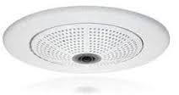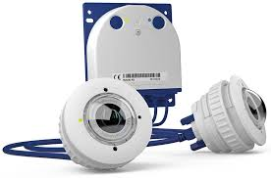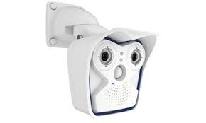

Unit 2, 1 Pusey Road
Cockburn Central, 6164
Phone: 08 6399 8550
info@lakessecurity.com.au
www.lakessecurity.com.au
Top of Form

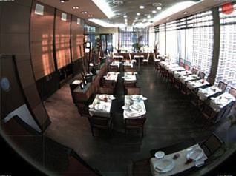

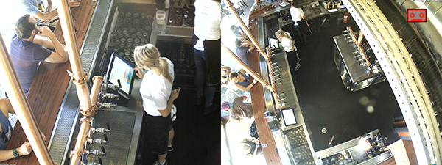

“When one of our clients need an IT overhaul, we call Lakes…”
Pat Higgins - Foundations
“Lakes simply provides the best service”
Reno – Maddington Concrete
“Lakes came along and now everything works as it should”
Shaun – My Place

www.lakessecurity.com.au
Why Mobotix
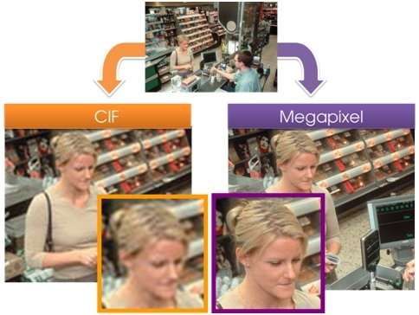
CIF Analogue vs 5 Megapixel
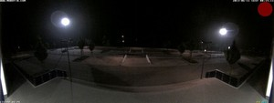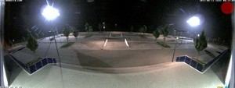
CIF Analogue 5 Megapixel

The German company Mobotix is known as the leading pioneer in network camera technology and its decentralised concept.
Fewer cameras! Due to the more accurate detail of wide angle images with megapixel technology, one Mobotix camera can provide the same level of coverage as multiple cameras.
Mobotix cameras have the ability to alert you 24/7 of suspicious activity, giving you the ability to engage intruders on your property via 2 way communication. The cameras can also be configured to activate pre-recorded messages, sirens, strobes and other devices, alerting intruders to the fact they are being monitored.
These alerts can be triggered automatically by the camera or via the click of a button on your iPad/tablet or smartphone, allowing you to protect your property from anywhere in the world.
www.lakessecurity.com.au

Why you Need CCTV
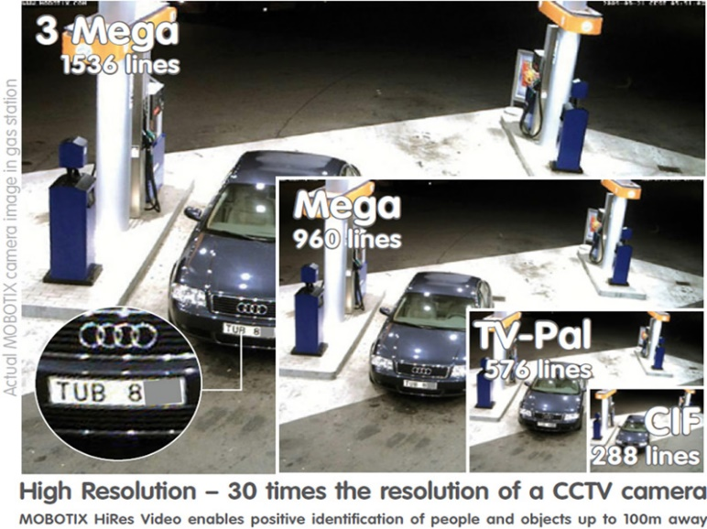
CCTV has become an affordable investment in preventing crime and enhancing public safety. It gives businesses the peace of mind that their valuable property is protected 24 hours a day tangible, visual evidence accessible at the touch of a button.
Business benefits of having a high resolution CCTV system solution
- Loss prevention
- Enhancement of employee safety and security
- Improving business performance & employee productivity
- Regulatory compliance
- Stock & inventory levels
- Customer traffic pattern
Benefits of using a Hi Resolution camera?The higher the resolution, the more accurate the detail in the image when zooming in to analyse the data. A single Mobotix camera with 3.1 megapixels records around 30 times more detail. Larger image areas with up to 360° panoramic views are possible, thus reducing the number of cameras and therefore the costs.
www.Lakessecurity.com.au

Top of Form

What We Do
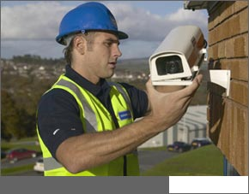

Moving away from the traditional CCTV, Lakes embrace the Decentralised approach of Mobotix cameras and is an Advanced Mobotix Partner

Lakes specialise in complete security management for businesses of all sizes. Lakes will work out the best solution for your new system so you can see the full benefits involved.

By incorporating both Mobotix CCTV and Inner Range Intergiti systems, Lakes can design complete turnkey solutions. By giving users one single interface to control CCTV footage and intruder detection, Lakes removes many of the headaches involved in running multiple solutions.

www.lakessecurity.com.au

