Qualex Financial Practice

One of the most challenging tasks for the financial analyst is to provide and interpret technical information to management that is relevant to the operational needs of the organization. Getting your financial analysis with up to date data when it is needed is crucial for an organization’s success. Having software tools that provide a real time solutions is a huge advantage for the highly competitive Financial Industry.
Qualex can help you keep your financial information organized, accessible and up to date so you can have your data deployed to business users for more efficient and effective management of their responsibilities.
Some of our clients include:
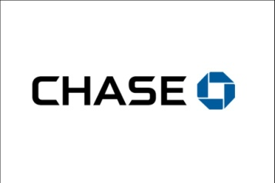
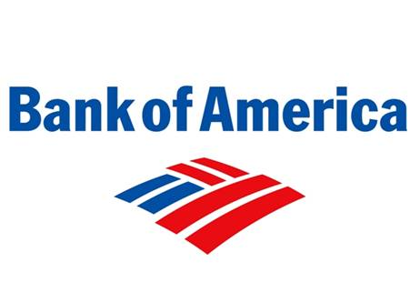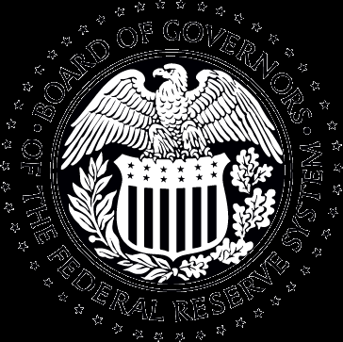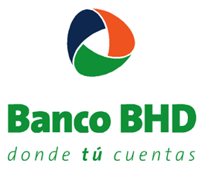

Qualex provides extensive services to the Financial Industry, including:

- Offering application software development and maintenance in support of critical data and Grid system. Qualex’s knowledge of SAS intelligence helped move data to a more rapid workflow allowing for additional process to be more effective.
- Providing SAS Migration from 9.2 to 9.3 and 9.4 versions, including preparation, deployment, execution, validation, rollout and training to SAS business and technical end-users.
- Providing analytical insights to enable the business to continually drive growth through the company’s mobile applications and website, including hand held devices for banking online.
- Offering full banking CRM solutions, which include payment risk, cross-sell, up-sell and risk management models.

Qualex Solutions Include: iQ-Support™

Qualex iQ-Support™ is an internet-based solution for organizations that, after implementing software solutions, need additional support to maintain their operational systems. Qualex offers bundles of consulting hours from its specialized consultants for Data Integration, Data Warehousing Construction, Business Intelligence Reporting and Sophisticated Analysis. All these services are provided at a low cost, with high quality and maximum accessibility.

The solution provides:

- Installation and re-installation of software.
- Updates for new versions of the software.
- Corrections to the use of the software.
- Modifications to reports.
- Assessment of reporting options.
- Adjustment of systems to local law needs.
- Support via telephone at the level required by the customer.
- IT support for software integration.
- Training to support staff.
- Administrative assistance in the creation or elimination of users.
- Assistance in the use of software.
- Assistance in writing basic software code.
- Assistance in the use of reports.
- Assistance to solve technical problems in multi-tiered environments.
- Assistance in the maintenance of stored processes.
- Support to your business users.

Service Level Agreement and Commitment

Once an issue concerning the use of software is reported, Qualex agrees to assign a resource to verify and investigate the issue. In critical issues (High), this resource will be assigned within specific pre-determine business hours and for regular issues (Low and Medium), the resource will be assigned within one business day and provide immediate resolution.

