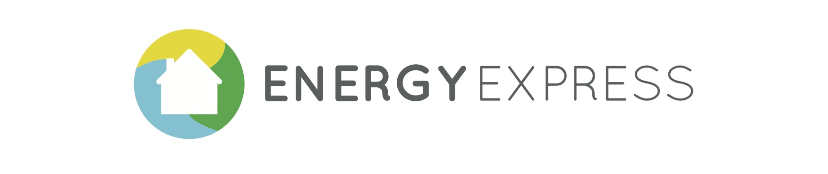
Image Commissioned to Design Crowd (Image related to the Project and explaining that this Site is Under Construction or that we are coming soon)

The Energy Express Service:

We all want to save energy, but we don’t really know where to start. My home is a place I truly value, it is different from other homes (because it is mine) and the energy saving choices are not always easy to understand.

What is Energy Express? Energy Express is a unique service which consists of helping people understand better the energy saving options available to their particular homes and aims to provide them with a set of low cost, quick and easy to install measures for start saving energy in domestic properties right away.

The Service: which we call 2 by 2, is the visit of two highly trained energy efficiency technicians who, will put in place in your home in two hours a set of measures and interventions for improving its energy efficiency. The technicians are very knowledgeable about the use of the technology and will be able to fit devices in your home quickly and hassle free, since they are very familiar with the technology itself and used to work in different household environments. As part of this visit, our technicians will also make recommendations in terms of adjustments to yours and your family’s use of energy, in order to become a more energy efficient household.

The Technology: During the visit you will be offered the possibility of installing a number of useful energy saving devices in your home, such as low consumption light bulbs, thermostatic radiator valves, reflecting back-films for improving the efficiency of your radiators, draught excluders for doors and windows, among others. Energy monitors are also part of the packages we offer and they could be instrumental for helping you understand where your money goes. Because technology evolves continuously, Energy Express researches the best possible technology available in the market for increasing the efficiency of lighting, heating and water usage in domestic environments. Energy Express also relies on information obtained from reputable bodies such as Which, Energy Savings Trust, etc.

If you think you might be interested in learning more about this project when it gets launched, please sign up with the following form, so we can send you relevant information about it:

Name
Last Name
E-Mail:
Address:
Post Code:
Privacy policy
Energy Express is a Reflex Marine Initiative (www.reflexmarine.com/energy-express)

Contact Details: Reflex Marine – Energy Express, The Mill House, Redcliff Backs, Bristol, BS1 6LY.
E-mail: info@energy-express.com Tel:

Reflex Marine Registered Address: 12-16 Albyn Place, Aberdeen AB10 1PS

