Want help in supporting kids and teens in tough times?
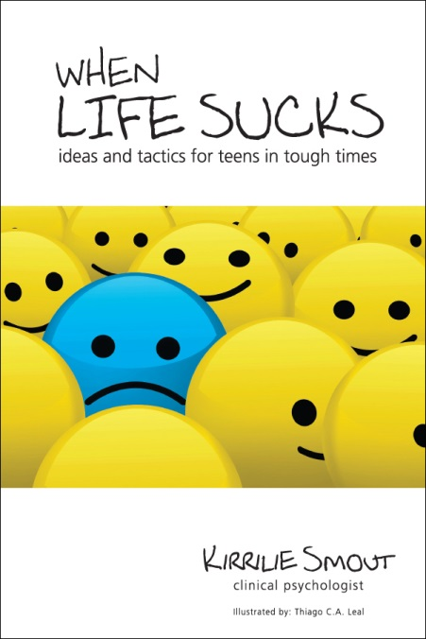
WHEN LIFE SUCKS: IDEAS AND TACTICS FOR TEENS IN TOUGH TIMES is a primer for Australian teens facing life challenges. Inside are the most common “life sucks” scenarios including “My boy/girlfriend cheated on me”, “I can’t motivate myself to do any homework”, “I drank too much last night”, “I feel really down and I don’t know why” and 30 more. For each scenario there is a real life story, ideas about what TO do, what NOT to do and things to tell yourself. This is the perfect book for teens to have on hand throughout adolescence and helpful for parents, teachers and those who work with teens who don’t always know what to say. Available as an ebook or hard copy from www.developingminds.net.au
P.S. I’ve made this book as an ebook available for FREE for teenagers who can’t afford it.

Get free articles, research summaries and ideas about working with kids and young people in tough times straight to your inbox. Written once a fortnight by Kirrilie Smout, clinical psychologist who has worked with young people for the last 20 years. Past topics include: In Defence of Helicopter Parenting, What You Must ask Teens about Sexting, Teens with Strong Emotions, “Mum: Why do Teachers Hate Boys”, The Four Lessons Teens learn in Tough Times and many, many more.
These emails are gold! Thanks for sharing your wisdom" Julie Sampson, Cornerstone College
Go to www.developingminds.net.au to sign up today – and get two free reports about how to effectively praise kids and how to help teens in senior school.

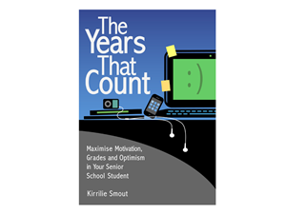 Are you concerned about a teen in senior school? Worried about their stress level? Their sleep? How much time they spend on facebook/gaming? Their “last minute” approach to homework? Having talked to and worked with thousands of Australian teens in schools over the last 15 years, Clinical Psychologist, Kirrilie Smout has written this book for parents, teachers and caregivers to help them know how to motivate and support teenagers in Years 10, 11 and 12. It includes help and real life stories on: communicating with quiet teens, reducing conflict, parties schoolies, drugs and alcohol, stress and helping teens motivate themselves. More importantly: there are cartoons! Available via ebook or in hard copy from www.developingminds.net.au

For a daily tip, quote or idea about supporting kids and teens – like Developing Minds Psychology on facebook.



