Infograph Data & Sources:

BLUE STREET DATA:

10: Number of years Blue Street Capital has been in the business of helping companies succeed.

77 years: Number of combined years of industry experience of Blue Street Capital staff
______________________________________________________________________

ELFA DATA:

Link to ELFAs Infograph

$1.5 trillion: U.S. businesses, nonprofits and government agencies will spend in excess of $1.5 trillion in capital goods or fixed business investment (including software) in 2014, an all-time high, financing more than half of those assets at 57% (ELFA)

57%: projected 2014 percent of overall equipment investment in loans, leases and lines of credit.

55%: percent in 2013 of overall equipment investment in loans, leases and lines of credit.

$827 billion, Equipment Finance industry as a whole for 2014(ELFA)

72% or 7 in 10 businesses in the US use some form of financing when acquiring equipment, includes loans, leases and lines of credit (ELFA)

99.7% of all employer firms in the US are small businesses (ELFA)

Link to ELFA IT / Computer Sector Fact Sheet

Lisa’s Calculations based on Graph 2 :
28%: 2012 percent of $100M new business volume in the IT sector (ELFA)
36%: 2011 percent of $87M new business volume in the IT sector (ELFA)

#s from ELFA Fact Sheet:
26.4%: Overall, computer equipment represented 26.4% of equipment financing new business volume reported by ELFA member companies, up from 23.2% in 2011.

Big Data analytics, CRM, security, cloud and mobility remain areas with the best potential
for above average IT investment in the near-to-medium term.
_____________________________________________________________________

LEASE FOUNDATION DATA: (link)

49%: Companies with less than $1 million in revenues used financing in only 49% of their equipment acquisitions

86%: companies with revenues between $25 million and $100 million used financing in 86% of their acquisitions.

Declined: The share of cash payments declined for large companies from 2007 to 2012, according to Foundation surveys, as larger companies have enjoyed greater access to credit markets. In the current low interest rate environment, financing equipment acquisitions is especially attractive.

Doubled: Companies with sales between $25 million and $100 million doubled their share of leasing volume from 2006 to 2011. Companies with less than 51 employees also doubled their share equipment acquisition via leasing in this time period.
Link to U.S. Equipment Finance Market Study 2012-2013 Fact Sheet

$36B: In 2014, the equipment finance market size is projected to grow by $36 billion to $778 billion

3: The three biggest equipment categories that large companies finance are communication equipment, computer equipment, and software, which together accounted for nearly 65% of the large companies’ total financing volume in 2011.

Link to Annual 2014 Equipment Leasing & Finance U.S. Economic Outlook

3%: The U.S. economy is expected to grow 3.0% in 2014, the fastest pace since the 2008-09 recession

______________________________________________________________________

PAYNET DATA:

Link to Paynet Small Business Lending Index graph (Graph 1)

1.44%: A measure of accounts overdue as a percentage of all loans hit a high of 4.73 percent in August 2009. The record low was 1.44 percent last October. (Paynet)

184%: Paynet small business lending index value 12/13 at 121.6 versus all-time low of 66 in 5/09.

______________________________________________________________________

Competitors:

Supposedly from the SBA:
85% of all companies lease equipment
89% of those companies will lease equipment again in the future
75% of all companies that lease indicate that leasing is their average-to-best means for financing equipment purchases

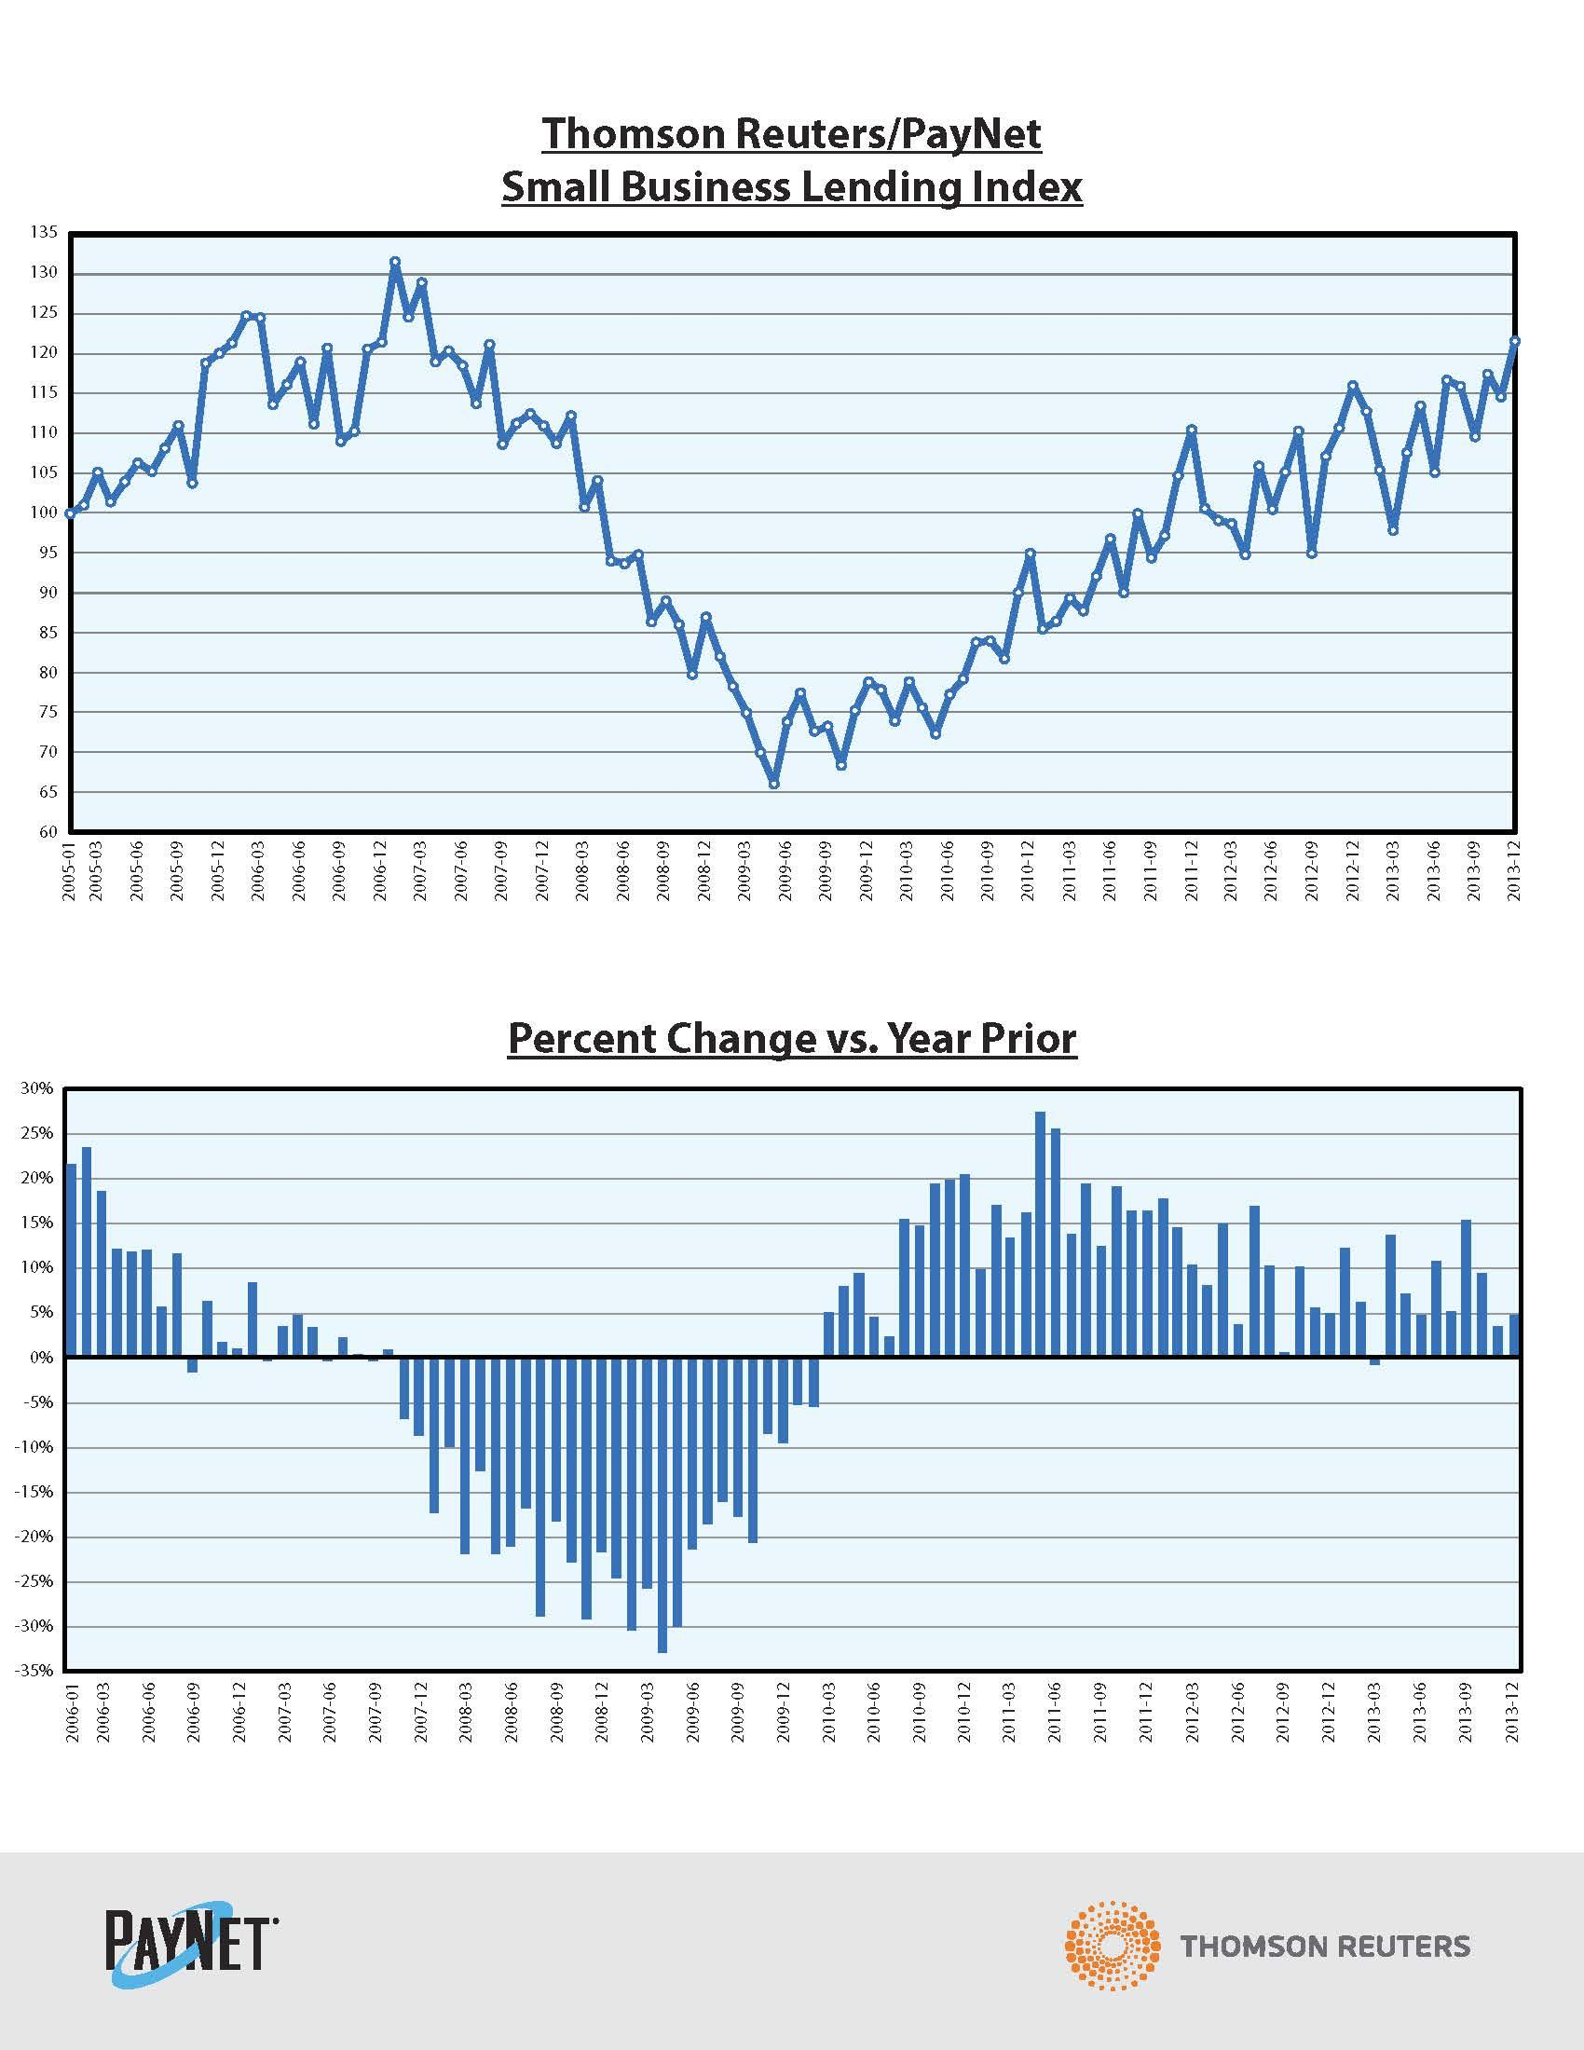
Graph 1

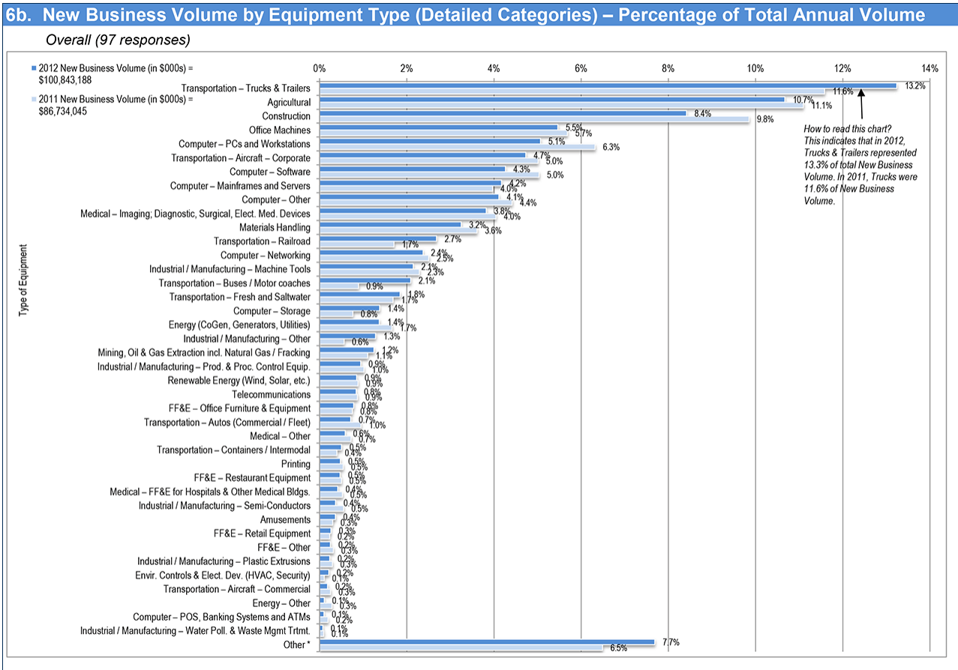
Graph 2

