Basic Beauty
From Home
MAKEUP

Manicures & Pedicures Waxing & Tinting
Shellac Manicure…………. $30 Eyebrow Wax…….…. $10
Cut, shape, cuticles & Shellac
Deluxe Manicure………. $40 Eyebrow Tint……….... $10
Soak, exfoliate, cut, shape, cuticles
& polish or add shellac for $10’ Eyelash Tint……….…...$10
Paraffin Manicure………. $45
Soak, exfoliate, paraffin treatment, Lip Wax…………………. $10
Cut, shape, cuticles
& polish or add shellac for $5’ Chin Wax……………… $10
Shellac Pedicure…………$30
Cut, shape, cuticles & Shellac Underarm………………$15
Deluxe Pedicure…………$40
Soak, exfoliate, cut, shape, cuticles
& polish or add shellac for $10’
Paraffin Pedicure………. $45
Soak, exfoliate, paraffin treatment, cut, shape, cuticles
& polish or add shellac for $5’

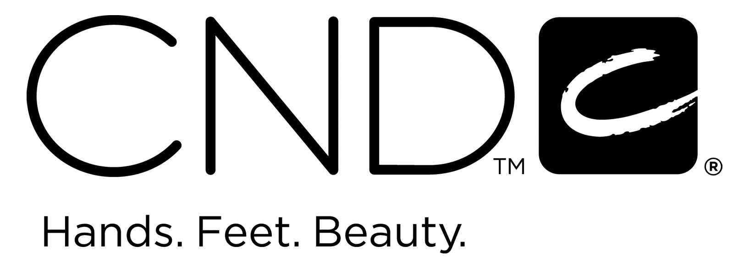

Tanning
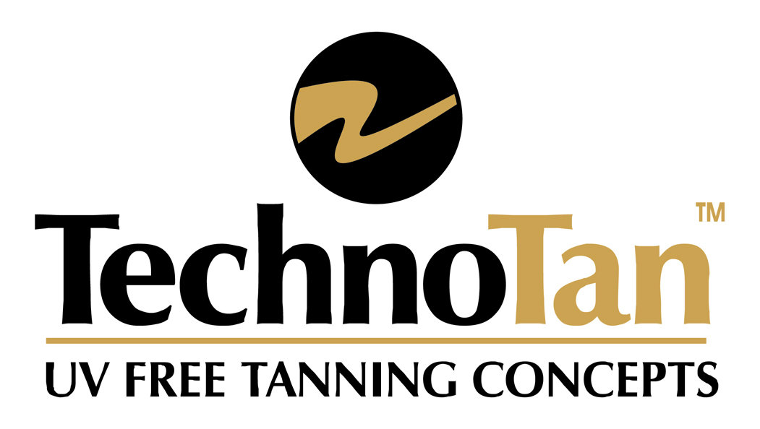

The very popular “2 Hour TECHNO TAN “in all ranges is now available for $25.00!

Check out my social media pages...
Basic Beauty Gold Coast  basicbeautygoldcoast

