Briefing LOGO

We are a technology company that does migration software, over the time we have developed a few products – each having their own logo. Now as we bring on more product – we run into the issues that we need “coordinate” the logos as they are part of a family.
The product are currently
- Archive Shuttle
- PST Flightdeck
- Mailbox Shuttle
- EV Management
We have played around with the idea around squares and rounded squares and just the letters representing the product (AS, FD, MS etc.) – but still not convinced. Color schemes could also be part of the LOGO identifying the products. Please do not necessary lean to much towards the examples below
Like Adobe
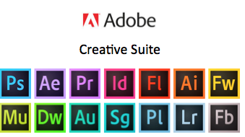
Our ideas
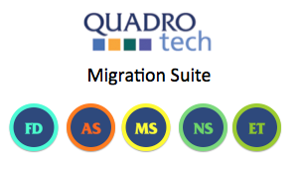
or
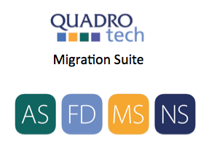

We are looking for ideas – and are open to suggestions. We need logo in both Positive and Negative as in .eps and .ai format
We are not intending to change the company LOGO
Colors should not conflict with the company logo colors – need to go well on the same paper.

Overtime we are looking for an identity that works across logo, business cards, brochure and website.
About Quadrotech:
Please visit the www.quadrotech-it.com for details

