Elements for the Album FRONT COVER:

- TITLE: The title of the album is

Jennifer Zhang
VS
- PARENT ADVISORY WARNING LABEL:
http://media.npr.org/assets/img/2010/10/29/parental-advisory_custom-d61ea6192ebc478d3a7ff147dbbe3e884ebcb5ac-s6-c30.jpg

- RECORD LABEL LOGO (see the uploads for this logo)

- THE ALBUM COVER IMAGE

Composite the two photographs provided in a graphic where the two girls look like they are facing off against each other on a video game “vs” screen that has this format (please recreated the font for “VS” too):
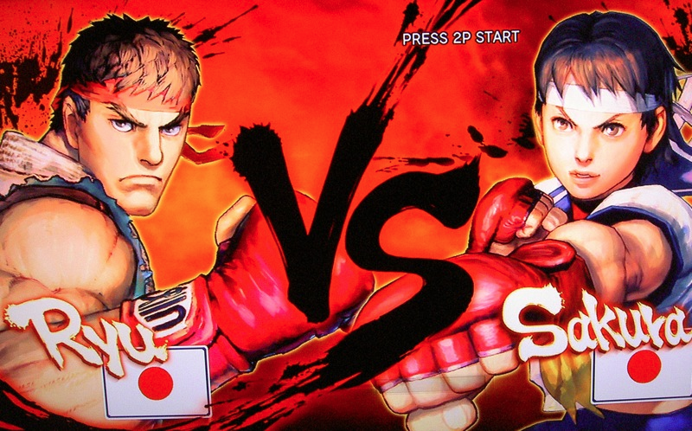

But use the full body framing of the photos instead of the close-ups of these characters.

Notes: Please design this cover so it is graphically beautiful, with the photos retouched, and with a bright, interesting patterned background, etc.

The only other graphical requirement is that the “bat” logo on the image with the girl in the mask needs to be photoshopped out and replaced with something that looks similar in style, but forms the letters “JZ”

Elements for the Album BACK COVER:
Please design so that it matches the design elements and themes of the front cover. It must be laid out like the back of an album with the following information and elements:

----------------------------------------

- SPACE COWBOY
- BATSUIT
- YOUR FANTASY
- I WIN
- FIGHT ME

Produced by JAMES tha Dj / Danger Squad Records
Songs Written and Performed by Jennifer Zhang
All Tracks Recorded and Mixed by Glenn Suravech / Mosaic Sound Recordings
“Batsuit”, “I Win”, “Space Cowboy” Mixed by Chris Hanebutt
“Your Fantasy”, “Fight Me” Mixed by Keith Burhans / Bird Productions

COVER:
Photos by Armen Asadorian Photography
Makeup by Jessica DeBen Polish
Costume Pieces by Matthew Hiscox & Jay Williams
Art by: ____________

www.jennifer-zhang.com
©2014 Danger Squad Records
[DANGER SQUAD LOGO]

----------------------------------------

