HONGJIN Website Requirement

To build a website showcasing the Chinese culture and the Chinese antique and artifact the shop is selling. The shop is located in the city fringe in Sydney CBD and position itself as a premium retail shop of Chinese art collection. The shop also host a few tea tables for client to sit down to appreciate Chinese tea and collection of Chinese artwork.

Another important function of the website is online shopping. By choosing the category of collection, it will take you a product catalogue. Each product comes with a descripton of name, origin, style, technique and price. By choosing the product, client will enlarge and browse, choose quantity, choose delivery option (pick up from store, or delivery address) and gift wrapping and a gift message. Payment will be made through credit card online.

Website Structure

[HOMEPAGE]
* About HONGJIN
* Collection
- Porcelain
- Bronze
- Painting & Calligraphy
- Terra Cotta
- Others
* Tea House
* Contact Us

[SUBPAGE]
* About HONGJIN
Hong meaning red, is the symbolic color from the mythical orient. Jin has a literal meaning of brocade, connoting prosperity and luxury in traditional Chinese culture.
At Hongjin, we present you the authentic oriental cultural experience through a rich collection of traditional Chinese artwork and artifact with premium quality and finishing.
At Hongjin, we handpick the highest grade tea from China to bring you to the amorous and tranquil world of Chinese tea garden.
At Hongjin, we await you.

* Collection - Porcelain:
Also known as “fine china”, porcelain originated in China dated from the Shang Dynastry (1600BC – 1046BC). Made of clay in the form of kaolin in high temperature kiln (between 1,200 °C to 1400 °C), Porcelain has considerable level of strength, hardness and toughness.
Porcelain making is one of the most significant forms of Chinese art，which has evolved over 3000 years.
- Shang Dynasty (1600BC – 1046BC) - Proto-porcelain wares were made;
- Han Dynasty (196AD-220AD) – Glazed ceramic wares developed into porcelain
- Sui and Tang Dynasties (581AD-907AD) – A range of ceramics, both low-fired and high-fired was made, including glazed Sancai (tri-color) wares, Yue celadon wares and other translucent porcelains.
- Song and Yuan Dynasties (960AD-1368AD) – Jindezhen established the city as the main production hub for imperial porcelain, able to produce porcelain using crused and refined pottery stones alone.
- Ming Dynasty (1368AD-1644AD) – It is a period of innovation in ceramic manufacturing. New techniques in design and shapes were implemented showing a predilection for color and painted design, as well as openness to foreign forms.
- Qing Dynasty (1644-1911AD) – Porcelain in China became well known worldwide, exported to Asia, Africa and Europe.
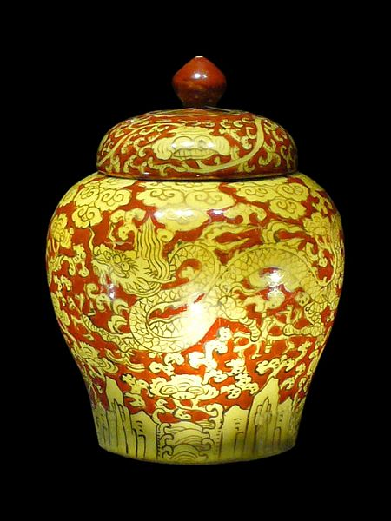
[Example of Product to be listed] [Showcasing of Item also supporting Online Shopping]
Dragon Porcelain Jar
Origin: Jingdezhen
Style: Ming
Technique: hand-made, high fire, lime-glazed
$280AUD
Quantity
Order (Complimentary Gift Wrapping and Delivery)
Collection – Bronze [content structure similar to Porcelain]
[Illustrative of products to be listed] [Showcasing of Item also supporting Online Shopping]

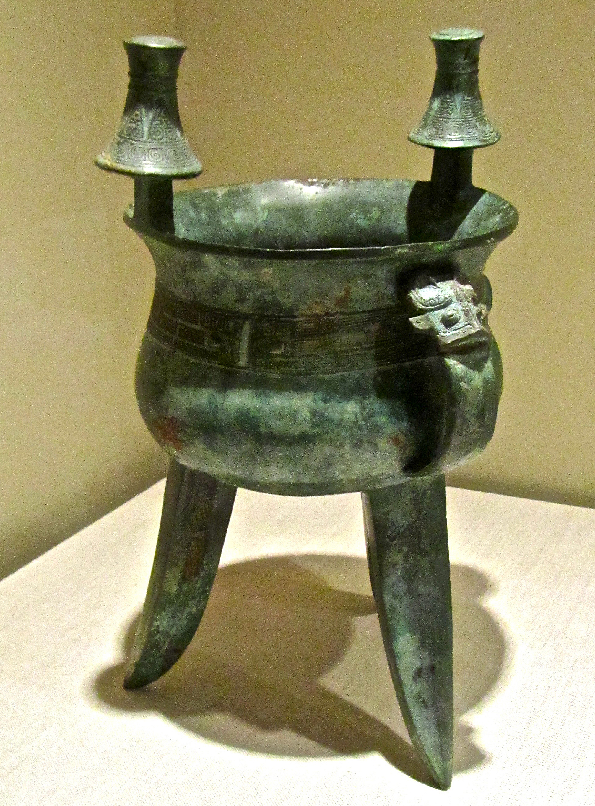
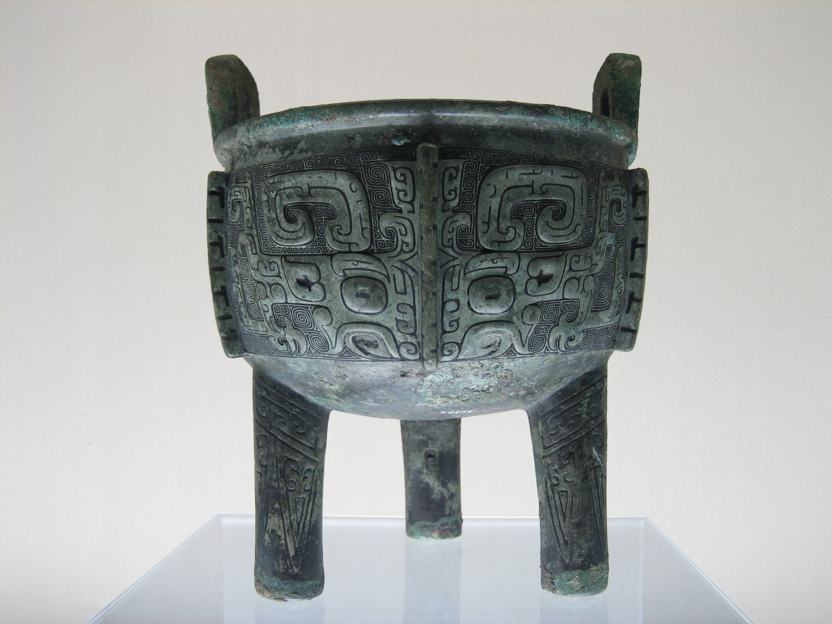

Collection - Painting & Calligraphy [content structure similar to Porcelain]
[Illustrative image of products to be listed] [Showcasing of Item also supporting Online Shopping]

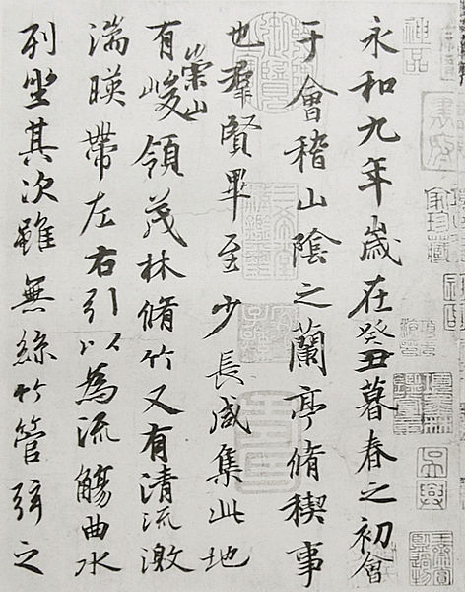

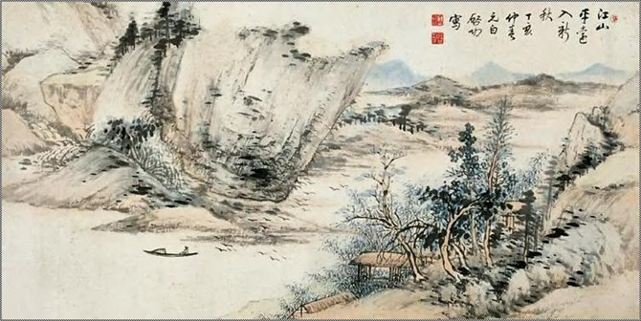

Collection – Terra Cotta [content structure similar to Porcelain]
[Illustrative image of products to be listed] [Showcasing of Item also supporting Online Shopping]

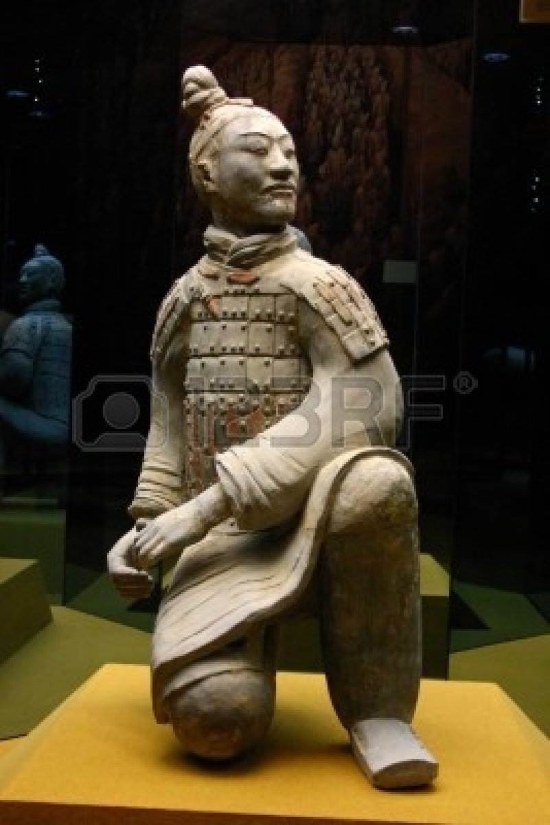

Collection – Others [content structure similar to Porcelain]
[Illustrative image of products to be listed] [Showcasing of Item also supporting Online Shopping]

[Folk’s Paper Cut]
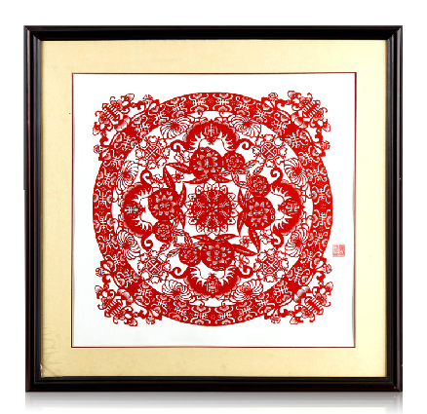

Tea House

A genuine Chinese cultural experience is incomplete without Chinese tea, which has been a significant part of the oriental culture and lifestyle. We handpick a variety of premium Chinese tea, with profound taste and tremendous inner-health benefit.

We look forward to seeing you here and sharing with you a genuine experience of Chinese tea culture.

[Illustrative image for Tea House]
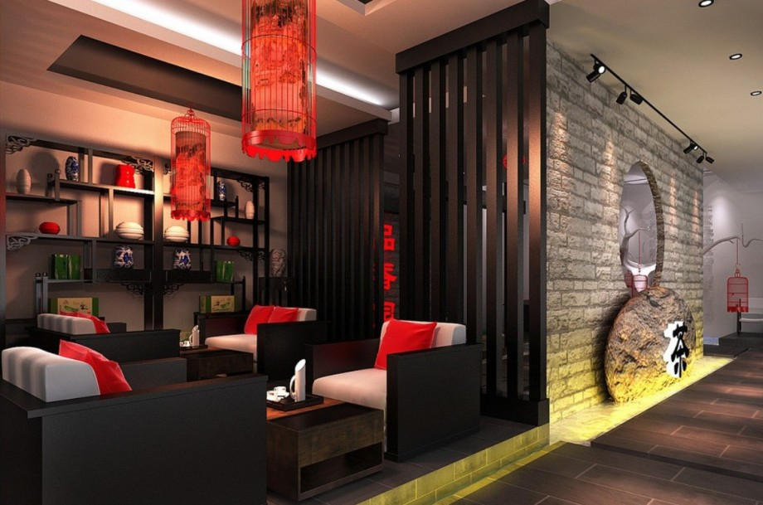

Selection of Tea and Tea Sets [Online Shopping]

[Illustrative Tea to be listed]
Green Tea
Origin: Yunnan China
Taste:
Health Benefits:
Price: $10AUD
Weight: 100g

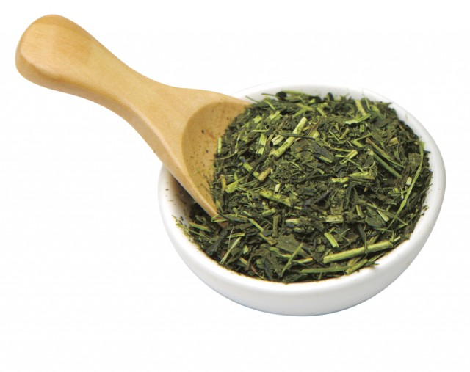

[Illustrative Image of Tea Pots to be listed]
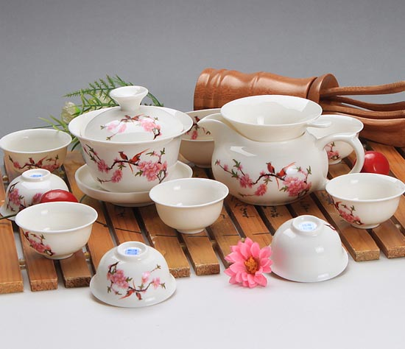

White Porcelain Flower Tea Pot
Material: Porcelain
Origin: Yunnan China
Setting: 1 Pot +5 Cups
Price: $20AUD

* Contact Us
A: Level 1, 57-61 Foveaux Street, Surry Hills 2010
T: 1800 xxx xxx
E: info@hongjin.com.au

