Website Development Brief

Section 1 - About J’s Bazaar

• Organisation’s mission statement - To provide an elegant, state of art system and expertly curated online market place with handpicked high quality suppliers for discerning expats community in Hong Kong. To Support local independent business and craftsmen.

• Services/products offered - High quality (bilingual) online market place for Expats, providing curated, customizable products by independent /small business sellers in an easy to use ecommerce platform.

Section 2 - E-business Vision and Objectives

• What is its vision? – To provide an elegant, state of art system and expertly curated online market place with handpicked quality suppliers for discerning expats community in Hong Kong.

• What are its objectives? – Provide mid to high-end quality independent suppliers for expats shoppers in a state of art online ecommerce platform and fast logistic service and tracking.

• What are the intended deliverables of the e-business plan? -

Section 3 - Target Audiences

Expat mums living in or about to move to Hong Kong.
Female, age between 25- 50, multinationals, internationals, well educated, high household income. Internet savvy. Already used to order goods/gifts online and ship internationally. Interest in buying business based in hong kong with international standard high quality goods, handmade or internationally sources goods with easy buying and shorter delivery process.

Our target audience is likely stay-home mums, or some working mums. They have limited time on their hand, so they like to glance topics between feeding or other things, they are usually multitasking,

They are a big fan of Facebook, and not very tech savvy. So need to keep the site layout simple and technology easy to use.

They will access the site via their smart phones, tablets and desktops. Most of them will be Apple users. So the website should be compatible to all above device.

Section 4 - Project Management

Explain the management structure - who are the decision-makers, their respective roles, internal decision-making procedures. Detail your expectations re project meetings:

• how frequently the project team is to meet with the developers – daily communication or whenever needed

• the agenda for those meetings – Progress and Q&A

• what is expected of the developers by way of reports – by a project spreadsheet

• how proceedings are to be recorded - by document

Section 5 - Background to the Project

Living in Hong Kong as expats, we constantly find it’s hard to find what we like on the malls, which is filled with super high-end brands such as channel, Gucci, LV etc. Or those local brands with local tastes that expats don’t like. We need a niche for the mid to upper middle end with more internationally tastful design and expressing more personality, individuality goods, and better quality yet not too expensive.

There are frequent shopping events, such as handmade hong kong Bazaar, or super mom road show, but they are only periodic and we need a 24/7 platform so people can shop whenever and wherever.

Hence most expacts like to order online from UK or the US, and have it shipped to hong kong which takes long time. But they are fairly customized to the notonhighstreet.co.uk or Etsy.com type of eshops. And this is what we want to bring to Hong Kong. The market place for independently sourced, individually crafted goods, shipped locally and hence cheaper and faster for the shipment.

Section 6 - Content

• content scope –

Stage I we will aim to list 15 suppliers covering Women’s Clothes, Handcrafted Jewelry, Accessory, Children’s Clothes, Children’s Toys, Food & Drinks, Party Supplies, Home Accessory

Content wise it’s managed by individual sellers to upload the inventory images ( provided by sellers but should be professionally shot), description, shipping policy etc.

Can consider a 1-minute video on the homepage for promotional purpose, such as how to use this site and why this site is superior to other small online shopping sites etc.

• content type - digitised, text, photos,

• provide an information design map showing all headings and sub-headings to be used in the site and how they relate to each other.

Homepage: Account sign in/ register, currency, my basket, Search

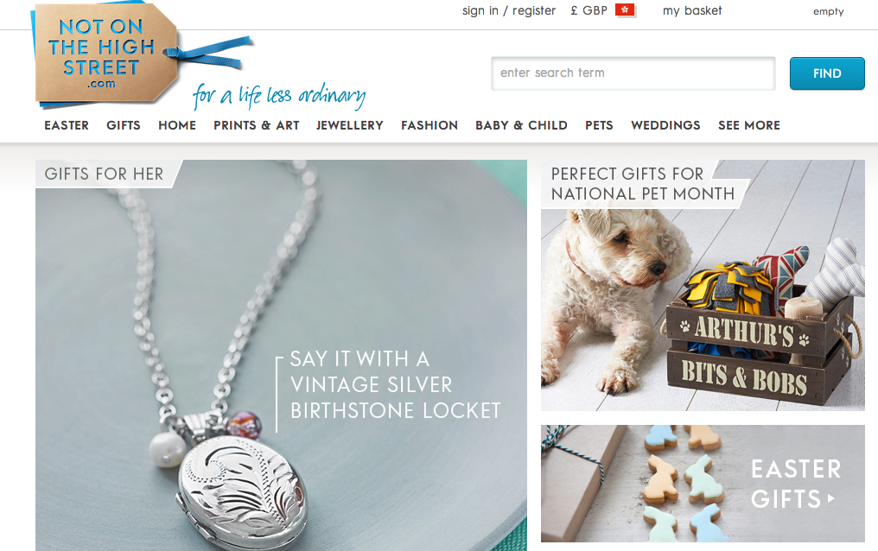

Header
Gifts |Fashion |Jewelry | Craft & Art| Children |Food & Drinks |Home |Party|

Advert for why shop with us and also encourage email sign up
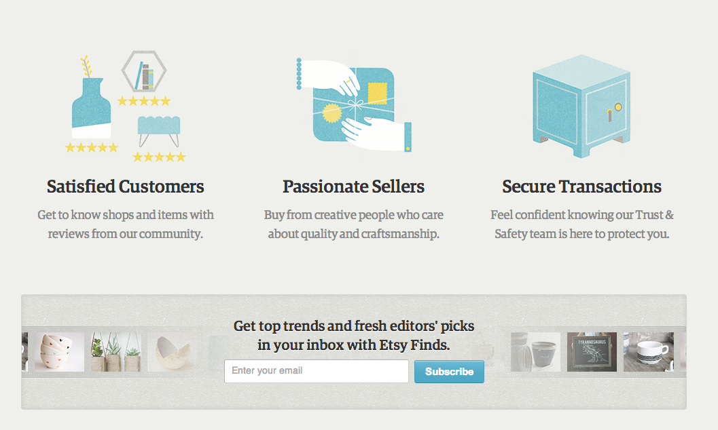

Footer:
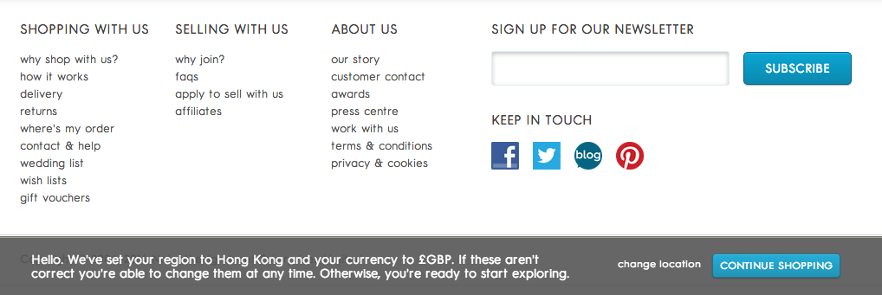

Section 7 - Functionality

User registration required for setting account, log in etc.

A powerful search is required. Show results from most relevant to least relevant.

Also it needs to be very easy to filter and narrow down via different criteria. So the filter option is key. Including price bar, category, product type, special feature ( can be personalized, gift wrapping available, made in HK, Eco-friendly) Delivery ( Free delivery within HK, Express Delivery, Usually within 2 days, self pick up)
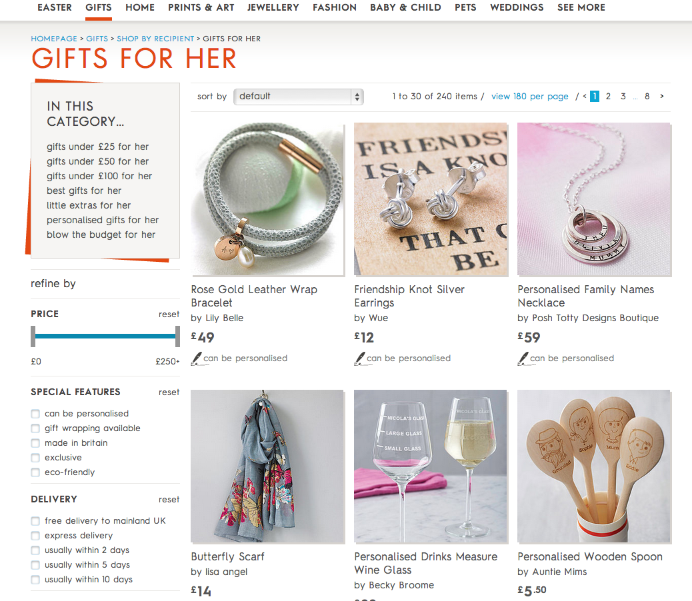

Use Ajax for loading images, in homepage. In product page, various tabs on product description, shipping policy and return policy , customer review etc. within product page
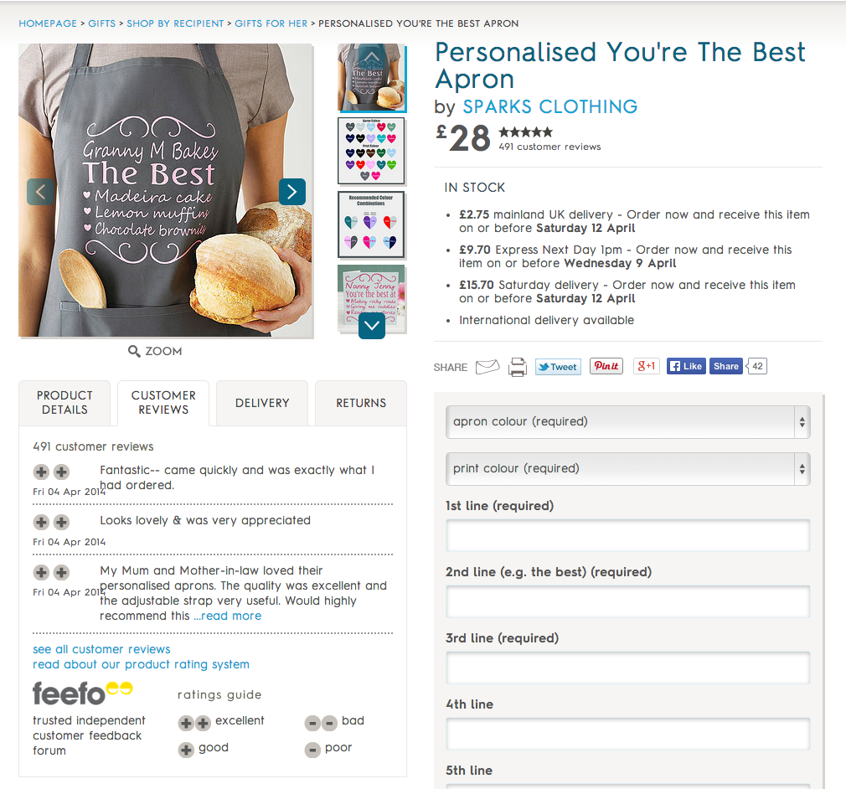

Users is asked discretely for rating each transaction and experience, so the seller could gradually build up popularity and credibility and buyers can also has a clear indication for which shop to go to.

Inbox for on platform communication(with notification email send to registered email address)

Order from multiple shops but pay in one go.

Social media integration plugin – users can like or share shops or products via social plugin.

User account management – buying history, tracking, inbox communication to sellers, managing account setting,

Seller database management – easy for multiple upload, copy similar page with similar content but different images, inventory control/management, online realtime tracking system, promotion function, so can choose seasonal product to feature.

Content management –on page edit. Easy for adding new design, adding new category for seasonal promotion i.e. Easter, Christmas etc.

Section 8 - Graphic and Information Design

• Describe the corporate identity – Elegant, modern, chic for modern females, sophisticated yet pro individuality.

• Detail your design criteria and provide URLs of sites you like the look of.
Fresh, clean and chic look and feel, not too busy, It will be less text and more images – to create better visual apparel to the target audience group as they are usually visual type of person and don’t have much time to read too much text. So the visual must be clean and simple and attract the eyeball.

www.popsugar.com/moms - i like that What's Trending in the last 48hrs section.
www.etsy.com

http://www.notonthehighstreet.com/ - easy to navigate. Time saving. Clean. The home page also change seasonally, with editor picked items to be featured to

• Describe how the information/content is to be organised (ie the information design) and provide guidelines.

• Specify accessibility requirements. – should be easily accessible via Smartphone, Tablets, laptops and PCs

Should develop a smartphone version in parallel

