
Add “n” to make Australian. Like the font and use of Southern Cross.
Incorporate Diamonds
Incorporate SPORTS MANAGEMENT

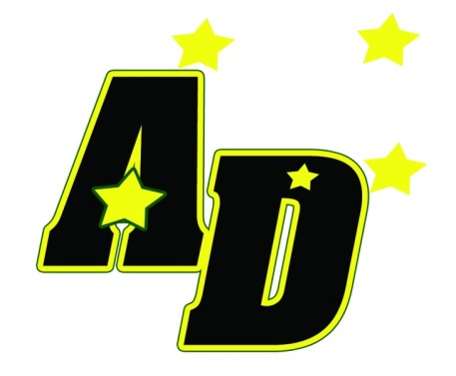
Like this design as a hat logo. Maybe some subtle changes

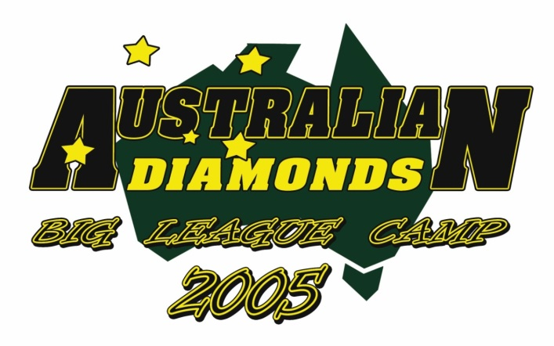
Take out the map of Australia.
Replace BIG LEAGUE CAMP with SPORTS MANAGEMENT
Like font and layout used for AUSTRALIAN DIAMONDS
Open to different fonts

