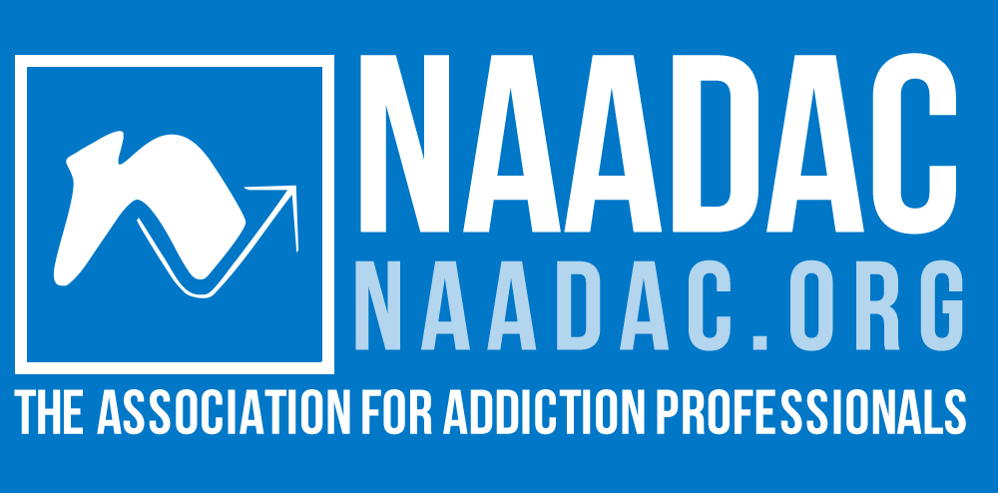
The Addiction Professional Business Learning Collaborative

  - Elevating and Focusing Addiction, Co-Occurring and Recovery Business Practices for Sustainability, Fiscal Strength, Clinical Excellence, Recovery Orientation and Industry Leadership

Most addiction and co-occurring treatment agencies are evaluating how to help ensure their agency's viability, sustainability, funding, and seeking growth opportunities within this evolving landscape. Get the education, guidance, and consultation your organization needs from those who know it best!
The Addiction Professional Business Learning Collaborative is an intensive, interactive program that is designed to help your organization maximize current funding and service opportunities inherent in healthcare reform and identify and address barriers to growth. Over six months, participants will receive training and consulting directly from industry leaders, highly successful provider CEOs, and national subject matter experts through live webinars, fireside chats, and private consultation. With hands-on guidance, participants will develop a concise, easy to follow, and comprehensive sustainability and growth plan for their organization using a proven and effective sustainability and growth template.

This Learning Collaborative will focus on:
- Increasing funding and sustainability
- Understanding and effectively working with third party payers (federal, state, managed care and insurance companies)
- Developing strategic partnerships (such as with ACO’s, Health Homes, Group Practices, FQHC, Recovery Organizations, and hospital systems)
- Learning how to access grants and manage contracts while insuring back-office business practices are in place to meet current demands
- Executive leadership development and so much more!
NAADAC and Via Positiva know where the opportunities are and how to help you get to them. We will be holding nothing back to help insure your success -- for you as an executive leader and for your agency. Register today!
Space is limited. Registration closes Wednesday, April 17, 2014!

What’s Included:
- A Kickoff Webinar Conference that provides an overview of the project, outlines expectations, introduces the facilitators and coaches, and describes a snapshot of the current funding environment
- Six monthly Training and Development Webinars
- Six monthly Small Group Sessions for in-depth interaction and strategic planning discussions
- Two consultation and strategic planning calls specifically dedicated to your agency's sustainability and growth plan
- Seven informal "fireside chats" presented by industry leaders and insiders on topics identified by LC members and faculty.
- Includes Organizational Membership for new members with NAADAC
- 38.5 continuing education (CE) credits
- Access to all trainings, archives, resources and templates
- Access to a team of knowledgeable, successful, enthusiastic, supportive, passionate and creative industry experts and leaders who will be on your team (for six months) to position your agency for increased funding and to walk you through this uncertain, sometimes turbulent and incredibly evolving healthcare landscape!
- Lots of "al a carte" options are also available, including on-site walk-thrus and consulting services/training, electronic health records training, a cutting-edge electronic clinical supervision tool that tracks outcomes at the single practitioner level in agencies and much, much more!

Tuition:
- $4,700 for NAADAC Organizational Members
- $5,500 for non-NAADAC Organizational Members

Curriculum Topics:
- Healthcare reform and the Affordable Care Act
- Immediate opportunities—environmental report and updates
- Managed Care Networks and Preferred Provider Networks
- Grants and contracts
- Identifying and utilizing source documents
- Marketing, outreach and strategic partnerships
- Unique perspectives and opportunities for addiction professionals
Want to learn more? Join us for a free info session on Friday, March 7, 2014 or Friday, March 21, 2014 from 3-4pm ET (2 CT/1 MT/12 PT)
- Whole Health, Health Navigation and addiction treatment & recovery
- Billing, Claims, Co-pays and third party payer contracts
- Record keeping and documentation
- New Reimbursement Models
- Recovery and Recovery Oriented Systems of Care
www.naadac.org/businesslearningcollaborative
- Electronic Health Records—Pros and Cons
- Sustainability and Diversification
- The New Role of Customer Service in Healthcare
- Employee wellness, satisfaction and leadership
- Effective Utilization Review
- Outcome measures made simpler
- DSM 5 and ASAM
- Special Topics: trauma informed care, cultural considerations, client choice and demographics within health reform
- Bringing change together within a flexible and updateable strategic plan
- Clinical and operational efficiencies

