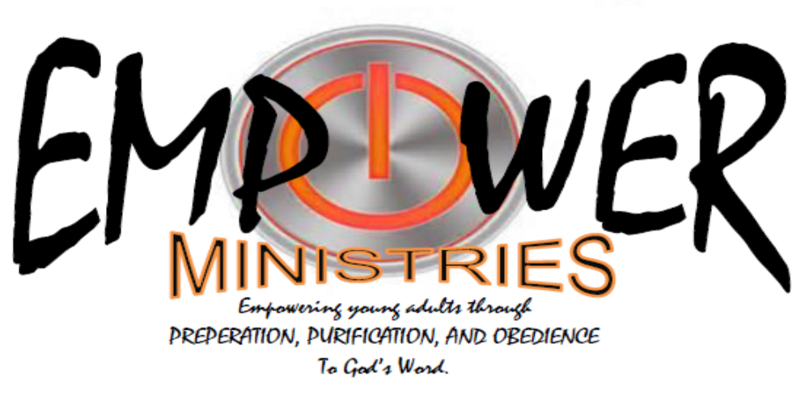

Are you 18- 25 years old? Are you looking to grow spiritually?
Are you curious about God, Jesus Christ, the Holy Spirit?
Are you searching for something but just can find anything that comletely satisfies?

Come, be our guests at Hillcrest Baptist Church’s Empower Ministries. Together we will walk, learn, and worship an eternal and everlasting God whose foundation will never faulter or fail.
Sundays
PREPARATION : Bible Study – 9:00 AM – Room 933-C – in the ANNEX
PURIFICATION : Worship and Message – 6:00 PM – Room 931-A – in the ANNEX
Wednesdays
OBEDIANCE : Worship – 6:30-6:45 PM – Student Ministry Building – BLDG 100, Outreach/Missions 6:45-7:30 PM

