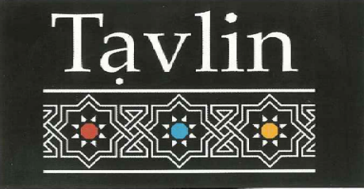
678 Glenhuntly Road, Caulfield South
Tel. 9972 5666
TAKE AWAY MENU
Salads & Dips
Small $5.50 / Large $10.00 / Jumbo $16.00

Baba Ganoush (GF)
Turkish (GF)
Chatzilim (Fried Eggplant) (GF)
Corn Salad (GF)
Mixed Pickles (GF)
Moroccan Carrot (GF)
Roasted Beetroot (GF)
Hummus (GF)
Tahini (GF)
White cabbage (GF)

Hummus Plates
Served with 1 Laffa and Pickles
Masabacha – served with tahini and whole chickpeas $12.00 (GF)
Ful – served with Fava beans $15.00 (GF)
Mushroom – served with Pan Fried Mushrooms $15.00 (GF)
Basar – served with Mince Meat $16.50 (GF)

Laffa Wraps
Served with Hummus, Tahini, Israeli Salad and Pickles
(One large skewer per serve)
Falafel $12.00
Chicken Shashlik $14.00
Lamb Shashlik $15.00
Kofta $13.00
Liver Shashlik $13.50
Schnitzel $13.00

From the charcoal grill
Chicken Shashlik $8.50 (GF)
Lamb Shashlik $9.50 (GF)
Kofta (Lamb kebab) Shashlik $8.50 (GF)
Liver Shashlik $8.50 (GF)
Schnitzel $10.00

Sides
Chips $7.00
Falafel Balls (6 per serve) $5.00
Moroccan Beef Cigars $9.00
Laffa $2.00

