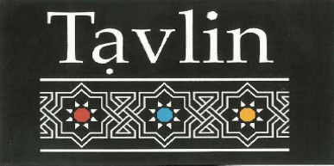

Entrée

Starters

6 Falafel Balls On Tahini $5.00
Moroccan Beef Cigars (3 per serve) $10.00
Fried Cauliflower $8.00
Pan Fried Mushrooms and Onions $8.00
Lamb Kibbeh & Pinenuts (3 per serve) $7.50

Traditional Hummus

Served with 1 Laffa and Mixed Pickles

Masabacha – served with Tahini and whole Chickpeas $11.90
Ful – served with warm, crushed Fava Beans $14.90
Mushroom – served with Pan Fried Mushrooms $14.90
Basar – served with Mince Lamb & Pine nuts $16.50

Salads & Dips Platter

3 Choices & Laffa for $15.00 or 6 choices & 2 Laffa for $25.00

Hummus
Tahini
Baba Ganoush
White Cabbage
Chatzilim (Fried Eggplant)
Adi’s Corn Salad
Moroccan Carrot
Roasted Beetroot
Turkish Dip

Mains From the Charcoal Grill

Plates
All plates served with Hummus & Tahini, Chips, Israeli salad and 1 Large Shashlik of your choice (Serves one person)

Falafel Plate $23.00
Chicken Liver $24.00
Chicken Schnitzel Plate $24.00
Kofta Shashlik $24.00
Chicken Shashlik $24.00
Lamb Shashlik $26.00

Individual Shashlik (1 Per serve)
Chicken Shashlik $10
Lamb Shashlik $11.50
Kebab (Kofta) Shashlik $10.00
Chicken Liver $9.50
Schnitzel $11.00

Sides
Israeli Salad $10.00
Chips $8.00
Laffa $2.50
Mix Pickles $6.00

Kids Meals
(10 and under only)
Schnitzel plate with chips and Israeli Salad $10.00
Falafel Plate with chips and Israeli Salad $9.00

$35 Set Menu (per person)
Entrée – Salads, Dips, Laffa bread & Falafel
Main – 1 Shashlik of per Person (Chicken, Kofta, lamb, Liver, Schnitzel), Chips & Israeli salad
Dessert – Chef ‘s Selection
(Min 6 People)

