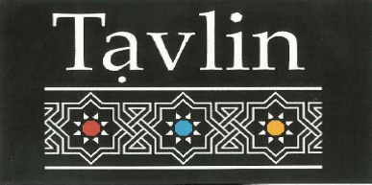

Entrée

Starters

Falafel Balls $5.00
Moroccan Beef Cigars (3 per serve) $11.00
Fried Cauliflower $8.00
Pan Fried Mushrooms and Onions $8.00
Lamb Kibbeh & Pinenuts (3 per serve) $7.50

Hummus Plate

Served with 1 Laffa and Mixed Pickles

Masabacha – served with Tahini and whole Chickpeas $11.90
Ful – served with warm, crushed Fava Beans $14.90
Mushroom – served with Pan Fried Mushrooms $14.90
Basar – served with Mince Meat $16.50

Salads & Dips Platter

3 Choices & Laffa for $15.00 or 6 choices & 2 Laffa for $28.00

Hummus
Tahini
Baba Ganoush
White Cabbage
Chatzilim (Fried Eggplant)
Adi’s Corn Salad
Moroccan Carrot
Roasted Beetroot
Turkish Dip
Mixed Pickles

Israeli Lunch Tasting Plate
All tasting plates include a Chef’s Selection of 4 Salads & Dips and Laffa
Chicken Shashlik Plate $10
Lamb Shashlik Plate $11.50
Kebab (Kofta) Shashlik Plate $10.00
Chicken Liver Plate $9.50
Schnitzel Plate $11.00
Falafel Plate

Wraps
Fresh Laffa wrap with Hummus, Tahini, Israeli salad & Mixed Pickles
(Chilli optional)
Falafel wrap $12
Chicken wrap $14
Schnitzel wrap $14
Kofta wrap $14
Lamb wrap $15

Individual Shashlik (1 Per serve)
Chicken Shashlik $10
Lamb Shashlik $11.50
Kebab (Kofta) Shashlik $10.00
Chicken Liver $9.50
Schnitzel $11.00

Sides
Israeli Salad $10.00
Chips $8.00
Laffa $2.50
Pickles $6.00

Kids Meals
(10 and under only)
Schnitzel plate with chips and Israeli Salad $10.00
Falafel Plate with chips and Israeli Salad $9.00

