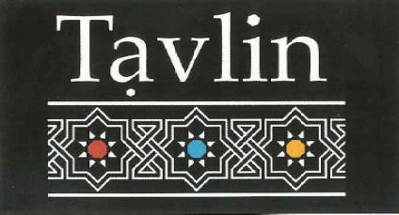

Cold Drinks

All Soft Drinks $4.00
Coke
Diet Coke
Coke Zero
Fanta
Solo
Sprite
Lemon, Lime and Bitters
Soda Water
Mineral Water

Israeli Drinks
Malt Star (Black Beer) $4.00
Israeli Grape $4.00
Israeli strawberry & banana $4.00
Apple Cider $4.00
Limonana –Old Fashioned Lemonade with mint
Glass $4.00
Jug $11.00

Hot Drinks

All Coffee and Tea $3.50
Soy milk extra $0.50
Decaffeinated available
Hot Chocolate $4.00
Turkish coffee $3.50
Tea with Nana (Fresh Mint) $3.50

Cold Drinks

All Soft Drinks $4.00
Coke
Diet Coke
Coke Zero
Fanta
Solo
Sprite
Lemon, Lime and Bitters
Soda Water
Mineral Water

Israeli Drinks
Malt Star (Black Beer) $4.00
Israeli Grape $4.00
Israeli strawberry & banana $4.00
Apple Cider $4.00
Limonana –Old Fashioned Lemonade with mint
Glass $4.00
Jug $11.00

Hot Drinks

All Coffee and Tea $3.50
Soy milk extra $0.50
Decaffeinated available
Hot Chocolate $4.00
Turkish coffee $3.50
Tea with Nana (Fresh Mint) $3.50

Cold Drinks

All Soft Drinks $4.00
Coke
Diet Coke
Coke Zero
Fanta
Solo
Sprite
Lemon, Lime and Bitters
Soda Water
Mineral Water

Israeli Drinks
Malt Star (Black Beer) $4.00
Israeli Grape $4.00
Israeli strawberry & banana $4.00
Apple Cider $4.00
Limonana –Old Fashioned Lemonade with mint
Glass $4.00
Jug $11.00

Hot Drinks

All Coffee and Tea $3.50
Soy milk extra $0.50
Decaffeinated available
Hot Chocolate $4.00
Turkish coffee $3.50
Tea with Nana (Fresh Mint) $3.50

