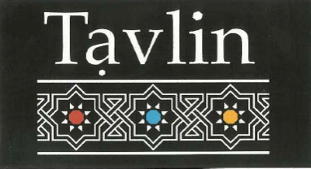

Dessert

Malabi
Rose water milk pudding with rose syrup and pistachios $9

Trio of Sorbet
Lemon, Mango, Berry $10

Turkish Delight Ice cream
With Turkish delight chances and pistachio $11

Hazel Nut Mousse
Hazel nut chocolate mousse topped with raspberries $9.5



Dessert

Malabi
Rose water milk pudding with rose syrup and pistachios $9

Trio of Sorbet
Lemon, Mango, Berry $10

Turkish Delight Ice cream
With Turkish delight chances and pistachio $11

Hazel Nut Mousse
Hazel nut chocolate mousse topped with raspberries $9.5

