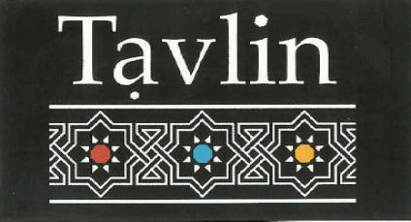

Beers

All Beers $6.50
Goldstar
Corona
Peroni
Pure blonde
Crown lager
Cascade light
Savanna Dry

Wines

White
Oyster Bay Sav Blanc $7 / $27
Tar & roses Pinot Grigio $7 / $28
Sticks Chardonnay $7 / $28

Red
Taltarni Sangiovese $8.5 / $33
Tahblik Shiraz $8 / $32
Oyster bay Pinot noir $7.5 / $30
House red $6

Spirits

Elite Arak (Israel) $7
Grey goose vodka $7.5
J. Walker Black label $7

Beers

All Beers $6.50
Goldstar
Corona
Peroni
Pure blonde
Crown lager
Cascade light
Savanna Dry

Wines

White
Oyster Bay Sav Blanc $7 / $27
Tar & roses Pinot Grigio $7 / $28
Sticks Chardonnay $7 / $28

Red
Taltarni Sangiovese $8.5 / $33
Tahblik Shiraz $8 / $32
Oyster bay Pinot noir $7.5 / $30
House red $6

Spirits

Elite Arak (Israel) $7
Grey goose vodka $7.5
J. Walker Black label $7

Beers

All Beers $6.50
Goldstar
Corona
Peroni
Pure blonde
Crown lager
Cascade light
Savanna Dry

Wines

White
Oyster Bay Sav Blanc $7 / $27
Tar & roses Pinot Grigio $7 / $28
Sticks Chardonnay $7 / $28

Red
Taltarni Sangiovese $8.5 / $33
Tahblik Shiraz $8 / $32
Oyster bay Pinot noir $7.5 / $30
House red $6

Spirits

Elite Arak (Israel) $7
Grey goose vodka $7.5
J. Walker Black label $7

