YourCentre

- All-encompassing provision of marketing and services

- Positioning your centre to your catchment

Work your centre

Protect your asset

Increase your MAT (Moving Annual Turnover)

- Highly specialised enterprise

- Focus on shopping centres - local & regional

- Customisable / tailored packages

YourCentre

- INCREASE foot traffic into and through your centre

- INCREASE quality tenant retention

- INCREASE moving annual turnover

- INCREASE leasing enquiries

- INCREASE customer loyalty

- IMPROVE tenancy mix

- LEARN about your centre and what it needs

- UNDERSTAND what your Customer is looking for

YOU

- Abreast of changes in the retail sector

- Seen to be forward thinking

- Making a community investment

- Keeping up with trends and technology

UNDERSTAND YOUR CUSTOMER


            - WHERE they live

            - WHO they are

            - WHAT they want / need

            - WHY they come

YOUR CENTRE … THE BEGINNING

COMMUNICATION
PROMOTION

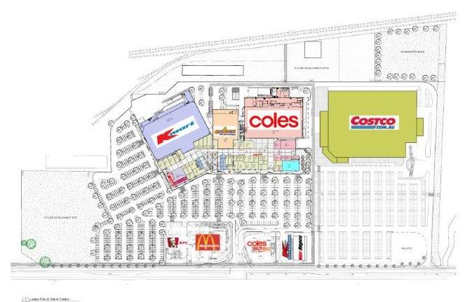

MEASURABLE

DIGITAL
FOOTPRINT

PRESENTATION

COMMUNITY

PROMOTION

We know WHAT customers WANT when they visit your centre


- Buzz-activated shoppers

- Autopilot shoppers

- Bargain-activated shoppers

- Variety-activated shoppers

Grand Openings

Competitions

Giveaways

School holiday activities

Christmas / Easter / Mother’s Day / Aus Day / seasonal / updatable

Interactivity

Management / Promotion of sales

DIGITAL

Is your centre connected?

Website production, design, implementation, maintenance

SEO (Search Engine Optimisation) / SEM (Search Engine Marketing)

Over 88% of Australians have access to internet ALL THE TIME – search your centre – opening hours – tenants – specials – parking – access

Make a digital footprint for your centre – critical for commercial success in the next generation – make your centre visible online by employing digital marketing strategies

Improves visibility

Maintains competitive edge

Targeted marketing

Optimise search terms

Lead generation / goal conversion

E – Commerce

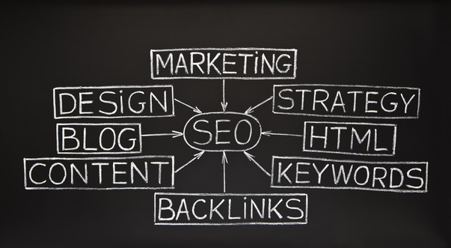

SMO (Social Medial Optimisation)

9 million Australians check FACEBOOK daily – 7.3million on their phone!

Is your centre on Facebook? Twitter? Instagram? Pinterest? LinkdIn?

Build a social profile – don’t get left behind



Gather and manage customer database

Promote giveaways and specials

Stay current - connect with customers on their chosen platform



COMMUNICATION

- Tell your story

- Wide ranging and reaching

- Variety – current / dependent on demographic

- Database management and interactivity

- Repetition is key



- Post

- Digital media

- Audio visual

- Integration into next generation

- Competitive advantage
COMMUNITY

- Investment in development


Groups

Facilities

Charities

- Customer focus

Connection

Giving back

- Additional services

Environmental

Justice of the Peace

Transport for elderly / mobility impaired

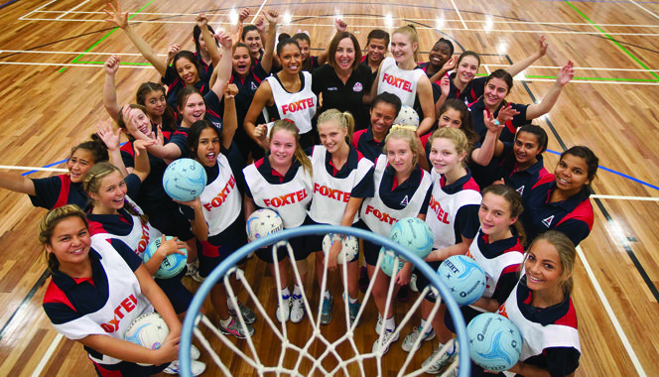
MEASURE IT

- One stop service Manageable

Measureable

Invaluable

- Packages – flexible / tailored / customised to your centre

Counters

Tenant Turnover

MAT

Ultimate shopping experience for your customer in your centre



PRESENTATION

- Facilities

Layout and usability optimisation

Appearance and presentation

Cleanliness / OH & S

- Your centre known in the community

Branding – recognisable / memorable

Better shopping experience

Improved image – giving back / rewarding



YourCentre TEAM

Hand-picked specialised team of experienced and highly qualified professionals

ALL-ENCOMPASSING SERVICE

Graphic design artists

IT integratation / Support technicians

Marketing gurus

Retail consultancy experts

Your own ‘on the ground’ person ideally sourced from your catchment

Combined experience of over 100 years in the retail sector



We work withYOUR customers and

YOUR tenants

to make YOUR centre the best it can be

