PhESi Introduction
PhESi is a data-driven solution provider serving clinical development organizations around the world in the following areas:
- Select best investigator sites: proven to deliver superior enrollment results
- Assess clinical trial feasibility: reliably identify the potential challenges for clinical trials in planning, and allow our clients to proactively take action to mitigate risk
- process improvement support: quantify opportunities potentially can be improved, recommend actions to realize the opportunities, measure the impact from implementation, and reward the people who contributed to the achievement
PhESi differentiate itself from competitors with the following:
- A second to none database both in scale and in capturing the details and dynamic in clinical development around the world
- A method with conceptual innovation and protected by patents and know-hows
- Consistently superior and quantifiable results from PhESi services
- Continuing input from clients including the most prominent industry leaders
PhESi clients include Merck, Pfizer, Sanofi, Novartis, Johnson & Johnson, Biogen Idec, Otsuka, and many medium and smaller sized pharmaceutical/biopharmaceutical companies.
PhESi Site Selection Services
Investigator site performance is one of the most important perennial challenges facing clinical trial execution teams across the industry. The inability to enroll the needed number of subjects in a targeted timeframe strains study budgets and resources, and prolongs cycle times.
PhESi performance based site selection has been helping our clients to deliver superior enrollment results in more than 100 clinical trials, and the number of trials continues to grow rapidly.
Moreover, PhESi recommended sites, as expected, have also resulted in decreased dropout, reduced query rate, and other improved quality measures.
The following table summarizes the results from a neuropathic pain clinical trial:
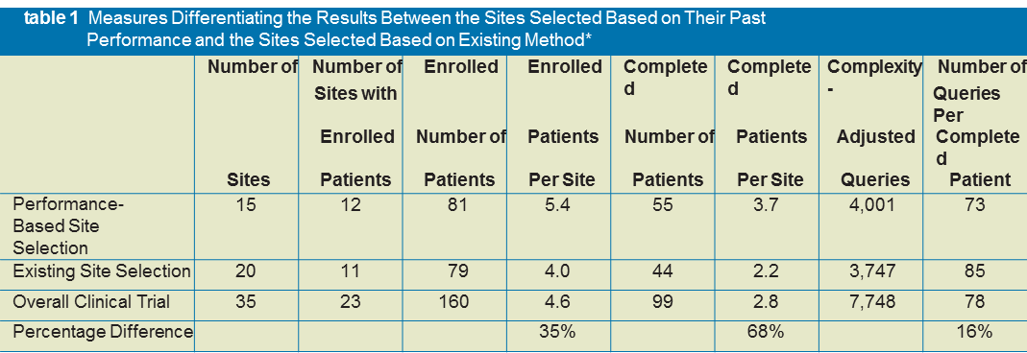
PhESi performance based site selection is enabled by an investigator performance database second to none in scale. This database is dynamic, and is updated automatically in real time. Our site selection services are also empowered by a combination of patent protected methods and technical know-how.
While PhESi site selection is arguably the best in consistently delivering superior enrollment results, it is not a silver bullet.
As shown in the following chart, PhESi site selection can minimize non-performing sites (12% vs. 8%) and poor performing sites (12% vs. 7%), but we cannot eliminate them. On the other hand, while PhESi site selection dramatically increases the top performing sites (9% vs, 28%), we cannot guarantee every site to be top performer:
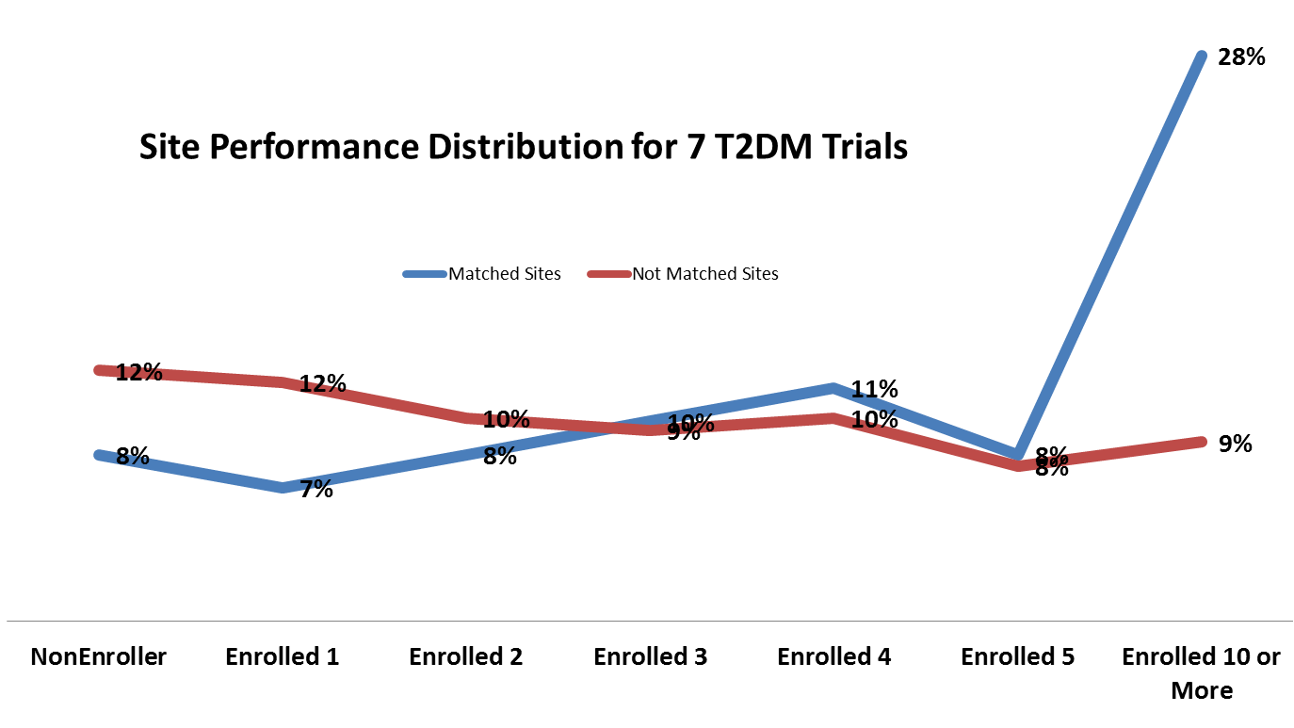
This chart summarizes enrollment results from a set of seven type 2 diabetes clinical trials.
We are proud of the fact that some of the drug candidates we have supported to develop are now available in the market, helping patients and saving lives.
While we are happy to help our colleagues when their clinical trials are at planning stage, the reality is that we are often involved in “rescue missions”, when a clinical trial needs more high performing sites to complete targeted enrollment.
We are flexible in delivering our services. We can help our clients on providing site candidates one clinical trial at a time. Some other clients can access to our proprietary web based site selection tool, through a competitive annual fee.
PhESi Clinical Trial Feasibility Assessment
When we encounter challenges in conducting clinical trials, the first thing we can measure is that the sites are not enrolling as we expected. So we blame site performance. That blame is intensified by the fact that there are still a few sites seem to do well in enrolling. Factually, there are more than just site enrolment performance can potentially derail a clinical trial.

Adequate number of sites: People usually understand that too few sites will end up with prolonged enrollment cycle time. So when we add more sites to contribute to enrollment, we should be able to shorten enrollment cycle time. But that incremental benefit diminishes quickly when we add sites beyond certain point:
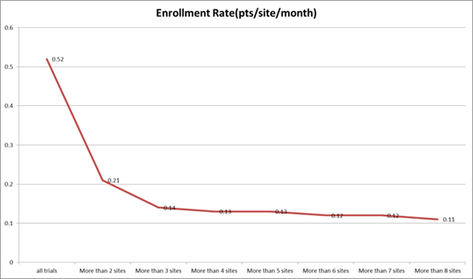
While this chart is from a specific disease indication, it is universally true for all the indications we have analyzed.
Sometimes too many sites also prolong enrollment cycle time, along with significantly increased costs.
Process limitation: Conventional wisdom tells us that we can activate more sites if we add more resources. We examined site activation curves from more than 1,000 interventional clinical trials with 10 or more sites per trial in a single company. 6% of the trials were able to activate 50 or more sites in 100 days. When we focus on the pool of trials with 50 or more sites, 20% of the trials were able to activate 50 or more sites. Unfortunately, we cannot extrapolate this relationship. It plateaus around 25% to 27% as show in the following chart:
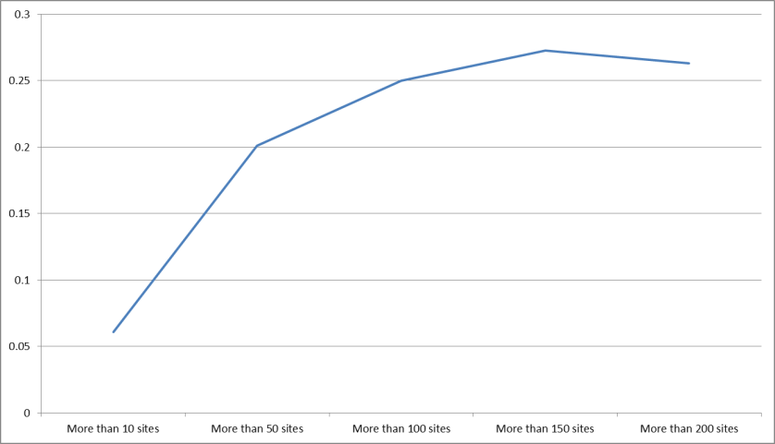

In another words, we do not have the freedom to manage a trial with large number of sites without significantly compromising the enrollment capability from individual investigator sites involved.

Inclusion/exclusion criteria: a company ran two pivotal Phase III multiple sclerosis trials side by side, with one key difference: one trial targeted both men and women, another trial enrolled only women. Given MS patients have a composition of 75% women and 25% men, you may have not expected that the women only trials took twice as much time to finish enrollment (1,073 days vs. 561 days). The process adjusted enrollment rate was merely 0.33 patients per site per month, compared to 1.41 patients per site per month for the trial included both men and women.
This impact also universally exists among the disease indications we have analyzed. The reduced pool of available patients often has far more overarching impact than a simple proportion of math can measure!

Armed with a database of more than 300,000 clinical trials and an integrated approach, PhESi clinical trial feasibility assessments provide answers to the following questions:
- Where to place the trial
- What sites to use
- How many sites needed
- What is a realistic expectation to the site activation process
- What are the impact of protocol design to operational deliverables
- What are the potential risks and what actions can be taken to mitigate the risks
- What will be the enrollment cycle time and what can be done to shorten it.
We also answer questions important to you and your management.
You can expect the following benefits from our services:
- Improved and quantifiable operational deliverable including:
  - Shortened enrollment cycle time
  - Reduced financial costs
- Better defined responsibility and accountability of involved functional teams, so that they can be more appropriately rewarded by what they have achieved
- More effective communication among stakeholders

