Front:
7th Annual Northern New England Facility Masters Conference

February 27th -28th in Portsmouth, New Hampshire

Register Today: tinyurl.com/FMC-Register _____________________________________________________________________________________________
This conference is proudly hosted by:
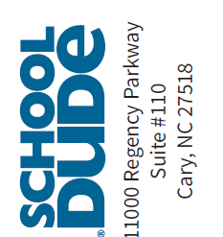
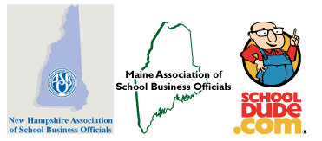
Back

February 27th -28th in Portsmouth, New Hampshire
This 2-day conference is packed with specialized networking,
leadership and learning opportunities focused on facility and
maintenance fundamentals for solving everyday challenges and
achieving operational excellence. Some that will be discussed include:

- Facilities Management
- Energy Management
- Personnel Management
- School Safety
- Sustainability

Register Today: tinyurl.com/FMC-Register

