
Main Menu
LEAN CLEAN EATING with ADRIANA SOLORZANO

YOU DON’T NEED ANOTHER DIET
TO GET THE BODY YOU WANT

ABOUT ADRIANA | THE MAGAZINE | BLOG & VIDEOS | SHOP

Get my FREE monthly E-Magazine
With delicious recipes,inspirational articles, workouts
& expert wellness tips that actually work! Yup FREE!
Mail-chimp
Opt In
Yes Please!
Email
First Name

Want a Body You’re Proud Of AND a Healthy Lifestyle You Love? Then You Don’t Need Another Diet!
Hey there I’m Adriana. I help smart, savvy, driven women just like you to slim down so you can not only rock your outfit but you can enjoy a lifestyle to match. As hard as it might be for you to believe right now, I‘ll teach you how to have this in a way that’s easier, and heaps more enjoyable than you’d ever thought possible – it’s time to kiss guilt and deprivation goodbye!

Hmmm... do any of these sound familiar?

- Tried a bunch of diet plans but you’re still stuck in body that just feels yuk
- You “know what to do” but somehow you’re still not doing it (WTF!)
- Suffer from emotional eating, feelings of guilt or frustration around food & exercise
- Feel bloated, guilty and maybe even a bit ashamed
- Overwhelmed and frustrated at yourself, feel that being slim and fit is a never ending chore
You’re not the only one... heck that was me at one time. But if you’re exhausted at not liking your body, and sick of seeing other women make it all look so easy, don’t you think maybe it’s time to try something new? Perhaps it’s time you stopped following what everyone else is doing (girlfriends, the 19 year old receptionist at work, or that really buffed chick at the gym)... obviously it’s not working. So what’s the alternative?

What If I Told You There Was An Easier & More Enjoyable Way?

- To Lose weight (most ladies I work with want to lose between 5kg-10kg... sometimes more)
- Have more energy
- Stop feeling bloated and exhausted
- Stop feeling frustrated for eating the "wrong" things and not exercising "enough"
- Feel hot in your clothes, at work and when you go out
- Feel proud of yourself
- Still have a social life... with you know, friends and stuff!

Ok... sounds good so far right, but you’re probably wondering what is about my method that’s so different for all the others out there? Honestly, the problem with most other diet programs is that they:
- Ignore the importance of pleasure in your life for weight loss. (I think it’s key)
- Aren't sustainable– (try and stop me from never eating a French pastry again & see what happens)
- Don’t teach you how to never need to be on another program, plan or diet again.
- Focus on what you need to cut out (I focus on what you need more of in your life to make it more pleasurable so you can stop feeding the voids in your life with toxic food, booze, etc)
- Assume you want the same things as everyone else. They assume your definition of healthy should be the same as everyone else's. (I’ll teach you what works for you)
- Ignore the impact that stress has on your ability to shift weight (biochemistry can be cruel).
I get it. I know and understand first hand your frustrations (I used to be you). I know you want it to be effortless. I know you want to not worry about putting on weight EVER, you want to just "Be". You may have some pieces of the puzzle already, but they just never seem to gel together for long enough to get the outcome you truly crave - A hot body you're proud of with a healthy lifestyle you love. I get it. I understand. And I can help you get there.
As a qualified Food & Wellness Coach (and Personal Trainer), I’ve helped thousands of women (starting with myself) just like you over the last 7+ years to not just lose weight (that’s nice) but take back control, regain self confidence and find peace with their bodies (that’s better – trust me). You can do it to.

- So what now? First things first, sign up for my E-Magazine (it’s FREE!) to receive some really fantastic recipes, inspirational articles, workouts & expert wellness tips each month.
Already Discovered By:

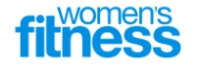

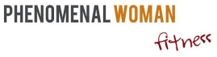


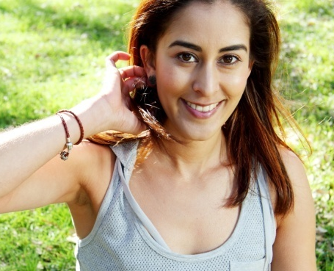
VIDEO
Banner Ad/ link

30 DAY KICK START + DETOX
A complete step by step program to get you on the path to a hotter, healthier & happier you!
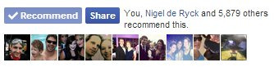
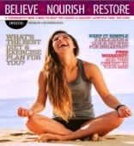
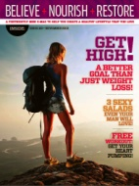
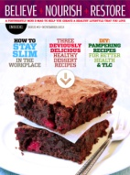
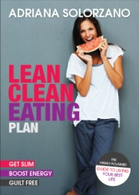
Face book
Banner Ad/ link
Banner Ad/ link
BELIEVE.NOURISH.RESTORE E-MAG

Your’s FREE Every Month!

Order Today
Yours for the
awesome price
of just $9.95!
(Valued $19.95)
*Limited Time Only
Buy now >
- Don’t teach you how to never need to be on another program, plan or diet again.
- Focus on what you need to cut out (I focus on what you need more of in your life to make it more pleasurable so you can stop feeding the voids in your life with toxic food, booze, etc)
- Assume you want the same things as everyone else. They assume your definition of healthy should be the same as everyone else's. (I’ll teach you what works for you)
- Ignore the impact that stress has on your ability to shift weight (biochemistry can be cruel).
I get it. I know and understand first hand your frustrations (I used to be you). I know you want it to be effortless. I know you want to not worry about putting on weight EVER, you want to just "Be". You may have some pieces of the puzzle already, but they just never seem to gel together for long enough to get the outcome you truly crave - A hot body you're proud of with a healthy lifestyle you love. I get it. I understand. And I can help you get there.
As a qualified Food & Wellness Coach (and Personal Trainer), I’ve helped thousands of women (starting with myself) just like you over the last 7+ years to not just lose weight (that’s nice) but take back control, regain self confidence and find peace with their bodies (that’s better – trust me). You can do it to.

So what now? First things first, sign up for my E-Magazine below (it’s FREE!) to receive some really fantastic recipes, inspirational articles, workouts & expert wellness tips each month.

SIGN ME UP!
Your First Name
Your Email
Banner Ad/ link
ULTIMATE 30 DAY KICK START PROGRAM
Finally an easy to follow program to help you get slim & eat well, but also help you create a Healthy Life you love!
Mail-chimp
Opt In
Footer
Get Slim, Boost Energy, And Need a hand getting started?
Create a Healthy Life You Love!
Subscribe to my FREE monthly e-magazine
for heaps of awesome recipes, workouts
& advice!

SOCIAL MEDIA ICONS
Privacy Policy | Returns & Refunds | Contact | Connect with Adriana
Facebook, Twitter, Youtube, Instagram
Opt In
LAYOUT EXAMPLES – HOME PAGE:
HEADER EXAMPLE: (www.kriscarr.com)
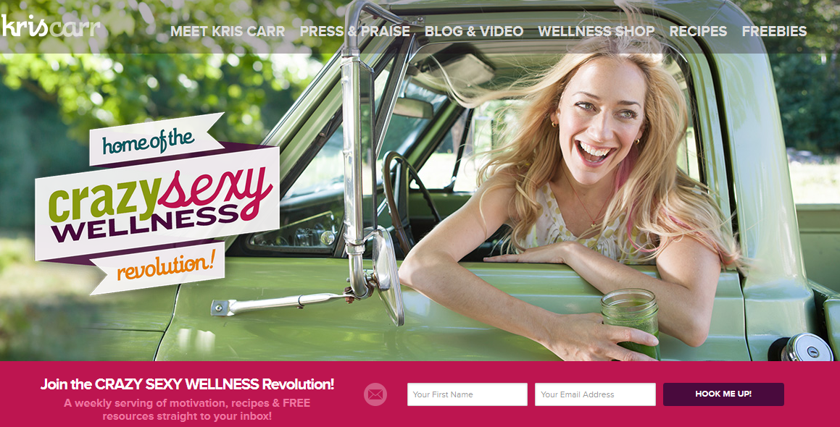
BODY EXAMPLE: (http://gabbyb.tv/)
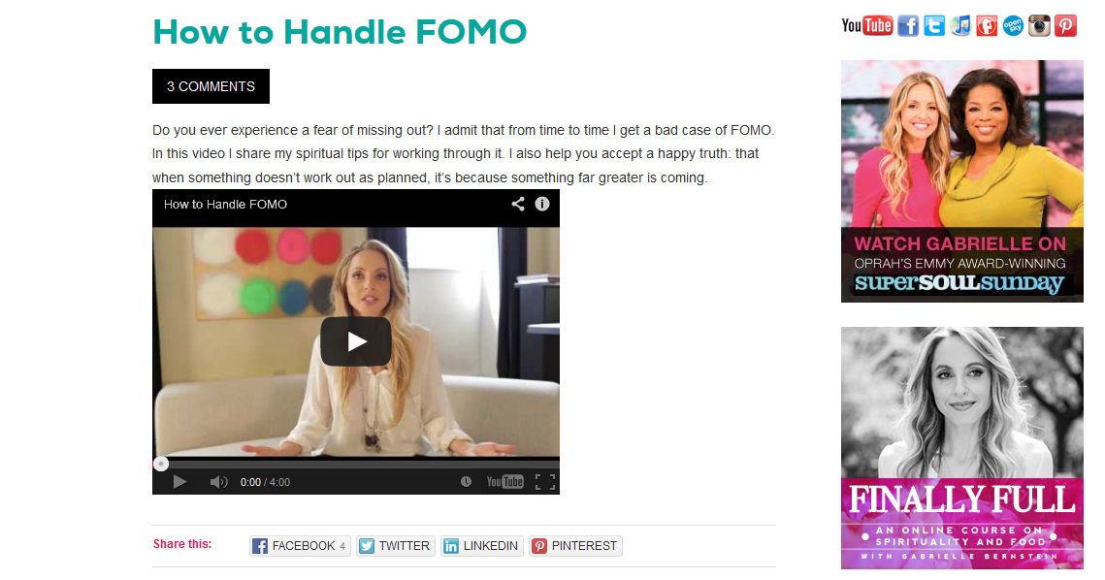
FOOTER EXAMPLE: (www.kriscarr.com) 