
Phone: 09 292 4400
Mobile: 021 948 508
alyson@nztravelbrokers.co.nz

Textile and Shopping tour of India

16 Days / 15 Nights

Escorted by Alyson Wilcock

India Tours take you to the rich cities in history and monumental splendour. View the ancient and modern attractions of Delhi, the marvellous Taj Mahal in Agra, and the forts and palaces of Jaipur on India Tours. The focus is on design while taking in all the wealth of Indian culture and of course the rich variety of textile crafts. We visit major craftsmen with some hands on workshops. India, the country that boasts of its rich culture, has to its credit the diversity of its costumes and traditions. Here, we take you on an ethnic textile tour which familiarizes you with the diversity that we have in terms of costumes. The itinerary is designed to explore everything from the dazzling array of silk-making to the intricate handwork of Chikankari.
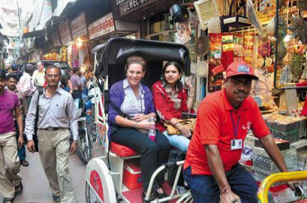
Unique Brass ware, Handicrafts, Leather, Silver, Marble, Carpets, Paintings and Textiles are India's trademark. Shopping for these crafts at the many bazaars and markets is a must when visiting India. Expect to bargain your way into owning a purchase. It's a fun way to meet the locals!! In the field of arts and crafts. Rajasthan is among the richest states of India. Each period of its history made if contribution to this field. The kings and nobles were patrons of art and crafts and encouraged the craft persons. These colours are a striking part of the Rajasthani life and are found in the bustling bazaars, in fairs & festivals, in the customs worn " and produced, and in the tradition al painting & murals. When shopping for souvenirs, the subtle yet ethnic appeal of every item is irresistible whether it be furniture, leatherwear, pottery, metal craft or textiles.
It is little wonder, therefore, that because of these artistic treasures which let you indulge without being extravagant, Rajasthan has been dubbed as the shopper's paradise its craft have always been a source of fascinations whether one appreciates them for purely pleasure or pauses to savour the underline history, culture and symbolism.

Day 01: Arrive Delhi (Flight: TBA) (Normal Check in 1200 Hrs.)
We arrive at Delhi International Airport. We will clear immigration & visa formalities, collect baggage and proceed to the arrival lounge The TOTAL HOLIDAY OPTIONS Executive will then assist the group. with a transfer to the hotel were you will receive a traditional welcome with Garland and Tilak while the hotel formalities are completed. Stay two nights in Delhi. (No Meals)

In Delhi Day 02
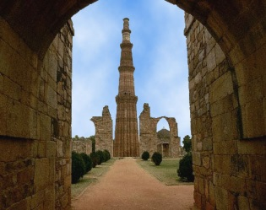
Enjoy buffet breakfast at the hotel. Assemble at the hotel lobby and Alyson (tour manager) will discuss your tour program. After a morning briefing, we will start our guided tour of Old and New Delhi, including the Qutab Minar, the 234-step tower dating to 1193; and India Gate, honoring the 90,000 Indian soldiers who died in World War I. Gandhi Memorial, the simple black marble slab honoring Mahatma Gandhi. Next, two renowned 17th-century landmarks: Lal Qila, the Red Fort palaces which we drive pass; we will view the Jama Masjid literally meaning the Friday Mosque, India’s principal and biggest mosque. Chandni Chowk, Shahjahanabad’s Main Street in 1650, facing the majestic Red Fort. Between the mosque and Chandni Chowk is a narrow shop-lined street along which you will be transported by cycle rickshaws on your most photogenic journey of the tour. Gali Paranthe Wali or Parantha wali Gali, literally meaning ‘bread-makers alleyway’, it once had 12 bread-makers. At last count it has just three, all established in the 1860s. They sell 20 to 30 varieties of Parantha, the layered, unleavened fried whole meal flour (ata) cooked on tavas in ghee. Also visit Humayun’s Tomb -the first garden tomb of the Indian Continent dedicated to Emperor Humayun and designed by Persian architect, is also believed to be the precursor for the design of the great monument of love, Taj Mahal.
Evening free to enjoy a drive through the streets of the city gives you the glimpse of joyous mood all around, As you drive through the various streets and roads of the capital city, you will see all buildings covered in decorative lights, small lighted earthen lamps lining the gates and perimeters of buildings and streets, people in joyous mood , dressed in new clothes exchanging sweets and pleasantries, children and youth engaged in fireworks , covering the skies with beautiful colours while the atmosphere resounds with the sound of the crackers. Enjoy welcome buffet dinner at the hotel. Overnight at hotel. (B, D)

Day 03: Delhi – Lucknow (Flight: 6E 312 ETD 1240 hrs. / ETA 1345 hrs.)
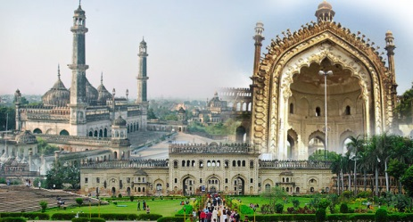
After buffet breakfast at the hotel, transfer to Delhi airport to board flight to Lucknow. This city, which prides itself in being the most cultured in North India, is now a mix of modernity and old monuments, sprawling parks, busy marketplaces, and congested alleys serving the most delicious food.
The City of Nawabs' is an intriguing blend of old world charm, warm hospitality, courteous people, beautiful architecture and rich heritage. Lucknow is the centre for Chikan embroidery, renowned for its timeless grace and gossamer delicacy, a skill more than 2000 years old.
After checking in we then explore the beautiful bazaar which is famous for textiles. Stay two nights in Lucknow. (B, D)

Day 04: Lucknow
Enjoy breakfast at the hotel and we visit a Chikan workshop and watch skilled karigars (workers) delicately working on unique styles and stitches. Later, you will see some of the highlights of the city Bada Imambara, a famous monument of Lucknow that has historical, cultural and heritage importance. Bada Imambara complex was commissioned by the then Nawab of Awadh, Asaf-ud-Daula in the year 1784. The complex also includes the large Asfi mosque, the Bhul-Bhulayah (the labyrinth) and a summer palace with running water. Government Museum is a must visit for all the tourists is situated in a modern three-storied building at Banarasi Bagh area of Lucknow. The museum has separate galleries dedicated to sculptures, bronzes, paintings, natural history and anthropological specimens, coins, textiles and decorative arts.
In the evening, enjoy cooking demonstration with traditional Dastarkhwan style dinner (either at the hotel or at a local aristocratic residence), where you will be served with Awadhi delicacies on the floor setting called ‘Dastarkhwan’. Later return to the hotel for overnight stay. (B, D)

Day 05: Lucknow – Varanasi (Train: Intercity Express ETD 0700 hrs. / ETA 1330 hrs.)
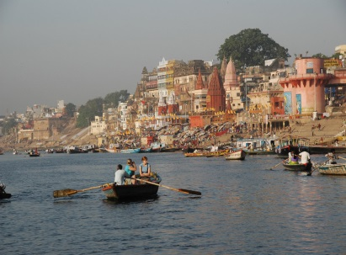
Early morning transfer to Lucknow railway station to board train to Varanasi. Upon arrival transfer to the hotel. Varanasi a city of traditional classical culture, it is the microcosm of Hinduism. Blessed by a legend and revered by religion, it has always lured a large number of pilgrims and worshippers from times immemorial. A city with rich and vibrant past, it has no exquisitely carved palaces, no impregnable fort, and no architectural splendor but still has an inherent charm of its own, with Ghats dotted with temples and maze of alleys alongside. The city is also a centre for the Silk textiles especially Silk Sarees – The traditional wear for Indian women. Varanasi Silk saree’s were considered as an essential garment in the bride’s closet.
Evening enjoy a heritage walk of the city & witness grand prayer ceremony on the ghats of river Ganges. Later return to the hotel for dinner with two nights stay in Varanasi. (B, D)

Day 06: Varanasi – Agra (Marudhar Express ETD 1720 ETA 0610 Next day)
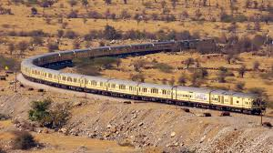
Wake up early morning around 0530 hrs. and proceed to enjoy the sunrise boat ride on river Ganges. The river will be thronged with early morning bathers, raising their faces to the rising sun and reciting the sacred mantra. One can see the perpetual movement of the pilgrims on the steps, the vivid colors of their clothes glistening against the pale gold water, the triangular flags fluttering atop the temple spires. Varanasi is associated with promotion of spiritualism, mysticism and Sanskrit, yoga and Hindi language. Visit the Banaras ghat, Asi ghat & various other ghats. Return back to hotel for buffet breakfast.
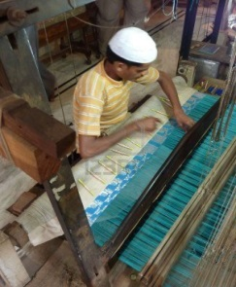
After breakfast take an excursion to Sarnath - the site of the deer park where Gautama Buddha is said to have given his first sermon about the basic principles of Buddhism. It has been a premier centre for Buddhism and has a rich collection of ancient Buddhist relics and antiques comprising of numerous Buddha and Bodhisattva images on display at the Museum.
Visit the silk weaving village to witness the hand woven silk saris which are also called the collector items for because of its highly expensive gold and silver thread used in weaving. Later in the evening transfer to the railway station in time to board overnight train to Agra. (B, D)

Day 07: Arrive Agra (ETD 0610)
Morning arrive Agra, transfer to the hotel. Morning free to freshen up. Afternoon visit Mehtab Bagh, The Mehtab Bagh garden was the last of eleven Mughal-built gardens along the Yamuna opposite the Taj and the Agra Fort. Believed to be built by First Mughal Emperor, Babur. Legend is that Shahjahan, chose this very place to make his own tomb, another identical Taj Mahal albeit in black marble. Mehtab Bagh, literally meaning moonlit Garden, laid in traditional Charbagh style, is an ideal place to view Taj Mahal in all its grandeur. Although in ruins now, it once ad orned a large octagonal pond on the southern periphery which reflected the image of the Mausoleum, It had red sandstone laid pathways, impressive Baradari’s and dome towers at the four corners, apart from a wall protecting it. It gives you a mesmerizing view of Taj Mahal from across the river.

Day 08: Agra
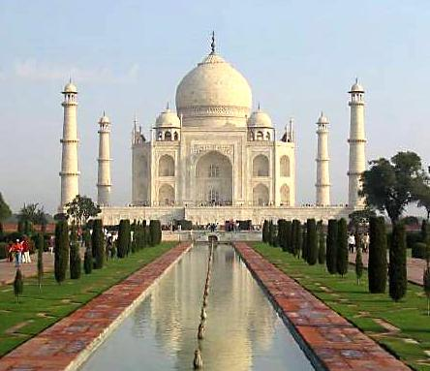
This morning, shortly before sunrise at 06:31, we’ll head out for a sun rise visit to the Taj Mahal, this time from another scouted vantage point designed to maximise the effect of the first pink rays of sunrise. You'll realize that all this talk about the Taj's chameleon-like color shifts is the real McCoy: those gorgeous acres of white marble really do pick up the subtlest changes in ambient light. The world's greatest monument to love and devotion with its superb craftsmanship of semi-precious stones inlaid into the marble in beautiful patterns, a process known as pietra dura. As you pass through the gates, words cannot do justice to your first close up view of the world’s most famous building. It was built by Shahjehan in deep grief upon the death of his wife Empress Mumtaz. Our guide will take his time explaining the detail, as he moves you closer to the mausoleum. And then, it’s up the steps, onto the vast marble plinth and up to then into the Taj itself.
Return back to the hotel for breakfast later continue with the guided tour of the Agra and visit the impressive 16th century Agra Fort, which was constructed in 1565 by Akbar with later additions made by his son, Jahangir, and grandson, Shahjehan.
The sightseeing finishes by 3:00 pm rest of the evening explore the colour bazaar of Agra famous souvenirs made out of marble. (B, D)

Day 09: Agra – Jaipur (Distance: 260 kms / Driving Time: Approx. 5 hours)
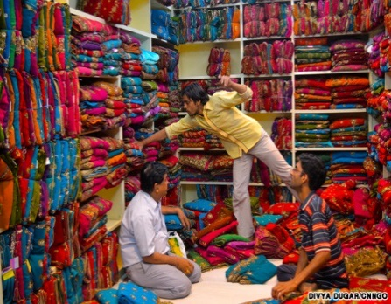
After breakfast check out of the hotel and travel towards Jaipur the Pink City of India. On arrival check in with rest of the day at leisure to explore the colour bazaar of Jaipur for textile, junk jewellery, carpet, world famous jewellery bazaar which offers a variety that ranges from chunky tribal jewellery to enamelled gold to modern diamond jewellery.
Among the wide list of availability, conventional Jaipur jewellery with ‘kundan’ and ‘minakari’ works is noted all over the world. With a string of retail and wholesale outlets catering to various local and foreign goods, the mind-bending shopping experience in Jaipur cannot be traded for anything else. Stay three nights in Jaipur (B, D)

Day 10: Jaipur
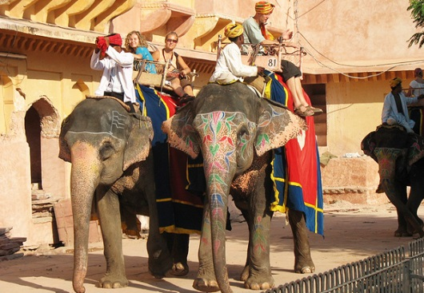
After buffet breakfast, enjoy guided city tour and visit Amber Fort, the ancient capital of Rajasthan and the majestic palace complex to witness a unique system of air-conditioning of 17th century. A beautiful complex of Palaces, halls, pavilions, garden and temples built by Raja Mansingh, Mirza Raja Jaisingh and Sawai Jaisingh over a period of about two centuries, it still stands in magnificent state. The historic pink-painted sandstone architecture, earned the city the affectionate nickname of the 'Pink City'. Rest of the evening is free for shopping. (B, D)

Day 11: Jaipur
Enjoy buffet breakfast at the hotel. Take a full day excursion to Sanganer. Sanganer textiles are renowned all over India and abroad for their hand printed goods, for their delicate designs and bright colours. A distinctive feature of Sanganer prints is that the colourful designs in all possible colours are printed on the white backgrounds.
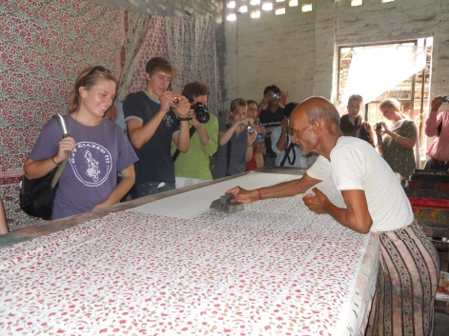
Block printed and screen-printed fabrics of Sanganer are equally popular. See for yourself the way in which they prepare the textiles with the help of hand block prints. Sanganer Tours feature a peek into the quaint rustic village life of the people which is simply a delight to experience. Return back to hotel. Buffet dinner at the hotel. Overnight at hotel. (B, D)

Day 12: Jaipur – Jodhpur (Distance: 330 kms / Driving Time: Approx. 7 hours)
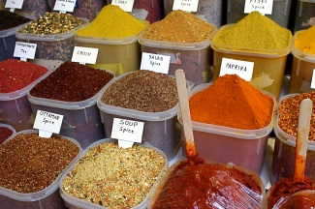
After buffet breakfast, travel to Jodhpur. Today you experience the feeling of travelling back in time to Jodhpur, while you catch a glimpse of the splendour and magnificence of this ancient desert city built on the edge of the Thar Desert. The folks here wear nice and lovely multihued costumes. One of the unique features of the culture is the colourful turbans worn by men. There is a warm and friendly feeling meted out by the local people. The bazaars have a range of items from tie and dye textiles, embroidered leather shoes, lacquer ware, antiques, carpets and puppets to the exquisite Rajasthani textiles, clay figurines, miniature camels and elephants, marble inlay work and classic silver jewellery.
In the evening visit Sadar Bazaar in the heart of the city, this market is one of the largest markets of Indian Spices and textile.
Buffet dinner at the hotel. Stay two nights in Jodhpur (B, D)

Day 13: Jodhpur
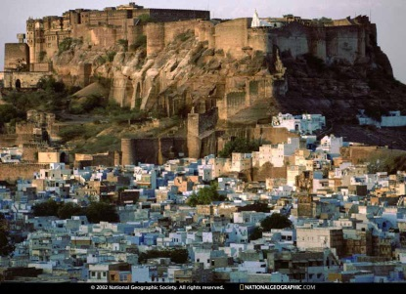
Have a leisurely breakfast and proceed for sightseeing tour and visit Mehrangarh Fort; one of the largest forts in India, the beauty and grandeur of numerous palaces inside narrates a saga of hard sandstones yielding to the chisels of skilled Jodhpur sculptures and to enter the fort one has to cross seven gates. Also visit Jaswant Thada.
Rest of the evening is free to enjoy shopping. A treasure trove for shoppers, Jodhpur bazaars are teeming with an array of handicrafts. One can shop for white metal curios, silverware, quilts, tie-and-die fabrics, leather goods, wooden toys, paintings, embroidered shoes, Jodhpur breeches or Jodhpurs and a range of souvenirs. Buffet dinner at the hotel. Overnight at hotel.
(B, D)

Day 14: Jodhpur – Ranakpur – Udaipur (Distance: 290 kms / Driving Time: Approx 6 hours)
After buffet breakfast, drive to Udaipur, en-route pass lush green valleys, streams and heart capturing views before visiting Ranakpur. Renowned for its Jain temples with intricately carved marble Pillars and Domes, Ranakpur is amongst the five holiest places of the Jain community and exceptional in beauty. Tucked away in a remote valley in the Aravalli ranges, it boasts of one of the largest and most important Jain Temples in the country. It has a four-temple complex which is famous for its peaceful and harmonious surroundings. After the sightseeing continue drive to Udaipur on arrival check in and relax. Stay two nights in Udaipur. (B, D)

Day 15: Udaipur
After buffet breakfast, enjoy city tour of Udaipur. Founded by Maharaja Udai Singh in 1568, Udaipur is situated on the banks of Lake Pichola with lush green hills of the Aravalli surroundings, making it the most romantic city of Rajasthan. Sightseeing tour to City Palace, Jagdish Temple, Lok Kala Mandal and Saheliyon-Ki-Bari. Enjoy rest of the day on the banks of the Lake Pichola, which shines like a jewel in the crown of the city adding more grace and grandeur to it. Enjoy boat ride at Lake Pichola.
Rest of the evening enjoy shopping at the local markets. Udaipur offers the exquisite variety of handicrafts Later returns to the hotel have dinner with overnight stay in Udaipur. (B, D)

Day 16: Udaipur – Mumbai (Flight TBA)
After a leisurely breakfast check out from the hotel at 1200 hrs. in time transfer to the domestic airport to board your flight to Mumbai. On arrival walk towards the international departure counter and check in to board the connecting flight home. (B)
There is a separate option should you wish to stay and explore Mumbai for a few days. Please advise at time of confirmation.

About your Tour Manager: Alyson Wilcock
Alyson has escorted many tours around India and has a passion for the culture and the people.
Alyson also has a business in New Zealand which deals with Rajastaini & South India business’s on a regular basic.

What’s included?

Airfares Auckland to Delhi/Mumbai to Auckland Direct
• Accommodation with private facilities.
• Travel, transfers and sightseeing by air-conditioned Mini / Large coach as per the itinerary
• Meals as specified (B=Breakfast, L= Lunch, D= Dinner)
• Entrance fee to the monuments as per the Program. (one visit per monument)
• Local English speaking tour guide during the sightseeing at Delhi, Lucknow, Varanasi, Agra, Jaipur, Jodhpur , Udaipur
• Rickshaw ride in Delhi.
• Elephant ride failing Shared Jeep ride at Amber Fort in Jaipur
• Common Boat Ride at Lake Pichola in Udaipur (subject to water level in the lake)
• Shared boat ride at River Ganges, Varanasi (subject to water level)
• Culinary delight tour in Lucknow
• Air conditioned chair car train fare for sector Lucknow – Varanasi
• Air conditioned two tier train fare for sector Varanasi - Agra
• 01 THO tour escort accompanying the group
• All excursions and sightseeing as mentioned in the itinerary.
• One Bottle of Mineral water per person per day
• All assistance and transfers
• All current taxes

What’s excluded?

• Visa fee, Early check in or late check out, Meals other than specified above, Porterage at the Airports / Railway Stations, Tips & Gratuities, Travel & Medical Insurance, Camera and video permits, Expenses incurred due to flight / train cancellation or delay, Any expense of a personal nature, like drinks, laundry, telephone calls, mini bar, etc., any optional excursion or tour, any other expense not mentioned in the prices include column.

Terms & Conditions:
- The price quoted for the land, airfare and taxes are subject to change without notice until final payment has been received in full and tickets are issued.
- Deposit is non refundable and due within 7 days of the invoice dates (unless otherwise stated) Deposit required is $400 per person
- Receiving confirmation of the booking means you and you have read and agreed on NZ Travel Brokers booking conditions attached. Due to any unforeseen circumstances booking conditions may change without notice hence please request a copy before making reservation.
- No early check-in or late check-out is included
- Activities mentioned above are subject to availability
- Driving time mentioned in the itinerary is approximately and is for guidance only. Travelling may take much more time than mentioned in the itinerary as it vary according to season, area of your tour and road conditions or the region.
- Every hotel is different in room size, services, location, category and decor. We take utmost care while selecting and suggestion hotels so every traveller can have comfortable stay.

