The project:

Production a folded flyer [10 cm (width) x 20 cm (height)]

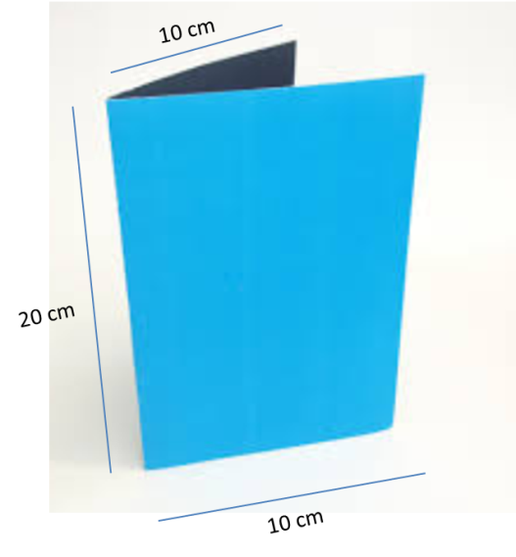

Page 1:
Logo Bagunça Box

Reconquer the space in your home
Keep everything that is importante but is not used in your routine in Bagunça Box.

Page 2:
Turn your clutter roo minto a real room.
before/after clutter room Picture
Before | After
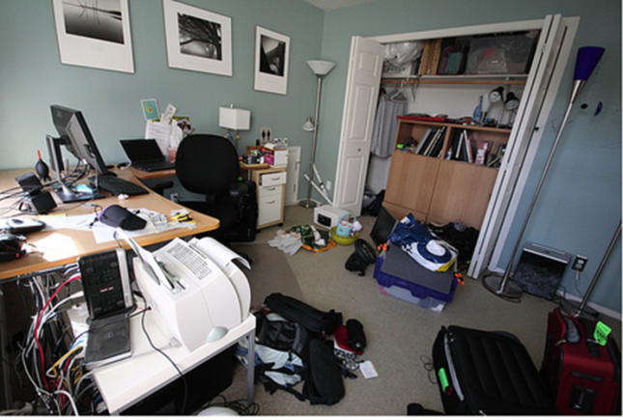 | 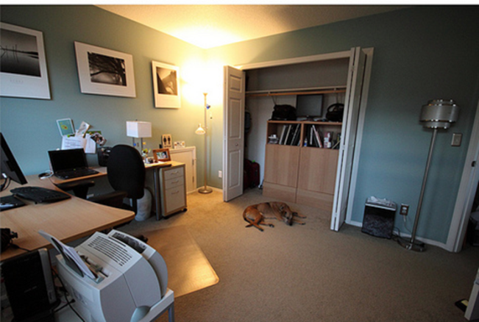

The Family is growing? Want to better receive your relatives? Are you moving to a smaller place? Reconquer the space in your home keeping everything you don´t need on your daily routine in Bagunça Box.
Don’t use your valuable home space as a personal warehouse. Let Bagunça Box take care of your stuff.

How Bagunça Box Works? [drawing showing how it works]
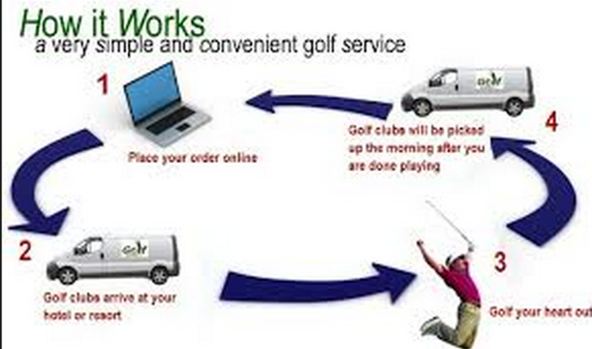
(Example of a fluxogram showing how the service works)
- Ask for a Bagunça Box at your home
- Put everything you want in the box, lock it and keep the key
- Schedule the box pickup
- Have access to your stuff whenever you want by asking for the delivery of your Bagunça Box in your home of at one of our Pick up Points.

Page 3:
Choose the box that better fit your needs.
(Table showing the 2 boxes types)
Foto Caixa Bagunça Box  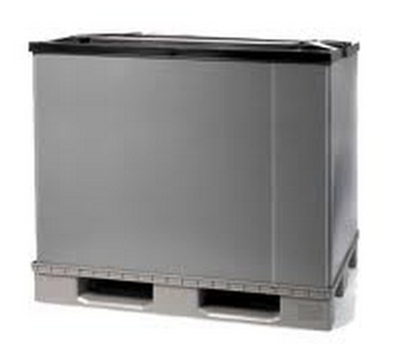 | Foto Caixa Baguncinha  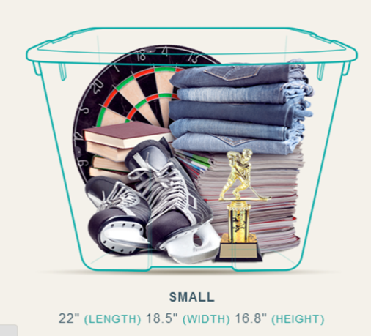
Dimensões Largura x Comprimento x Altura  Volume total: 800 Litros | Dimensões Largura x Comprimento x Altura  Volume total: 130 Litros
Valor armazenagem | Valor armazenagem
Valor entrega nos Pontos de Coleta | Valor entrega nos Pontos de Coleta
Valor entrega em domicílio | Valor entrega em domicílio

Bagunça Box offers:
- Security: have all your stuff stored at a safe warehouse, monitored 24 hours a day
- Easyness of use: choose to have your stuff delivered at your home or at any of our Pick Up Points at Flamengo, Tijuca, Ilha do Governador and Recreio dos Bandeirantes.
- Economy: better enjoy your home space that you already have.

Página 4:
(Picture of someone receiving the box at home)
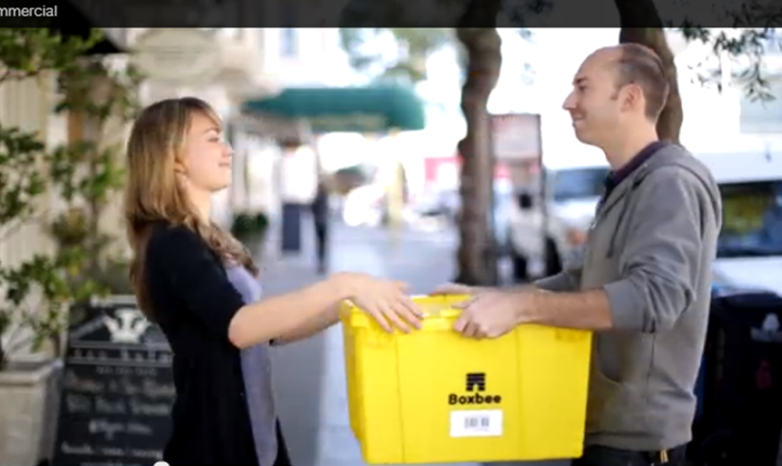
(Picture example)
Headline: Access your stuff whenever you need

Pick Up Points:
(4 maps showing the Pick Up Points with it´s addresses)

Contact:
www.baguncabox.com.br
Phone: (21) 3344-9555
Address: Estrada do Rio Morto, 222

