We need a logo for a European research project, named RECONASS. The project’s full title is Reconstruction and Recovery Planning: Rapid and continuously updated Construction Damage, and Related Needs Assessment.
The aim of the project is to develop a monitoring system for buildings that will provide a continuously updated assessment of their structural condition. In case of a terrorist attack, in order to assess the physical damage in the whole affected area, the detailed assessment of damage in the monitored facilities will be used for calibration of satellite and aerial photography, dramatically reducing the required time to inform the post disaster needs assessment process and provide data for reconstruction efforts.

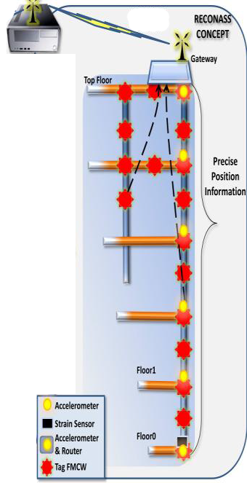
The next picture, describes the RECONASS concept. The tags provide info for the structure that has emerged from the disaster and strain sensors and accelerometers help to estimate the structural condition.



The acronym RECONASS should appear in the logo.
The following picture is a test logo.
