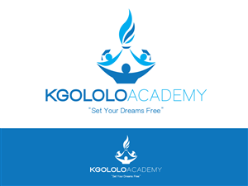

www.khululafoundation.org


Our Mission: At Kgololo Academy we grow and strengthen our academic and character skills and are prepared for success in university and beyond. We work collectively to develop ourselves and others and grow as leaders who lend our voices and align our actions to enrich our communities.

1

WHO ARE WE
Kgololo Academy will open its doors in January 2015 as the first Grade R- 12 university preparatory school in Alexandra. Admission to Kgololo Academy is on a first come, first serve basis and the school will serve Grade R students in 2015 and will add a new grade each year.
Kgololo Academy is a proud member of The One World Network of Schools, an organization, founded in the United States, committed to building a global network of transformational breakthrough schools.
OUR COMMUNITY
Alexandra is a historic area located in the Gauteng Province in South Africa with several notable leaders residing in Alexandra at some point in their journey, including President Nelson Mandela and former First Lady Zanele Mbeki. Alexandra is a community full of promise but is considered one of the most economically disenfranchised urban communities in the country. The average household income in Alexandra is under R5000.00 per month and an estimated population of 500,000 people live on 1 square mile of land.
OUR MODEL
Kgololo Academy has several unique features aimed to put all students on the path to university:

- University preparatory curriculum and learning environment
- Highly qualified, caring, and passionate educators and staff
- Extended School Day
- Dual Language Programme (English and Zulu0
- Creative Arts and movement classes
- Technology Integration across subject areas
- Extra-murals built into the school day

CORE COMPONENTS
At Kgololo Academy, we have outlined four core components that will be prioritized, with each area providing an avenue for achieving our mission of ensuring that all students are prepared with the academic and character skills that they need to be successful in university.

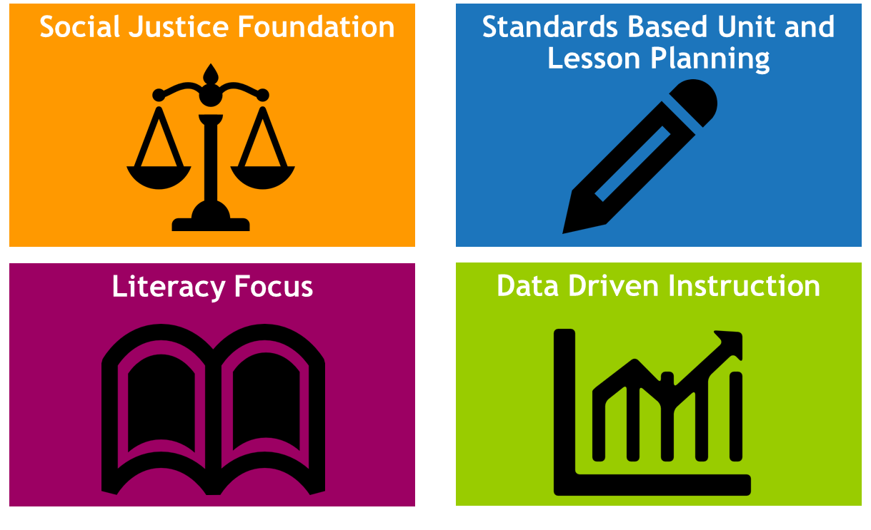

OUR SCHOOL LEADER: Waahida Tolbert-Mbatha is passionate about education and social justice and has been a contributing writer for Education Southern Africa and Rethinking Schools and in 2012 Waahida gave a TEDx talk on the importance of an education steeped in social justice. Waahida is excited about the opportunity to learn and serve the Alexandra Township and is one of the organizers for TEDxAlexandra. In 2013, Waahida completed the highly selective KIPP Global Fellowship in the United States which is a specialized programme that prepares fellows to found and lead high performing schools in underserved communities. Prior to establishing the Kgololo Academy, Waahida taught middle school humanities for seven years and worked as an education programme coordinator. Waahida holds an MS Degree in Education Policy from the University of Wisconsin-Milwaukee, where she was an Advanced Opportunity Fellow and a BA in education from Berea College.

QUESTIONS: If you have questions, please contact a member of our team at +27 79-594-5682 or by email at info@khululafoundation.org.

