RS-Transmitter Brochure design

Instructions

- Layout: 4.25” X 6” or 5” X 7” Postcard size, landscape, one-fold, four sides
- Preferred font: Calibri or similar
- Accent curved lines / patterns are requested. Those lines / pattern will have varnish spot finish to create a glossy spot finish. Please design with appropriate lines / patterns.

- Logo:

- Black background is preferred
- The content for all four pages is specified below.

Contents
Page1
(Opening page – No text preferred. Please use the image below)

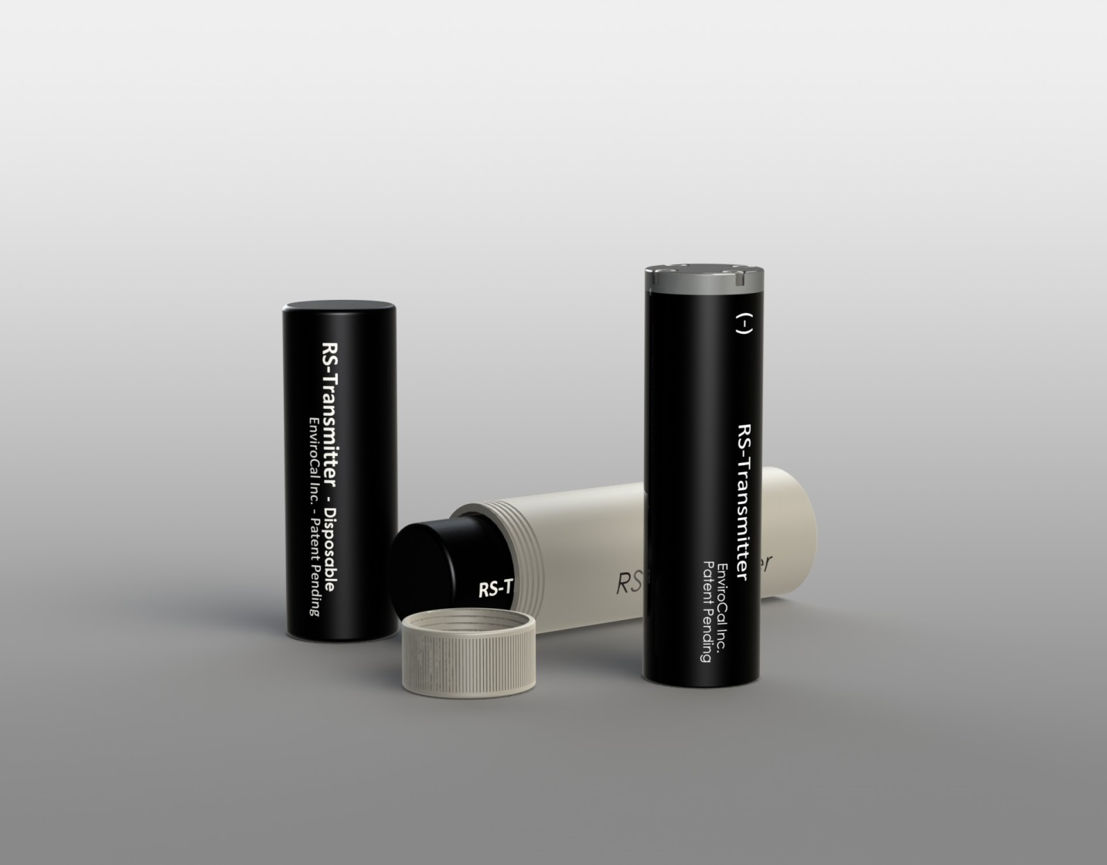

Page2 (Inside – Left hand)
List of items to be included in Page 2.
- Heading Level 1 – “RS-Transmitter Disposable”
- Heading Level 2 / Tagline – “World's first Disposable Transmitter”
- Feature Bullets –
  - Highest and Constant signal strength through entire life
  - Buy it for the price you rent
  - Lower Financial liability
- Image shown below
- Information in the table below
 | xSD | SD |  | MD
Standard Run-Time¹ | 64 hours  [2.5 days] | 130 hours  [5 days] |  | 500 hours  [21 days]
Frequency | ELF – 16Hz to 30 Hz (22Hz default)
Pressure | 1800 PSI | 1800 PSI |  | 1600 PSI
Length | 3” [76mm] | 6” [152mm] |  | 9.5” [241mm]
Dia | 1” [25.4mm] | 1.25” [32mm] |  | 1.875” [48mm]
Temperature² | -40˚F to 150˚F [-40˚C to 65˚C]
Price (USD) | 320 |  | 400 |  | 500



¹ Standard Run-Time is at 25˚C. Continuous option available. Longer Run-Times possible with decreased pulse rate.
²Run-Times may vary below 32˚F [0˚C]

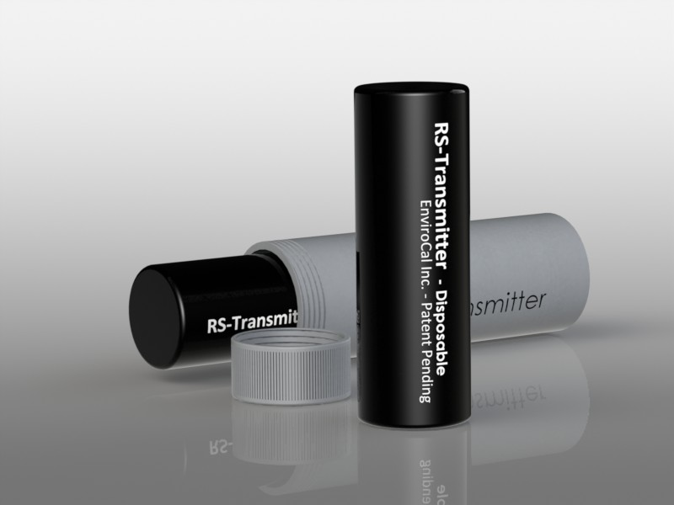

Page3 (Inside – Right hand)
List of items to be included in Page 3.
- Heading Level 1 – “RS-Transmitter Reusable”
- Heading Level 2 / Tagline – “Powerful and Economical in one Package”
- Feature Bullets –
  - Best signal strength in the industry
  - Reliable sealing with spare o-rings
  - Includes a Free Pelican style case
- Image shown below
- Information in the table below
 | xSD |  | SD | MD
Standard Run-Time¹ | 64 hours  [2.5 days] |  | 130 hours  [5 days] | 500 hours  [21 days]
Frequency² | ELF – 16Hz to 30 Hz (22Hz default)
Pressure | 2000 PSI |  | 2000 PSI | 2000 PSI
Length | 3.4” [86mm] |  | 6” [152mm] | 9.5” [241mm]
Dia | 1” [25.4mm] |  | 1” [25.4mm] | 1.875” [48mm]
Temperature⁵ | -40˚F to 150˚F [-40˚C to 65˚C]
Price (USD) | 1200 | 1400 |  | 1600

¹ Standard Run-Time is at 25˚C. Continuous option available. Longer Run-Times possible with decreased pulse rate.
⁴Higher Pressure rating possible
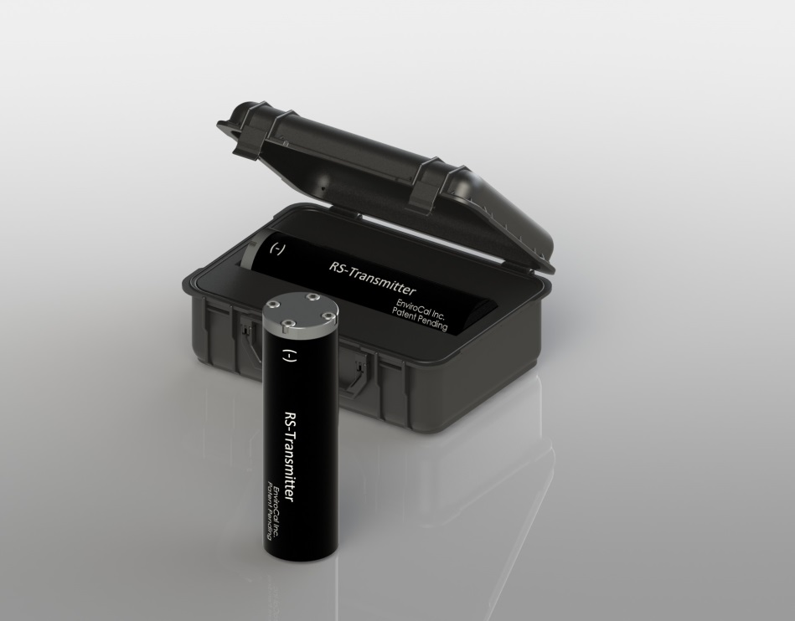
⁵Run-Times may vary below 32˚F [0˚C]
Page4 – Be creative
Use Logo and info below and / or ???
EnviroCal Inc.
1718 Fry Road Suite 235
Houston, TX 77084
281-347-3007

