STRATEGIC REVIEW
June
Sample Company Pty Ltd



Contents
1 Now, where, how 1
2 Workshop toolkit 2
2.1 Simple strategic focusing principles 3
2.2 Business segmentation 4
2.3 Pest analysis 5
2.4 Key influences 6
2.5 Business attractiveness analysis 7
2.6 Competitor analysis/Competitive strategy 8
2.7 Understanding business growth and diversification 9
2.8 Strategic SWOT for strategy development 10
2.9 Objectives, KPIs and critical things 11
2.10 Impact/Ease: Establishing the priorities 12
2.11 Impact/Ease matrix – Graphing the priorities 13
2.12 Action planning 14

1 Now, where, how
Our current situation: |  |  |  |  | Now |  |  |  |  |  |  |  |  | Where |  |  |  | Our vision comprises the following key objectives:  The critical things to December 2009 are  Key performance targets
Name
Strategic Plan
2010-2013
 |  |  |  |  |  |  |  |  |  |  |  |  |  |  |  |  |  |  |  |  |  |  | 6/2010 |  | 6/2011 |  | 6/2012
 |  |  |  |  |  |  |  |  |  |  |  |  |  |  |  |  |  |  | Free cash flow trend
 |  |  |  |  |  |  |  |  |  |  |  |  |  |  |  |  |  |  | Net profit per customer
 |  |  |  |  |  |  |  |  |  |  |  |  |  |  |  |  |  |  | W/Cap
 |  |  |  |  |  |  |  |  |  |  |  |  |  |  |  |  |  |  | Revenue
 |  |  |  |  |  |  | How |  |  |  |  |  |  |  |  |  |  |  | Number of sales
 |  | Strategies |  |  |  |  |  |  | & |  |  |  |  |  |  | Actions
Growth |  |  | Customer focus |  |  |  | Systems & processes |  |  |  |  |  |  |  |  |  | People & learning |  |  |  |  |  |  | Financial

2 Workshop toolkit

2.1 Simple strategic focusing principles
Now-Where-How
Now-Where-How is a simple but effective process for problem solving and decision-making. The first step is to understand your current situation (Now), then assume you are very successful and hence identify your end-goals (Where), and only then create strategies (How) to get from Now to Where. A typical mistake many organisations make is to discuss the problem (Now) and then seek to solve it immediately (How). Including the extra step of Where means you have a common view of the future and a means to measure the potential effectiveness of the strategies created.

80/20 Principle applied to focusing and planning
The 80/20 Principle states that 80% of the effect typically comes from 20% of the causes. So our objective in the planning process is to define and prioritise the strategies and actions for at least the 20% of things that will deliver 80% of the progress. And because strategic planning is always subject to the vagaries of the environment and changes in our business, we would like to develop a plan that is sufficiently good, but is done in a short time frame—this means a plan that is relatively simple but which can be updated easily as the need arises in the future. To achieve these things will be to have used the 80/20 Principle well in our planning.
Now-Where-How approach
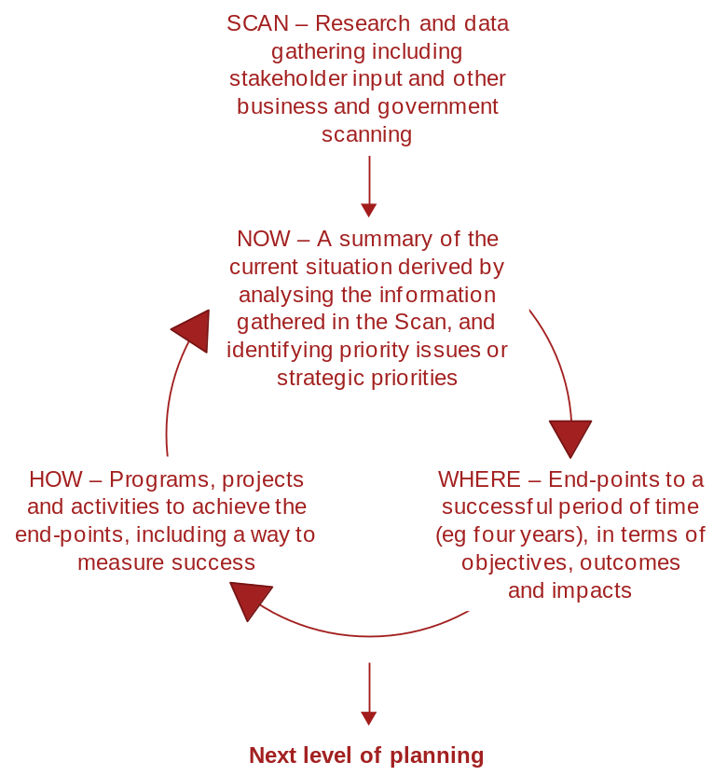

2.2 Business segmentation
This is a table for analysing the breadth and depth of your business in the future, to track progress in developing the business. Within these cells you can place different forms of information such as Sales Revenue, Profits, Level of Opportunity, Rate of Growth or Decline etc. This table allows you to cross-reference each product/product group with each customer group and discuss opportunities and risks. Note the outcome of discussion in the relevant box.
Product groups | Customer groups
 | A | B | C | D | E | F | Totals
1

2

3

4

TOTAL

What does this say about the breadth and depth of our business? Where are there good opportunities to grow?

2.3 Pest analysis
What are the key external factors that are likely to influence our business in the next couple of years?

Political/Legal factors | Economic factors
 | .
Social/Cultural /Environmental factors | Technological factors

2.4 Key influences
Using the results of the Business Segmentation analysis and the PEST analysis (and any other relevant information), note down the key influences and their implication for your business.

Customer group | Key influences | Key implications for you
A

B

C

D

E

2.5 Business attractiveness analysis
Rate each customer group out of 10 (10 being maximum attractiveness) in relation to each attribute. Then multiply the rating by the relevant weight (Wt) to obtain a score for each customer group.
(e.g.; if Customer Group A is rated an 8 for Volume of available business, multiply rating 8 by its Weighting of 4 = Total 32.)

 | Customer or product groups
Attribute | Wt | A | B | C | D | E | F | G | H
Volume of available business

Ease/Margin

Your ability to deliver value
(e.g. a complete solution)

Competition
(10 = low competition, 1 = high)

TOTAL | 10

How attractive are your different customer groups, compared with each other?
(Note: the weighting of each attribute can be adjusted to better reflect the importance of each attribute to your business. You can also add an extra attribute, but more than five attributes tends to dilute the analysis and the outcome is generally less valuable)

2.6 Competitor analysis/Competitive strategy
This analysis develops strategies to assist your organisation to compete. Complete the boxes by working across the page (e.g. consider each competitor separately and entirely).

Competitor / product | Their strengths | Their weaknesses | Our relative strengths | Our relative weaknesses | Strategy to compete

2.7 Understanding business growth and diversification
How does this apply to your business?
Note: By changing one variable at a time, and changing both variables over time (e.g. moving from Outcome A to Outcome B1, and then to Outcome B2), the net result leads to Outcome C without the risk and stress of a single move from Outcome A to Outcome C.
Basis for business growth | Existing customers | New customers
Existing products or services | Outcome A  The easiest, lowest risk business growth often comes from focusing on more of your existing business | Outcome B2  A medium risk strategy because only one variable, the customer, is being changed
New products or services | Outcome B1  A medium risk strategy because only one variable, the product or service, is being changed | Outcome C  Diversification is the highest risk approach to growth—because two variables are being changed at the one time

2.8 Strategic SWOT for strategy development

 | Strengths | Weaknesses
Opportunities/Objectives | How do we use our strengths to achieve our opportunities & critical objectives? | How can our opportunities be used to reverse our weaknesses?
Threats/Restraints | How do we use our strengths to overcome our threats & restraints? | How do we manage risk & vulnerability (i.e. where threats align with weaknesses)?

2.9 Objectives, KPIs and critical things
Consider all the previous discussion. If you are really successful over the next 3 years, what specific things will you have achieved in 3 years?
End point notes |  | How will you know when you have achieved your end-point?
1

2

3

4

5

In order to have any chance of reaching the 3 year objectives, what critical things must you address
in the next 6 – 12 months?
1
2
3
4
5

2.10 Impact/Ease: Establishing the priorities
Note your key strategies into the table from the Strategic SWOT. Consider firstly the relative impact of each strategy on your objectives—10 is the maximum positive influence, 1 is the minimum. After you have finished rating the impact, move on to rate each strategy according to its ease to accomplish (time, resources, $ etc)—10 is the maximum ease (easy), while 1 is minimum ease (very difficult).
# | Strategy | Impact | Ease
1
2
3
4
5
6
7
8
9
10
11
12
13
14
Note: This exercise continues over the page.

2.11 Impact/Ease matrix – Graphing the priorities
Graph each strategy according to its rating. Where do the strategies fall? What are the priorities? What are the implications for the business?
Impact |  | High 10
Impact |  | 5
Impact |  | Low 1
Impact |  |  | Low  1 | Ease |  | High  10

2.12 Action planning

Priority strategy | Actions | By whom | By when
1

2

3

4

5

6

7

